
Vision Access
Volume 33 - Number 3
August 2026
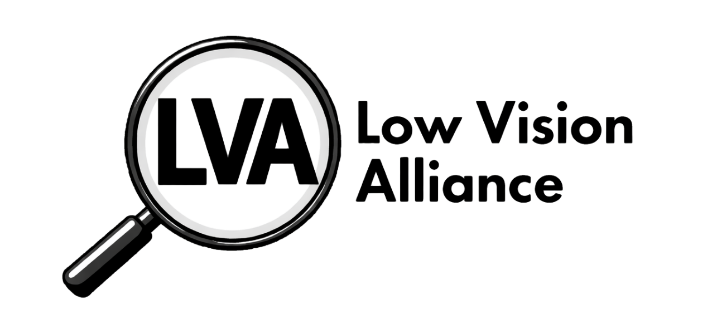
QR Code

(formerly Council of Citizens with Low Vision International)
Winner of the 2026 Hollis Liggett
Braille Free Press Award
Vision Access | Vol. 33 – No. 3 | August 2026

Table of Contents
President’s Message 3
LVA Receives Hollis Liggett Award 5
LVA Annual Business Meeting Recap 7
2026 LVA Awards Recipients 10
Meet the 2026 Scheigert Scholarship Winners 13
Meet the 2026 Genensky-Foley Magnification Award Winners 17
LVA at the 2026 ACB Conference and Convention in St. Louis, Missouri 21
Anthony Akamine Wins Walk to St. Louis Contest 29
DKM First-Timer and ACB Leadership Fellows from LVA 31
Rebranding Committee Update 33
LVA Affiliates’ Corner 39
LVA Book Club 45
Scout’s Corner: Two Paths, One Perfect Plan 46
America 250: Revolutionary War Heros: Did They Have Low Vision? 50
America 250: Unscathed, Still There: A Semiquincentennial Reflection 58
Low Vision Rower Sets Goal to Join Competitions 64
Are the New EchoVision Smart Glasses for You? 67
Apple AirPods Pro 3: A Small Device That Makes a Big Difference 70
Join Low Vision Alliance’s Email Lists 76
Contact Low Vision Alliance 77
Low Vision Alliance Officers and Directors 78

Cover Art Description
The design features a vertically elongated gray diamond. In the top half of the diamond is the Low Vision Alliance logo, which is a black and white with a depiction of a round handheld magnifier with its handle pointing diagonal left, displaying the letters “LVA” capitalized in bold black font within the magnifying glass. Just below the center of the diamond, stretching across is the text “formerly Council of Citizens with Low Vision International”. The bottom half of the diamond displays the newsletter title “Vision Access,” with “Volume 33, Number 3, August 2026” underneath. A QR code appears in the lower left corner.

President’s Message

Looking Back on Convention and Looking Ahead

It was wonderful to see so many of you at the convention this year! For those who were unable to attend, LVA offered some great sessions in a variety of formats, including virtual, hybrid, and in-person opportunities. I hope everyone who participated enjoyed the sessions and had a great time. More importantly, I hope you came away with valuable information you can use not only in your own life but also to help others in your communities.

During our business meeting, all of the incumbent officers and directors were voted back into their positions. I want to sincerely thank each member of the board for their continued support and for their willingness to give their time, energy, and talents to LVA. I truly appreciate all that you do for this organization.

Our Committees Need You!

Now, let’s talk about our committees. In the past, I have appointed a chairperson for each committee, and members have then volunteered to join. Some of our committees have a good number of members, while others have only a few.

If you would like to serve on a committee, please email me or give me a call. We especially need members to get involved with committees that currently have only a few people.

I believe that member involvement is the key to keeping LVA strong and moving forward. Every member has something to contribute, whether it is an idea, a talent, experience, or simply a willingness to help.

So, if you have been thinking about getting more involved, now is the time! Please don’t wait for me to call you, reach out and let me know what interests you. And for those of you who haven’t volunteered yet, don’t be surprised if your phone rings!

Together, we can make LVA even stronger. I look forward to working with all of you in the coming year!

Patti Cox, President, LVA

LVA Receives Hollis Liggett Award
Source: ACB Board of Publications

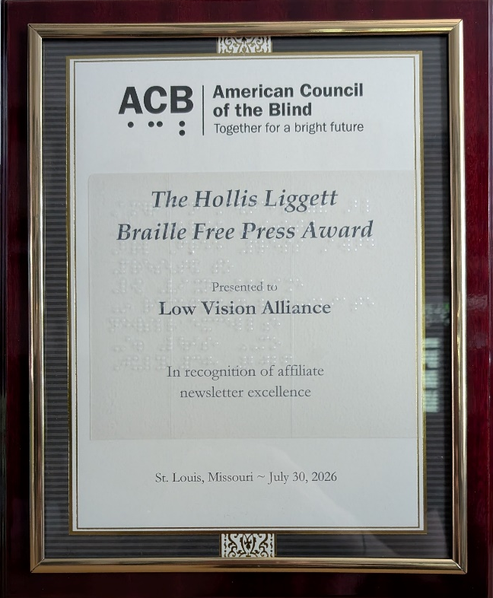
Photo Left: The Hollis Liggett Braille Free Press Award certificate presented to LVA at the banquet held during the 2026 ACB Conference and Convention in St. Louis, Missouri.

Each year, the American Council of the Blind Board of Publications proudly recognizes excellence in communication, journalism, and media through three distinguished awards: the Ned E. Freeman Excellence in Writing Award, the Vernon Henley Media Award, and the Hollis Liggett Braille Free Press Award. These awards celebrate individuals and organizations whose work informs, inspires, educates, and strengthens our community through the written and spoken word.

The Hollis Liggett Braille Free Press Award recognizes excellence in affiliate publications and encourages the highest standards of journalism among the state and special-interest affiliates of the American Council of the Blind. Eligible publications must be distributed at least twice each year and are nominated by an affiliate's newsletter editor or president. Judging is based on several criteria, including the diversity of contributing writers, the variety and quality of information presented, how effectively the publication reflects the affiliate and its mission, the overall quality of writing, and the publication's layout and presentation. This year's competition was exceptionally close, reflecting the outstanding work being produced throughout our affiliate publications.

The recipient of the 2026 Hollis Liggett Braille Free Press Award is Low Vision Alliance, (formerly the Council of Citizens with Low Vision International) for its quarterly publication, Vision Access. Vision Access consistently delivers informative, engaging, and professionally produced content that reflects the mission, accomplishments, and voices of the Low Vision Alliance while serving as an outstanding resource for its members and others.

During the ACB Convention banquet on Thursday, July 30, Zelda Gebhard, Chair of the ACB Board of Publications and LVA 1st Vice President presented the 2026 Hollis Liggett Braille Free Press Award to Melanie Sinohui, Chair of the Low Vision Alliance Publications Committee.

The BOP congratulates the 2026 award recipients. Your commitment to excellence in writing, publishing, journalism, and media helps educate, inform, and connect our community and thanked them for the lasting impact their work continues to make throughout the American Council of the Blind and beyond.

LVA Annual Business Meeting Recap

LVA’s Annual Business Meeting was held virtually on July 18, 2026. A review of the year was presented by each committee and elections were held for two officers and three directors with the following results:
- President (2-year term): Patti Cox
- Secretary (2-year term): Melanie Sinohui
- Director 2 (2-year term): Kathy Farina
- Director 4 (2-year term): Paul Lewis
- Director 6 (2-year term): Donna Williams

To learn more about the members of the LVA Board of Directors, read their bios in the August 2025 issue of Vision Access, which can be found at https://lowvisionalliance.org/visionaccess/

Constitutional Amendments

5.2.6: Immediate Past President

Purpose: The Constitution and Bylaws Committee feels it is unfair to require or expect a former Immediate Past President to assume the position if a vacancy occurs.
By definition, once a new President is elected, the former President automatically becomes the Immediate Past President. The committee believes that an individual should not be expected to continue serving in a role that no longer applies. Additionally, a member serving as President and Immediate Past President could potentially spend up to 12 years on the Board, which already represents a significant commitment to the organization’s governing body.

Outcome: The amendment was adopted unanimously.

8.2: Voting, Affiliates

Purpose: This proposed amendment, unlike the current language, places no cap on the number of delegates votes an affiliate could have in LVA. While we do encourage affiliates in our organization, we should remain balanced and representative of its overall membership. The Committee believes this proposed amendment could create the potential of an affiliate within LVA to exert significant influence over elections or organizational decisions. While this may never occur, the possibility exists.

Outcome: The amendment was referred back to the LVA Constitution and Bylaws Committee.

Bylaw Amendment

3.15: Scheigert Scholarship
Purpose: This proposed amendment gives greater flexibility to respond and adapt to available funding.

Outcome: The amendment was adopted.

The updated LVA Constitution and Bylaws can be found at https://lowvisionalliance.org/about-cclvi/constitution-and-bylaws/

2026 LVA Awards Recipients
by Zelda Gebhard

The Awards Committee is proud to announce the recipients of the 2026 LVA Awards. LVA members submit nominations each year and then selections are made by the Committee, which includes the Immediate Past President and representatives from the Public Relations and Membership Committees.

Bernice Kandarian Service Award
The Bernice Kandarian Service Award recognizes members who demonstrate exceptional service and dedication to our organization. This year, we are proud to honor Debbie Persons for her outstanding commitment and tireless volunteer spirit.

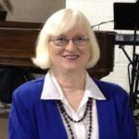
Debbie Persons
Debbie is a familiar and welcoming presence at events, always ready to help and make others feel included. She currently serves as Treasurer of Low Vision Alliance and also serves as Secretary of both the Kentucky Council of the Blind and the Kentucky Low Vision Alliance. Her service extends far beyond elected positions. From ACB conventions and Low Vision Alliance events to Kentucky Council of the Blind state conventions, Kentucky School for the Blind alumni weekends, and numerous fundraising auctions, Debbie consistently gives her time and energy wherever needed.
Whether greeting attendees, assisting behind the scenes, or lending a helping hand, Debbie serves with enthusiasm, kindness, and genuine care for others. In recognition of her exceptional dedication and lasting contributions, we are honored to present the Berniece Kandarian Service Award to Debbie Persons.

Friend of Low Vision Alliance Award

Dr. Sarah Koehnemann
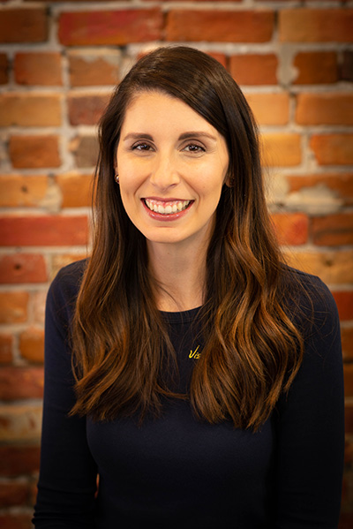
LVA is pleased to present the 2026 Friend of Low Vision Alliance Award to Dr. Sarah Koehnemann of Aker Eye Vision Source in recognition of her support of individuals with low vision and her commitment to exceptional eye care.

A Titusville, Florida native, Dr. Koehnemann's interest in optometry began while shadowing Dr. Aker in high school in 2002. She earned a Bachelor’s Degree in Molecular Biology and Microbiology from the University of Central Florida in 2007 and graduated with highest honors from the NOVA Southeastern College of Optometry in 2011. During her training, she completed an externship in ocular disease at the renowned Bascom Palmer Eye Institute.

Through her dedication to eye health and vision care, Dr. Koehnemann has made a positive impact on the lives of many individuals. Low Vision Alliance is honored to recognize Dr. Koehnemann as the recipient of the 2026 Friend of Low Vision Alliance Award.

Meet the 2026 Scheigert Scholarship Winners

Addison Allen – Freshman
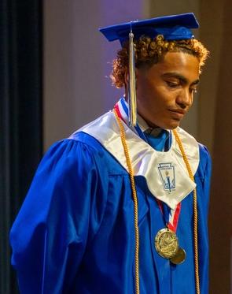
My name is Addison Allen, and I am a freshman at Howard University majoring in Human Performance with the goal of becoming a physical therapist. I am passionate about helping athletes and others recover from injuries, improve performance, and live healthier lives. I am grateful for this scholarship and the support it provides as I work toward my education and future career.

Nicholas Frazier – Freshman
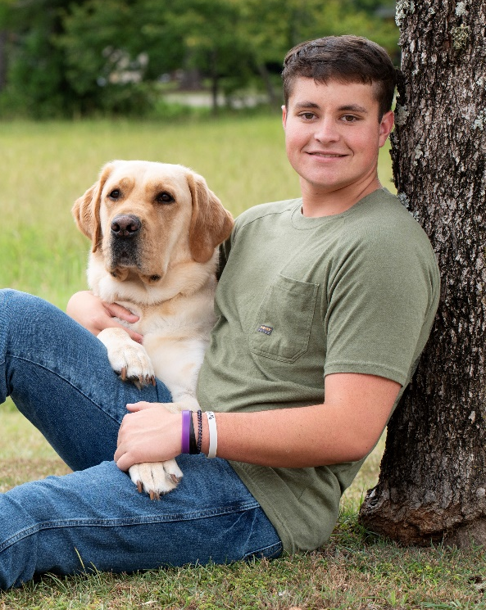
Nick is a driven and resilient student pursuing a future in sports business with the goal of becoming a sports agent. Maintaining a 4.42 GPA, he has demonstrated consistent academic excellence while actively developing leadership and discipline through his involvement in JROTC. His efforts have been recognized through honors such as the Principal's Award, the Bryant-Jordan Achievement Award, the Superior Cadet Award, the Millbrook Civitan Service Award, and the Mayor’s Award.

At the age of 11, Nick began losing his vision, an experience that has shaped his perspective and strengthened his determination. Rather than allowing it to limit him, he has used it as motivation to push beyond expectations and pursue his ambitions with focus and resilience.

Outside of academics, Nick enjoys attending sporting events and concerts, which fuel his passion for the sports and entertainment industries. He is committed to using his experiences, leadership skills, and perseverance to succeed in the field of sports business and make a meaningful impact as a future sports agent.

Hansal Devre – Undergraduate
My name is Hansal Devre and I was born and raised in New Jersey, where I am attending Rutgers University. Currently, I am pursuing a Bachelor’s Degree in Computer Science as I am quite interested in networking security and the Internet. My hobbies beyond learning computer concepts include reading science fiction, going around town with friends, and exploring my small state of New Jersey with my family, as there is always something new to uncover. I applied to the Fred Scheigert Scholarship as my first scholarship experience, plus I also wish to learn from the other recipients.

Lauren Mack – Graduate
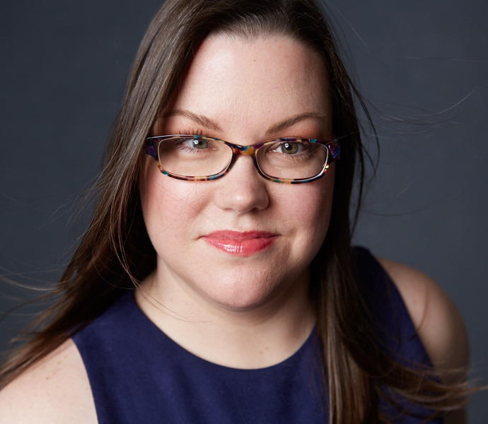
Lauren is an aspiring social worker based in Manhattan. A journalist for 25 years, her writing about travel and food has appeared in 150+ publications. She has traveled to 60 countries on five continents, circumnavigated the globe by ship, and has called Beijing, Miami, and Taipei home.

Newly blind, Lauren is on a mission to inform people about vision loss. "I am grateful for the Low Vision Alliance's Fred Scheigert Scholarship. This generous scholarship is helping me earn a Master of Social Work at my dream school, New York University Silver School of Social Work. The Low Vision Alliance's support is essential to achieve my goal: to open my own practice and be in the service of others, providing counseling, advocacy, and visibility, particularly to under-resourced community members. I know my efforts will bring awareness, transparency, access, and healing, both to my future clients and myself."

Meet the 2026 Genensky-Foley Magnification Award Winners

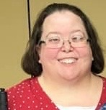
Becky Dunkerson
Becky Dunkerson is from Iowa and is a Life Member of Low Vision Alliance and a member of the Low Vision Now chapter. She is honored to be receiving the Topaz reading device. She has always been considered low vision and recently lost more vision, making her a low partial rather than a high partial. She didn’t think she would need any assistive device other than just a handheld reading light. However, after her husband passed away, she discovered that her vision was not as good as she thought.

She finds it difficult to read mail, bills, letters, and everything else that comes in print and didn’t realize how much her husband helped by sorting the mail and reading things to her. She wants to become more independent so she applied for the device.
She wants to encourage all people who face vision loss to learn skills and obtain devices that will help, such as the items LVA puts forth every year. She is honored to be a recipient of the Genensky-Foley Magnification Award.

Kristen Gati
Kristen Gati is a dedicated reading specialist, teacher, wife, and mother of three who has spent many years helping children become confident readers and learners. She is currently pursuing her master’s degree while continuing to support students each day through literacy intervention and small-group instruction. Despite experiencing significant vision loss, Kristen remains deeply committed to her family, her students, and her passion for education. She enjoys theater, reading, creative projects, and designing engaging learning experiences for children. Kristen is incredibly grateful for the generosity and support of organizations that help individuals maintain independence and continue pursuing the work and activities they love.

Kristen is particularly grateful to have been selected to receive the Mano 5 Electronic Magnifier by Reinecker. The flexibility and portability of the device will expand Kristen’s ability to support her students, contribute to her community, and remain actively engaged in the activities she values most. She plans to use the device to move freely about her classroom to work with her students at their own desks and to read to her literacy students in a more natural setting rather than at a fixed work center. In volunteer work as a Girl Scout leader and board member of the South Plainfield Summer Drama Workshop, Kristen will be using the device to read agendas, scripts, handouts, and other important printed materials. This will allow her to fully participate in these community programs.

Cecily Laney Nipper
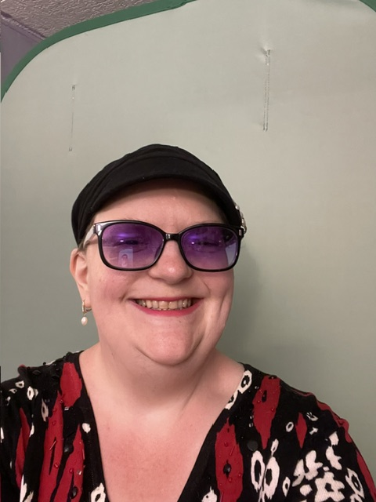
Cecily Laney Nipper resides in Covington, Georgia and has been awarded the Clearview CCTV. With this device, she hopes to once again engage in hobbies, self-care activities, and volunteerism with greater ease. For volunteerism, she hopes to act as her affiliate's treasurer in the fall, and the CCTV will greatly assist her with reading and writing checks and other written materials. Cecily enjoys crafting and doing her own manicures, and having a CCTV again will enable her to do those things independently. She owned a CCTV in the past, but it no longer works, and she can't wait to use one again with the Clearview. Cecily thanks the Genensky committee for selecting her to be awarded this device.

Lisha Pottackal
Lisha Pottackal is the recipient of the Mercury 8 Magnifier. She is excited to use the Mercury 8 Magnifier to enhance her daily life. She works in Accounting and Finance and volunteers as a director on the board for the American Council of the Blind Next Generation while serving on their Membership Committee. Her hobbies include ice skating, reading, crocheting, and knitting. The magnifier will help her read mail, write checks, and prepare her personal taxes. Additionally, this device will help with crocheting and knitting by enlarging numbers on a measuring tape, selecting the size of the crochet hook or knitting needle, and finally make it easier to sew together crafting projects. Lisha appreciates the generosity of the Genensky-Foley Committee and LVA for making a difference in her life!

LVA at the 2026 ACB Conference and Convention in St. Louis, Missouri

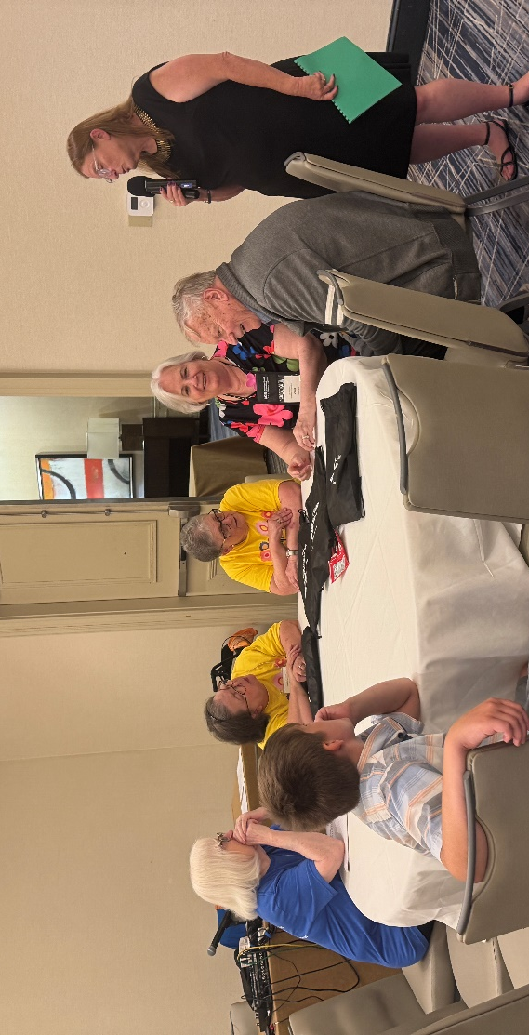
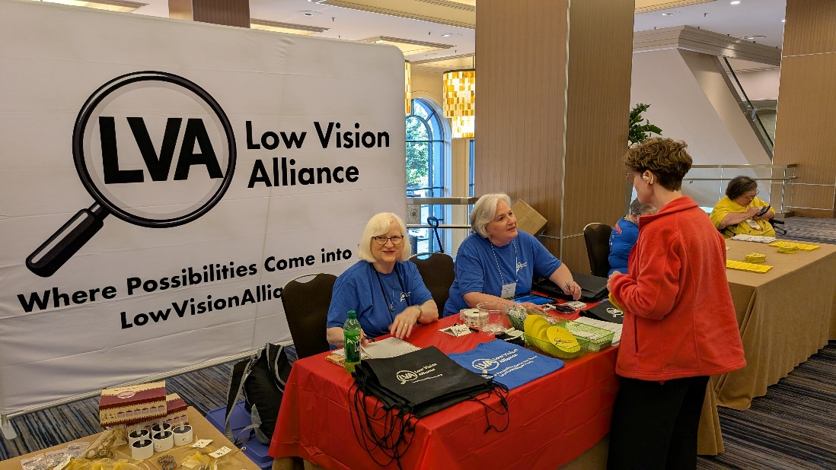
Photo Left: Debbie Persons and Zelda Gebhard man the marketplace table outside General Session Monday and Tuesday morning, share who LVA is. Photo by unknown.

Photo Left: One of several teams playing Outburst at the LVA Big Bash Monday night. Debbie Persons, Becky Dunkerson, Linda Byers, Zelda Gebhard, and Alan Peterson sit around a table, while Patti Cox hosts. Photo by Samantha Hubbard.
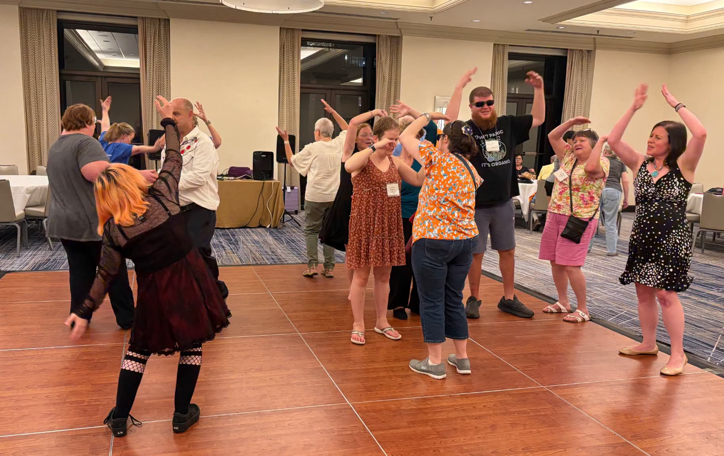
Photo Left: LVA members and friends dance the YMCA during the LVA Big Bash.
Photo by Dianna Leonard.

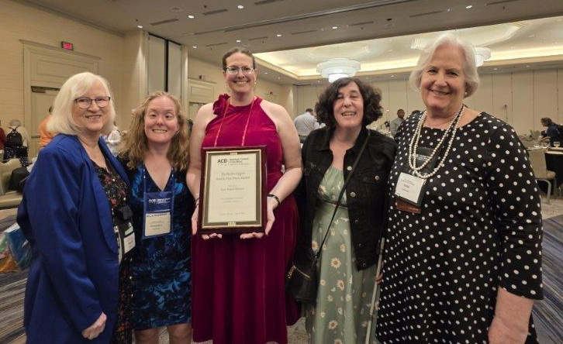
Photo Left: Debbie Persons, Samantha Hubbard, Melanie Sinohui, Dianna Leonard, and Zelda Gebhard pose with the Hollis Liggett Braille Free Press Award LVA was presented with at the ACB Banquet Thursday night. Photo by Terri Lynn Higashi Akamine.
LVA Sponsors at Convention
LVA thanks the following sponsors for their donations and support of our organization during the 2026 ACB Conference and Convention.


Turn your iPhone into a hands-free digital magnifier

Who We Are
A precision-engineered magnification solution and companion app that empowers comfortable, hands-free viewing. Read mail, watch TV, follow a presentation, or enjoy hobbies without lifting or holding your device. Designed for people with low vision and built to work seamlessly with iOS accessibility features.

Products
- Cases For Vision MagSafe, Solaris, Ergo
- Cases For Vision for iPhone and iPad

Contact Information
Email: contact@caseforvision.com
Website: www.caseforvision.com

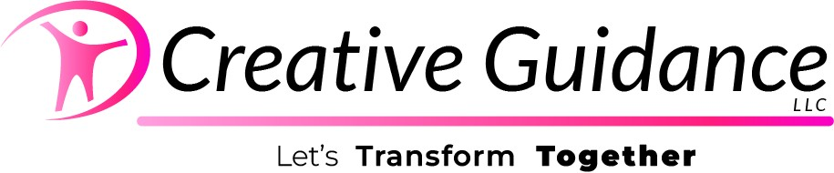

Who We Are
Creative Guidance is dedicated to coaching clients through the barriers that hold them back, with a specialized focus on supporting the blind and visually impaired community. Led by Coach Kaila, the practice uses somatic awareness and mindfulness to help individuals process and move through the complexities of identity and life transitions. She partners with you to navigate the "messy middle," ensuring you evolve past challenges to arrive at a place of clarity and joy.

Contact and Social Media Information
Phone: (480) 788-4144
Email: creativeguidancellc@gmail.com
Website: https://creativeguidancellc.com
YouTube: https://www.youtube.com/@CoachKaila2



Who We Are
A premier transcription service and print shop, transforming content into accessible formats. We also hand craft tactile art, personalized just for you!

Contact Information
Tashya Taylor, AA, AS, CBT
Phone: (785) 393-2202
Email: ttaylor@braillehubusa.com
Website: www.braillehubusa.com

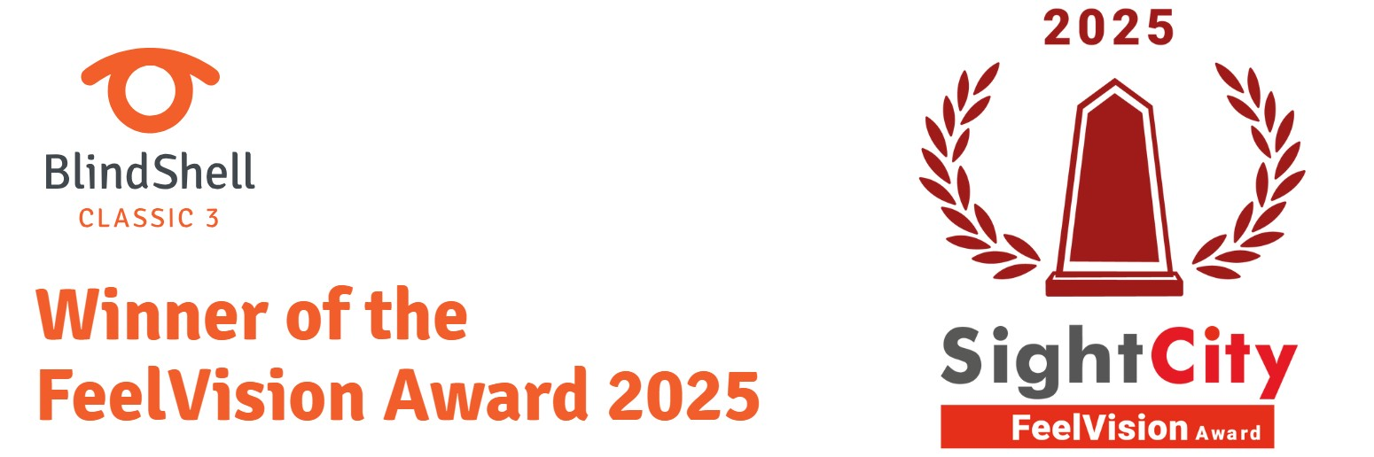

Who We Are
Products for people who are blind or visually impaired.

Products
- Blind Shell Classic 2
- Blind Shell Classic 3
- Blind Shell Classic Lite

Contact Information
Email: info@blindshell.com
Website: Blindshell.com



Who We Are
EZ2See Products was launched in 2015 by a low- vision senior to make a truly, accessible weekly-style calendar. Its many unique features help those dealing with low vision or who need an extra-large amount of uncluttered writing space.

Products
- EZ2See® Large Print Calendar
- EZ2See® Organizer and Address Book
- EZ2See® Academic Weekly Planner
- EZ2See® Sticky Note Pads
- EZ2See® No-Bleed Pens and Markers

Contact Information
Phone: (507) 2226-8040
Email: edward.cohen350@gmail.com
Website: https://ez2seeproducts.com/

Who We Are
Publisher of state resource handbooks for the blind and visually impaired communities. Insightful Publications is a sole proprietorship serving the United States.

What is included in the state resource handbooks
- Organizations for the blind and visually impaired
- Employment, housing, and transportation resources
- Local, regional, and national contact information
- Available in Microsoft Word and PDF formats

Contact and Social Media Information
PO Box 14
Kailua-Kona, HI 96745-0014
Phone: (808) 329-9512
Email: insightfulpub@gmail.com
Website: in-sightful.com
Socials: https://www.facebook.com/insightfulpublications/
Socials: https://www.linkedin.com/in/insightful-publications-15366446/
Socials: https://mastodon.social/@InsightfulPublications

Anthony Akamine Wins Walk to St. Louis Contest
by Anthony Akamine
(Introduction by ACB Get Up and Get Moving Committee)

Introduction
During our Leadership Conference the Get Up and Get Moving Committee (GUGM) announced a contest, asking people to write about their journey to get to St. Lewis.

We judged all contest entries by evaluating three criteria:
- Consistency: Walking every day or nearly every day.
- Creative storytelling: Bring your journey to life by describing the “landmarks” you’d encounter on your imaginary walk to St. Louis.
- Distance walked: Please include the distance you walked in your submission.
- Our in-person winner is Anthony Akamine.
- Our virtual winner is Jeanette Kutash.

Never Give Up!
Hello there! Imagine this: inspired by Katie Frederick's talk in Hawaii, I was eager to head to St. Louis, whether virtually or in person. However, the universe had different plans with the flooding in March and early April. Not exactly ideal for a leisurely stroll, right? Nevertheless, I managed to adapt. I strolled around the mall, took relaxing walks around the hospital while visiting people, and even danced at the train station – complete with Hi Knees! In March, I was averaging 7,600 steps a day. They say April showers bring May flowers, and indeed, I flourished despite the many puddles and buckets of rain which did not dampen my spirit! Thanks to Hawaii's great rail system and a nearby bus stop to work, I made it a habit to walk for 30 minutes before starting my day in April. In April I averaged 6,831 steps. Picture this: a refreshing breeze, the scent of breakfast in the air, and friendly pets greeting me along the way – bark, bark! By May, I increased my daily steps to 9,185 steps after meeting an inspiring elderly couple who were early risers for their daily walks. So, I set my alarm for 4:30 AM. and hit the pavement. June presented a challenge with a bus incident (ouch!), but that didn't deter me from maintaining my routine and averaging 11,676 steps a day with my Hi Knees. And guess what? Alongside all this activity, I bid farewell to some unwanted weight by swapping fast food for apples, fresh fruits, vegetables, and more protein. I lost a total of 9lbs in the process! This journey has been a blast, forming new habits, and providing me with plenty of chances to dance and keep the momentum going. Here's to more exciting adventures ahead! Warm regards, Anthony

DKM First-Timer and ACB Leadership Fellows from LVA
Source: ACB Durward K. McDaniel Fund Committee

Low Vision Alliance is excited to share with you two of our members who were recognized by the Durward K. McDaniel (DKM) Fund Committee as a 2026 DKM First-Timer and a 2026 ACB Leadership Fellow.

Timothy Hill -
2026 Durward K. McDaniel First-Timer
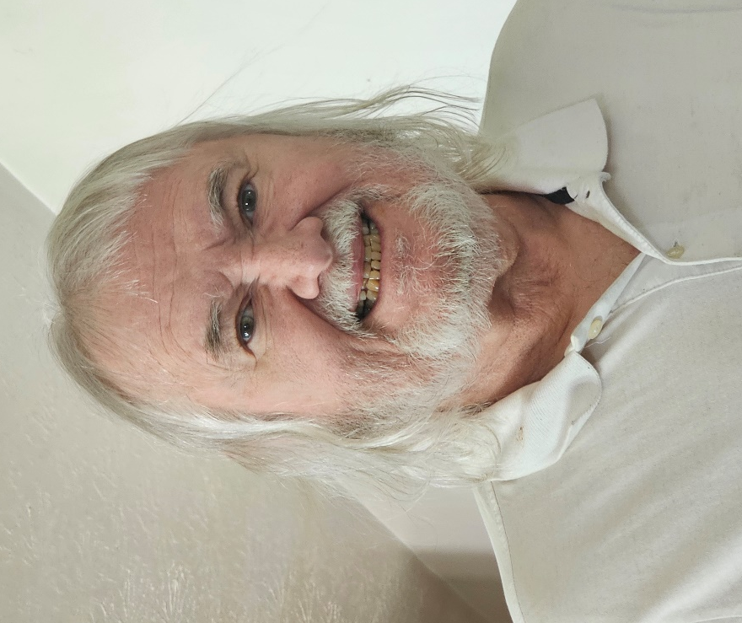
Timothy Hill from West Virginia is our DKM First-Timer representing the East. He is a dedicated advocate, community leader, and proud member of ACB since 2021. A 69-year-old widower and former Randolph-Sheppard vendor, Tim serves on the Board of Directors and multiple committees of the Mountain State Council of the Blind, where he is known for his reliability, service, and strong advocacy for the blindness community. He actively engages with legislators on issues affecting accessibility and opportunity and recently attended the 2026 ACB Leadership Conference in Washington, DC. Tim is also an Explorer in the INSPIRE Mentoring Program where he is strengthening his leadership skills for the future. A passionate musician, he plays drums and is learning bass guitar. He enjoys audiobooks, movies with audio description, and fellowship through his church and community organizations.

Marja Byers
2026 ACB Leadership Fellow
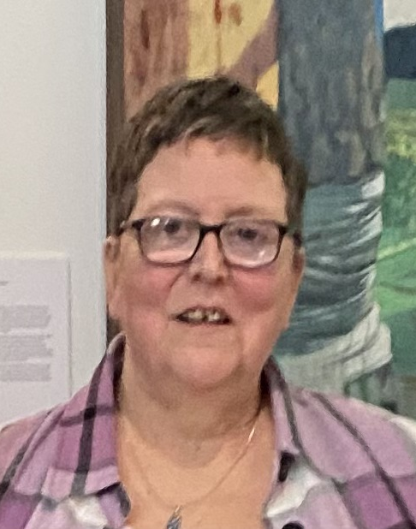
Marja Byers of Salem, Oregon, is a passionate advocate, community leader, and longtime supporter of the blind and low vision community. After losing her sight again in 2010 following a 30-year career in hospital obstetrics, Marja found renewed purpose through support groups, American Council of the Blind, and her work with Blindskills. She served as Executive Director of Blindskills and now leads efforts to create social meet-up opportunities and peer support programs across Oregon. Marja has held numerous leadership roles in transportation advocacy, accessibility initiatives, and state affiliate service in ACB of Oregon. Marja also faithfully serves on the Fred Scheigert Scholarship Committee for the Low Vision Alliance. Known for her powerful advocacy and mentorship, she is committed to reducing isolation, strengthening leadership, and building inclusive communities for blind and visually impaired individuals statewide. Marja lives with Lucy, her demonic cat, and in her downtime, she loves listening to music, going down rabbit holes (researching), and reading.

Rebranding Committee Update
by Melanie Sinohui, Chair

Our Final Phase
This is a bittersweet update to submit. Your Rebranding Committee has spent the last year tirelessly and excitedly working for LVA. After approval of the name change and finalizing a new logo, we had to tie the bow on the whole process by completing our branding package. This package is a one stop shop for our leaders to use to ensure we stand out, our image is consistent and we look professional. The branding package includes various versions of the logo (black on white, white on black, transparent backgrounds, etc.), official letterhead for documents coming from our organization, business cards, an updated flyer both in regular print and large print. The Publications Committee is also in the process of working with the Public Relations Committee to create a new brochure, now that we have new photos from convention.

Speaking of convention, if you were in St. Louis, you also saw our LVA swag all over the place. We had black drawstring bags, green keychains with our white logo, and yellow jar grippers with our black logo. Our marketplace table was a show-stopper with our new gigantic banner with our logo on one side and a step and repeat logo on the back like at awards ceremonies. It was also very exciting to meet new people in St. Louis who were unfamiliar with our organization and when we said we were “Low Vision Alliance” they immediately had an idea of who we are, who we support, and what we do. Whether we were at the marketplace table, in a breakout room, or just wearing our shirt around the hotel, they understood.

We also acknowledge we didn’t have the new t-shirts for sale very long but sales were so good that we are passing on the recommendation to the Fundraising Committee to do another round of sales, whether they be t-shirts, sweatshirts or both. So stayed tuned.

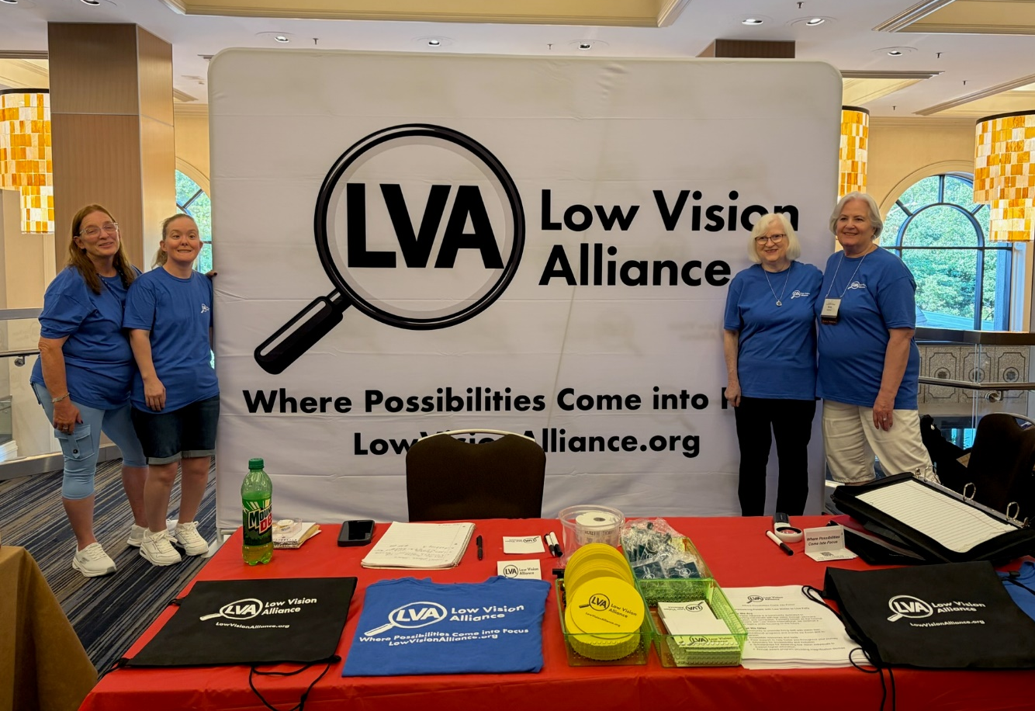
Photo Above: Patti Cox, Samantha Hubbard, Debbie Persons, and Zelda Gebhard wear their new blue Low Vision Alliance shirts and pose beside our new massive, eye-catching, freestanding banner at the ACB Marketplace outside of General Session during the 2026 ACB Convention. The table in front is covered with LVA-branded shirts, black drawstring bags, yellow jar grippers, and informational materials.

And last by not least, the E-Communications Committee has officially transitioned our website to LowVisionAlliance.org and are working on updating it day by day so please make sure to provide any feedback to webmaster@LowVisionAlliance.org

Thank You!
Thank you to everyone who submitted name and logo ideas over the last several years; your input was invaluable. We hope we have not left anyone off this list but please know everyone’s contributions made the difference. Thank you!

Sara Alkmin
Susan Ament
Patricia Belcher
Christine Chaikin
Patti Cox
David Cox
Carroll Ewing
Kathy Farina
Joyce Feinberg
Tom Frank
Zelda Gebhard
Kathy Gerhardt
Samantha Hubbard
Bernice Kandarian
CCLVI Board of Directors
Dianna Leonard
Kathy Lyons
Robin Mayr
Amanda Petrisin
Melanie Sinohui
Michael Smitherman
Ralph Smitherman
Leslie Spoone
Cae Swanger
Mikey Wiseman
Renee Zelickson

Our Job is Done!
We are honored and humbled to have been tasked with this effort. Thank you, LVA!

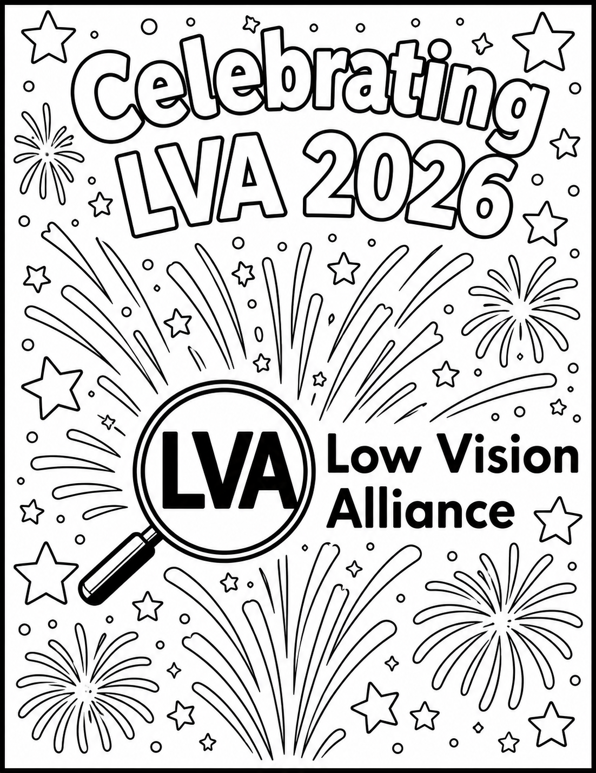
Created by Cheryl McNeil Fisher with the use of AI

LVA Affiliates’ Corner

Florida Council of Citizens with Low Vision (FCCLV) News
by Jeanne Struhar, FCCLV Secretary

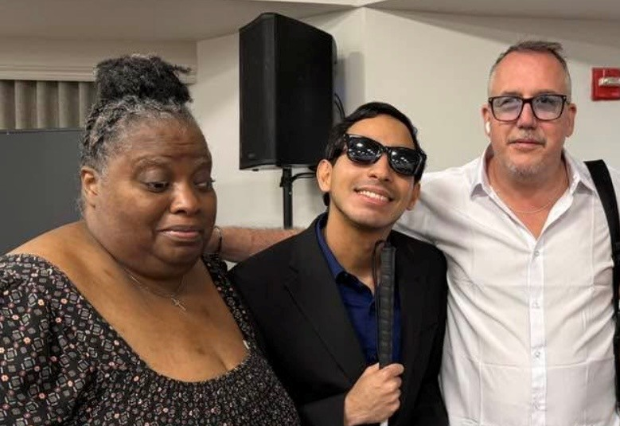
Photo Left: Newly elected FCCLV President, Cassandra Jessie and 1st Vice President, Ricardo Salazar pose with FCCLV Immediate Past President Mikey Wiseman.
Photo Below Left: Sally Benjamin
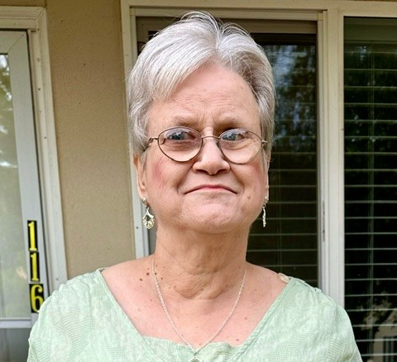
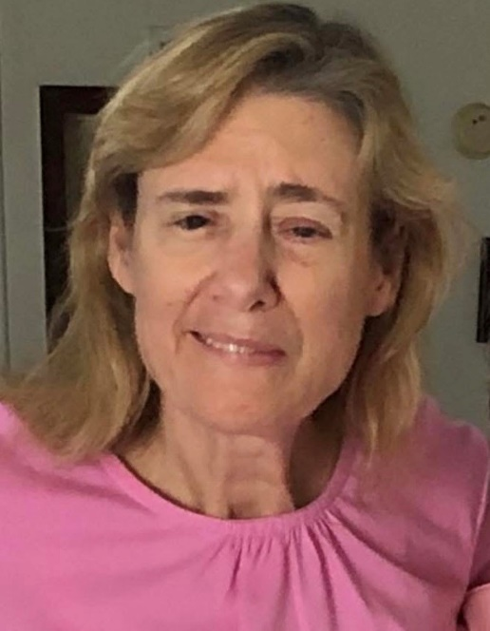
Photo Below Right: Jeanne Struhar
All who attended the FCCLV sponsored session at this year’s FCB Convention in May were treated to an incredible presentation by Low Vision Specialist Dr. Francisco Jose Richardson of Winter Park, Florida. First, we learned some fun facts about the human eye from Dr. Richardson. Did you know there are 2 billion working parts of the human eye? The retina uses up more oxygen than the heart. 40% of the brain is used for vision. The fastest moving muscle in the human body is the blinking muscle. There may be some fancy name for it. It is the muscle that causes your eyes to blink. The human eye can see up to 10 million different colors.

Following the interesting facts about the eye, Dr. Richardson spoke about macular degeneration in aging adults. He explained the condition and how it affects vision loss. Currently there is no cure for macular degeneration. However, there are ways to manage its symptoms. Dr. Richardson said much research is being done in this area.

Dr. Richardson has dedicated himself to helping individuals with low vision. He advocates and does what he can to provide low vision services and resources to those living with low vision.

Thank you, Dr. Richardson, for your support, time, and availability to the members of FCCLV and all being affected by low vision!

During the FCB Convention, FCCLV held its election of officers. Congratulations to our new officers:
- President Cassandra Jessie
- 1st Vice President Ricardo Salazar
- 2nd Vice President Sharon Youngs
- Treasurer and Membership Secretary Sally Benjamin
- Secretary Jeanne Struhar

You make a fabulous team. We look forward to seeing what the future of FCCLV holds under your leadership!

The Low Vision Now Corner
by Glenda Such, LVN President

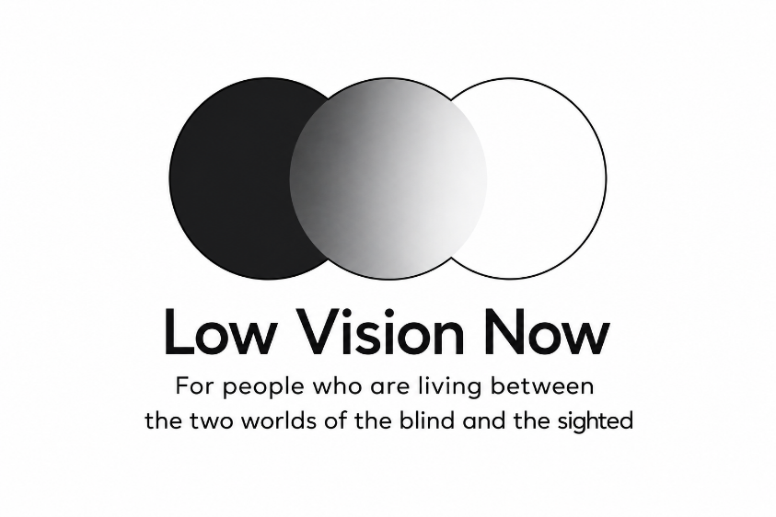
This has been an especially exciting time for our organization. As our monthly programs continue, more individuals are choosing to become members of Low Vision Now, an affiliate of the Low Vision Alliance. One of our newest members, Tirupati, is a college student from India who discovered us through a Google search and contacted us immediately. In addition to Tirupati, six new members from across the United States have recently joined. With these additions, Low Vision Now has members representing 16 different states.

What inspires people to join Low Vision Now? In addition to belonging to a community whose members choose to share names, phone numbers, email addresses, and eye conditions in order to connect between meetings, members also benefit from engaging monthly programs featuring informative and compelling speakers. After each presentation, we hold a support group session that gives participants the opportunity to discuss current challenges and offer encouragement and practical support to one another.

Recent Programming
Our May program focused on reducing stress through meditation and mindfulness practices. Our guest speaker, Dan Surkin, a graduate of the ClearLight Meditation Teacher Academy Training Program, has devoted more than 900 hours to his development as a teacher in this field.

As part of his presentation, Dan led participants through several breathing exercises and answered many questions from the audience. By the conclusion of his presentation, Dan had encouraged many participants, if not all, to consider incorporating mindfulness and meditation into their daily lives.

In June, our meeting focused on how to use Meta smart glasses effectively. For those who may be unfamiliar with them, Meta smart glasses look like standard eyewear but contain built-in technology that connects to a smartphone, both Android and iPhone. The glasses can read printed materials aloud, identify clothing colors and patterns, indicate whether garments are wrinkled or stained, and even detect whether bread is moldy.

Our guest speaker was Glenda Such who holds a master’s degree in the education of the visually impaired. She has used her training to work extensively with people who have low vision or blindness to learn to use a wide range of technologies.

During her 90-minute presentation, Glenda explained in-depth the mechanics and functions of the Meta glasses. She discussed battery life, proper care, and demonstrated activities such as photo description, comparing bananas for ripeness, evaluating toothpaste brands for price and protection, and read a menu to identify only the chicken dishes and their prices. Throughout the presentation, participants asked questions and shared their own experiences using Meta glasses and for activities such as walking outdoors, locating objects, matching clothing, and reading pill bottles. They also contributed additional insights about features they use regularly.

Low Vision Now continues to have great speakers each month. To hear a recording of many of those speakers, you can do so by visiting our website at https://www.lowvisionnow.org. Simply go to the option to listen to previous meetings and you will find a large list from which to choose.

Upcoming Meetings
All Low Vision Now meetings are held via Zoom beginning between 12:45 PM and 12:55 PM ET. At the end of each month’s speaker presentation, a support group begins, which is open to all. While the speaker portion of our Zoom meetings are recorded, the support group is not. Confidentiality is kept for anything said during the support group.

Saturday, September 18, 2026
Beginning between 12:45 and 12:55 p.m. Eastern Time
David Goldfield, Assistive Technology Specialist Topic: Cybersecurity—keeping your technology and accounts safe.

To learn more about joining Low Vision Now, call: (484) 566-3619 Or email at: lowvisionnow@hotmail.com.

Please see the Calendar of Events at the end of this issue for additional Zoom joining information.

LVA Book Club
Book Selection for August 31, 2026

Touch the Top of the World: A Blind Man’s Journey to Climb Farther than the Eye Can See
- Author: Weihenmayer, Erik
- Book Number: DB51505
- Reading Time: 12 hours, 3 minutes
- Read by: Dan Bloom

BARD Description: “In this adventure-packed memoir, the author recalls rebelling against becoming blind by age fifteen. Relates acquiring a passion for mountaineering and developing the character traits that enabled him to succeed. Covers his climbing exploits and his wedding on top of Mount Kilimanjaro.”

Scout’s Corner: Two Paths, One Perfect Plan
by Scout and Cheryl McNeil Fisher
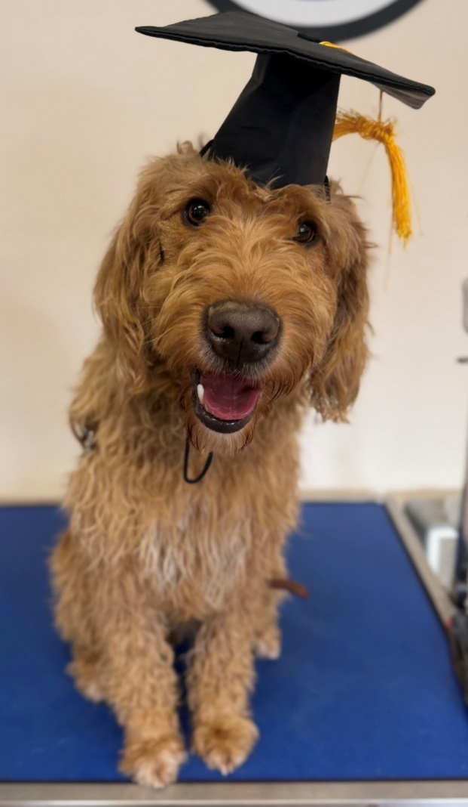
Photo Left: Scout, a golden-brown, curly-haired dog with dark eyes sits on a blue table, wearing a black graduation cap with a gold tassel and chin strap. The dog faces the camera with its mouth open as to say, “I did it!”

If you had told me a couple of years ago that a free spirit like me would be a certified professional, I would have barked out loud. Cheryl challenged me, and being the smart doodle, I am, I aced everything she put in front of me. We went everywhere—stores, restaurants, public events, new places, and new people. The world became my classroom. I also enjoyed walking on my hind legs and performing what Cheryl called my “poodle dancing.” I called it performance art. Center of attention, mission accomplished.

As the months passed, Cheryl began to wonder whether I might someday become her guide dog. She contacted Freedom Guide Dogs in upstate New York, and they agreed to evaluate me. On the Monday after Thanksgiving in 2025, she and her husband drove me to the school. For more than 13 months, we had been a family training together. We traveled to new adventures where I had fun learning. And although I occasionally disagreed with the boundaries of personal freedom, Cheryl patiently and diligently taught me why they were important. I have to be honest and tell you that it wasn’t my willingness to adapt. Treats are a great motivator. I love hearing, “Yes. Good Boy,” followed by a treat.

Here’s where the story takes a turn only God could have written.

Cheryl had been waiting for a guide dog since 2023, navigating devastating loss, two matches that didn’t hold, and months of uncertainty. I arrived in October 2024, and let me be clear: I helped. Enormously. She poured everything she knew as a handler and puppy raiser into our work. None of us is perfect, but she and I came close. I gave her exactly what she needed, and she did the same for me.

Just three days after they dropped me off at Freedom Guide Dogs, Cheryl received a message from Guiding Eyes trainer Kat Polo. Because of her professionalism, diligence, and tenacity, she found Helix. She knew the moment she saw him that he was the right match for Cheryl. Home training began in December 2025.

That the journey ended with the right dog at the right time is a tribute to Kat’s persistence, Guiding Eyes for the Blind, and to Cheryl’s absolute refusal to give up, even thtough grief and disappointment.

The team at Freedom Guide Dogs was surprised but happy that Cheryl had found her match, and they were thankful for her selfless decision to allow them to continue training me to find the right partner. They affirmed what I already knew: she had done a great job training me.

I graduated from Freedom Guide Dogs in May 2026 as a certified working guide dog. The puppy who escaped his collar. The puppy who defeated the crate repeatedly, creatively, and with great personal satisfaction. The puppy who chewed through cables, leashes, and one very surprised baseboard. That puppy became a guide dog. Today, I am somewhere in the United States, helping my person move through the world safely, confidently, and independently.

This is not the end. This is simply a new chapter—and if you know anything about me by now, you know I do not do anything quietly or without flair. There are more stories to tell, more adventures to report, and more wisdom to share from someone who once required two latches, three luggage locks, and a crate topper to make it through an hour alone.

And I have a feeling that a certain 82-pound black Lab named Helix may eventually find his way into these pages. He’s new to this family. He doesn’t know yet what he’s gotten himself into. But give him time. Every great story needs a strong supporting cast.

Cheryl thought she was bringing home a puppy. I thought I was finding a family. God had a plan that was better than either of ours, and it is still unfolding. Not bad for a puppy who didn’t believe in leashes.

Until next time!
Love, Scout

America 250: Revolutionary War Heros: Did They Have Low Vision?
by Jeanne Struhar

Happy 250th Birthday, America!

This year we are spending time celebrating our country, and looking back at the events and people who shaped our great nation. Many fought and believed deeply in gaining independence from Great Britain and making a new way of life for themselves and their neighbors. This included people who were blind or had low vision.

Were there people with low vision who fought in the Revolutionary War? After all, George Washington did not give vision tests back then. If you could pick up a gun and point it in the direction of the enemy, you were in. If highly trained Redcoats with rifles and bayonets came charging toward you, and you could run and follow your tattered uniformed, barefooted comrades into the woods to hide (without tripping over twigs and branches), you just might have been able to get away with joining the Continental Army. Here are two stories of American Revolutionary War heroes who may have had low vision.

General James Reed
James Reed was from New Hampshire. His first trade was as a tailor. He was from a wealthy family and purchased land on the New Hampshire frontier. He founded a town called Monadnock, now known as Fitzwilliam. He was a leader in the small village. When the French and Indian War broke out, he served and gained experience in developing strategies and methods of fighting a war. He learned how to defend against the enemy. He was given positions of leadership in battles fought. Following the end of the war and the signing of the Treaty of Paris in 1763, Colonel Reed returned home to his quiet town. He wasn’t there long before the colonists began rebelling against Great Britain for the taxes levied against them.

When New Hampshire sent militia leaders to help fight the British, they sent Colonel Reed. He joined the Continental Army and quickly moved up the ranks to Colonel. In New York City, Colonel Reed led his troops in the Battle of Bunker Hill. Although the British eventually ran off the Colonists, Colonel Reed’s men stood their ground for an impressive amount of time, with minimal wounded men. His men from New Hampshire were used to the wilderness. They were hunters and could aim with extreme accuracy. When they were outnumbered and low on ammunition, they retreated. Colonel Reed was the last officer on the field. He reported only 27 wounded and 5 men killed.

Colonel Reed caught the attention of George Washington and Congress. Washington had so much trust and confidence in Colonel Reed that he assigned him to carry 3 boxes containing $300,000 from New York City to Albany for delivery to General Schuyler. The money was backpay for the troops, and to purchase supplies and food.

Colonel Reed was on his way to a prominent military career. He was passionate about serving his newly formed country. George Washington promoted him to brigadier general and Congress approved it. However, he never served in that role. General Reed developed smallpox. His body recovered from the illness; however, it resulted in a total loss of vision.

Did he serve in the Continental Army with low vision? How quickly did he lose his vision? No documentation was found stating the amount of vision he lost and when. In Revolutionary times, the patriot’s passion for fighting for independence was so fierce, even when sick, it was not uncommon to stay involved and continue to move with the Army and serve in any capacity. If he had functional vision for some time before losing all of it, he would not have reported it. He would have tried to hide it or waited until it was noticed. Either way, once he lost all his vision, he could no longer serve in the army and returned home to New Hampshire.

History books don’t speak of the disappointment he felt when his military career ended. He had a strong desire to serve. But now, for him, it was over. He dreamed of helping bring the nation to victory and being a part of building a new way of life, a life of freedom and equality. He wanted a land where, instead of living under the heavy hand of a king, all could live a life they chose, where opportunities were given to all. He wanted to bring people together. He had dreams of families using the same stores, schoolhouses, and places of worship. He so hoped to build a sense of community.

General Reed found a way to do those very things. He just did it in a different way. After he retired from the Army, he moved back home to New Hampshire. We were a new country formed on July 4, 1776. However, instead of celebrations, there was much discouragement. We were losing the war. Many lives were lost. Food was scarce. Smallpox and other illnesses were running rampant throughout the Army and civilians alike. People were dying and medical attention was not easily accessible. Farmhouses and entire towns were burned down by the British. Some people turned against the Patriots, feeling it would be better to return to living under the powerful Crown of England. Many just wanted to give up.

Then people in the small town of Fitzwilliam started to notice something different happening. They began to see General Reed, the blind general, come out of his house and go for daily walks. They saw him frequently go horseback riding with his wife, each rode separate horses. She would guide her horse and his. The reins from his horse would be extended and tied to hers. They both enjoyed horseback riding and they found a way to do it. They continued to do what they loved doing, despite General Reed’s loss of vision. He greeted people in the street. He talked to them. He talked about the war and what might happen. General Reed did not know what would become of their new country. He had no answers. But he offered hope. He showed the townspeople what life could look like when it turns unexpectedly in another direction, when things don’t happen as planned. General Reed was, and still is, a great American hero. He is an example of how to turn life around and not let it turn you down.

Life got better. General Reed lived a happy and full life. The Americans won the war. Soldiers returned home to their families. Food became abundantly available. Doctors and medical care became accessible. Deadly sickness decreased. The country grew. Roads were built. Businesses started. Banks opened. More schools. More places to worship. This happened in great part because people like General James Reed had hope and led others with hope. As life took him down an unknown and unexpected path, he found a way to turn that path into a journey set forth to achieve what he set out to do from the beginning.

James O’Hara
James O'Hara was from Maryland. He was part of what was known as the Maryland 400, members of the 1st Maryland Regiment who repeatedly charged the British forces during the Battle of Long Island. One cold night, O’Hara stood guard and developed a fever. It turned into a severe illness. He developed a painful skin infection called erysipelas. Today there are antibiotics to treat it. Back in the 18th Century, there was nothing to heal the ailment. O’Hara experienced a severe rash that spread to his face, then eyes and eventually caused total blindness. His medical records document that he “lost his eyesight at the conclusion of the campaign”, meaning at the end of the battle.

So, did O’Hara fight in the war with low vision? Perhaps. Like General James Reed, if he had some vision and wanted to continue to serve, as many soldiers did, he would not have reported it. Maybe it was noticed, but he was allowed to continue. It is unknown.

What is known is that at the end of the Battle of Long Island, he was granted a discharge from the Council of Safety and issued 6 months of backpay. He moved back to his hometown of Annapolis, Maryland. O’Hara had no known family. No natural support network. It was a very challenging time in his life.

He decided to find his own support network. He reached out to people. He talked to people. He asked for help. He found people to help him write letters to the government of Maryland. At that time, there was no financial assistance. There was no assistance for veterans. It was highly unlikely that he would receive the help he asked for. Petitions to the State of Maryland for help during the Revolutionary War days were either denied or ignored. O’Hara tried anyway. He received the help he sought. He was given rations of food and clothing from Army supplies. He was provided with housing and cash.

O’Hara was a great self-advocate. Perhaps the first blind veteran advocate in the country’s history. With strength and confidence, he would not give up. He acted with hope. He did not listen to or give in to what others thought was impossible, he found a way. He set an example for many generations to come. Another American hero!

Conclusion
Two great American heroes whose message is just as relevant today as it was then. Namely, to live with hope and don’t give up. When life gets tough and struggles bubble up and there seems to be no way out, remember these two American Patriots. Remember the many others as well who sacrificed and gave their lives so we may live with the freedoms and independence we know today. Let’s celebrate their greatness, and ours! Happy 250th Birthday, USA!

Sources: Revolutionary War Journal, “Colonel James Reed – Tailor Whose Regiment Held the Line at Bunker Hill” Archives of Maryland (Biographical Series) “James O’Hara”

America 250: Unscathed, Still There: A Semiquincentennial Reflection
by Dr. Lorise Diamond

The world reaches me out of order.

Most people are handed a scene whole; the shape, distance, and the face of a thing arrive together in a single glance they never think about. I am legally blind. What comes to me first is rarely what comes to others first. A sound before its source. A voice before the body that carries it. Authority before the person wearing it. I assemble the world in a sequence that I do not get to choose, working for what the sighted spend without noticing, and by the time the whole picture arrives, I have usually already met its loudest part.

I did not know, walking out on the Fourth of July, that this way of seeing would show me something about the country I could not catch any other way.

I want to begin where the day began, because, at this desk in the days since, I keep trying to understand how I traveled the distance between the morning and the dark.

The morning of the Fourth, I walked out into my complex and found it finely dressed for the occasion, flags in the windows, bunting on the railings, neighbors out in the early cool to catch a breeze. I carried a doubleness with me, as I nearly always do now; it is the occupational condition of reading culture and power for a living, that you cannot fully unsee. And yet, passing amid that earnest color gave me an impulse, and I called out, “Happy Birthday, America!” The answer came back wordless: smiles. Cheery smiles. And their enthusiasm surprised me into a gladness I did not plan to feel. The doubleness did not leave me. The gladness simply arrived beside it, unbidden, faster than my analysis. My neighbors did not argue me into warmth, they smiled me into it, and the three of us, my doubleness and me, walked together the rest of the day.

Further along, the morning offered its one small omen, though I could not read it yet. Barricades. A traffic light stripped down to a single flashing yellow signaling proceed, but watch. Caution, with no object I could name. I did not know what it was for, so I went home and looked it up, and that is how I learned what the evening held: 400 drones, live music, student art, and the country’s 250th year. I am telling you this in the order I learned it because the order matters. The caution reached me before its meaning did. It lodged first and explained itself later, which is, I think now, how a warning works on a body.
My gladness held all day. It held through the afternoon and into the evening and right up to the threshold of the display itself, which is where it broke, and where I should share what happened, because I continue to turn it over, more times than I can count.

When the drone show began, I learned that I’d settled in behind it; someone said so, kindly, which was why the formations took me a moment longer to read, assembling themselves out of the dark at my own pace. I decided to cross the street to the front, then a voice barked out of the night to stop me — the barricade, the security — and because of how I see, the voice reached me before the woman did: authority first, arriving as sound, the person still somewhere I could not yet find. The fear came in that gap. Then I looked into her eyes, middle-aged, nice enough, a body doing a job, and I did what the fear had already decided. I deferred. I asked her: “Can I go back to where I was?” She let me. I returned to my place, and the permission did not soothe me. It confirmed me where I stood.

As the drones rose, humming with the sound of a thousand bees, and finding their formations, there were no bombs bursting in air. I caught myself asking the old anthem question in reverse: without the bombs, how would we know our flag was still there?
Francis Scott Key saw the flag by the light of the shelling. Bombs bursting in air was not a metaphor; it was the proof. The flag was still there because it survived the bombardment. Every Fourth since, we re-enact that bombardment and call it celebration: the boom, the concussion in the chest, the acrid gunpowder drifting over the crowd. This year the boom was gone, and in its place an eerie silence haunted the festivities.

Into that silence the icons streamed. The Liberty Bell, ringing back and forth without a sound. A covered wagon, rolling westward across the darkness, across a sky that is never empty. “We the People,” spelled out in light. A dazzling flag. No fireworks I ever saw looked this… perfect.

And here is the tension I could not resolve and decided not to. That silence was a mercy. No booms to send dogs bolting under beds. No percussion to return the veteran to the firefight, or the survivor of gun violence to the worst night of a life. A quieter Fourth is a kinder one. I know this and won’t pretend otherwise.

We humans adapt, and I wanted to know to what. It is wildfire season in California. Pollution sits at warning levels across Los Angeles County. Fireworks became a hazard we can no longer quite afford, so we reached for the drones, 400 of them, calm and uniform and obedient, tracing our symbols without a spark. What makes this artful? Who programmed them, and how? Were they watching us as we watched them? And once I asked that, my mind moved to the sentence I could not un-think: the silent machine drawing the flag across the sky is akin to the silent machine that draws a target across a village. The same technology. A different night. And the covered wagon had rolled west under that same sky, over the same ground the maps called empty and never was, so the whole lineage stood there at once: the eye that once looked west and called it destiny now looks down and calls it security.

250 years. This is how we marked it, the founding “We” written in the glimmering light of the instrument that watches us, in a silence we told ourselves was peace.

I did not understand the yellow light until I sat down to write this. It is still flashing in me. I understand now that the question I asked the guard was never only about a place to stand. “Can I go back to where I was?” At this desk, I hear the other voices that sentence passed through before mine, the people compelled to ask a country whether it might let them return to ground already theirs. She said “yes.” That was the mercy, and that was the warning. I am still not certain, on the far side of that silent and perfect sky, which “yes” or whose “yes” it was.

Like social and cultural puzzle pieces, the voice reached me first, out of the dark, all authority; then her body and uniform came into view, and I saw the woman inside the uniform, the tired person, separate from the duty she wore. Seeing her did not make me safe. Even as I told them apart, part of me rehearsed what I would do if she responded “no.” The crowd, though, I could read plainly. Walking out beneath that quiet sky, I looked at the people I stood with in the night, and the sorting came clear: some came to break the silence, and some came to keep it. I know which I am. The question that flag on its pole leaves hanging is only which of them this country will finally choose to be.

When the last drone powered down, my gaze returned to the flag in front of me. Unscathed. Still there. Unscathed the way a thing survives the storm, and unscathed the way a thing is left untouched because it is being watched, and unreckoned with. Still there. Like us — not unscathed, never that; we bear our marks. But still there.

Low Vision Rower Sets Goal to Join Competitions
by Jeanne Struhar

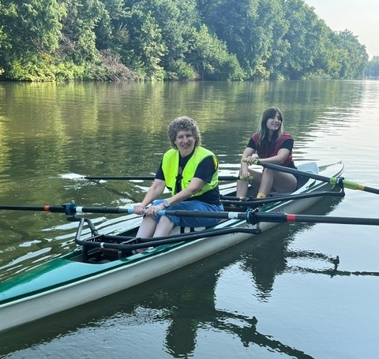
Photo Left: Debbie Deatherage sitting in the front of the boat with a yellow vest with her guide is sitting directly behind her. They are rowing on the Ohio River as part of the Louisville Adaptive Rowing Program.

Five years ago, Debbie Deatherage of Louisville, Kentucky saw a Facebook post about a rowing group. She enjoys spending time outdoors and decided to try it. Debbie joined the Louisville Adaptive Rowing Program and has participated in weekly rowing outings from mid-May to the end of September ever since. The rowboats have slide seats and it seats two people. Debbie rows with one other person in the boat with her. That person acts as a guide and helps her navigate around the waterways.
Rowers and their guides row along the Ohio River. Practice is normally forty-five minutes once a week. The river is pleasant to row along. The water is calm. They stay away from other boat traffic, avoiding large waves crashing into the sides of the boat, or having to attempt rowing the boat while it rocks back and forth from the wakes of a motorboat. Debbie says she has never fallen out of the boat into the water or intentionally jumped in for a swim. Even during July and August, the hottest months of the summer, the water is still too cold for swimming.

The Louisville Adaptive Rowing Program is a nonprofit organization that provides both recreational and competitive rowing experiences for individuals with physical, visual, and intellectual disabilities. Debbie says there are four or five other rowers with visual impairments. Debbie rows for the recreational aspect for now. She enjoys getting out on the water, getting involved in an active water sport, meeting people, and building community among others with disabilities that share the same interest. She plans one day to start participating in the competitive side of rowing. Debbie is also thinking about moving to a different model of adaptive rowing, where she would be in the rowboat by herself and the guide would be in a separate boat, following close behind. This would be new for Debbie, but she is not nervous or afraid to try it.
Debbie lives with low vision. Her eye condition is called Anterior Segment Dysgenesis. It happens when the front part of the eye (cornea, iris, lens, and drainage angles) fails to develop properly before birth. Debbie explained, “My eye condition had something to do with my mom coming in contact with someone that had the German measles”. She can see large objects, such as the rowboat when climbing in for a rowing session. She can see the large dock as they approach to bring in the boat after a journey out on the water. She is challenged by small and detailed objects. Debbie needs to hold items close to her face to see them. She is a member of LVA. She is actively involved with the Kentucky Council of the Blind (KCB). Debbie works at LC Industries, a manufacturing plant where blind and visually impaired individuals are employed. A large percentage of the work they receive is from government contracts. Debbie’s job includes working to fulfill these contracts. She helps with packaging flatware, document protectors, and other such projects.

Debbie states rowing is “a lot of fun. I really enjoy it. It’s good exercise and I love being outdoors”.
Debbie, we wish you the best and lots of fun out on the water. We look forward to hearing more about your rowing adventures in the future!

Are the New EchoVision Smart Glasses for You?
by Cheryl McNeil Fisher

I researched smart glasses for a solid year before I ever bought a pair, and the moment I saw the Meta Ray-Ban Skyler frames, I jumped on them. That was almost two years ago, and I have been thrilled ever since. I still remember the first time I opened my refrigerator and just asked what was in there. Something that simple felt like getting a piece of my life back.

It can read script writing, like the kind on a birthday card, which a lot of people don’t realize. Cursive handwriting used to be a wall for a lot of assistive tech, and these glasses knock it down. New updated features like “AI View” let me keep a constant view without having to say “Hey Meta” every single time. I can ask what’s in front of me and get a real answer. Another is face recognition. I’ve used it when I was looking for a friend in church or my husband in a crowded meeting. While it can’t tell me exactly how far something is, it gives me a solid read on my surroundings. Conversation Focus softens background noise so I can hear the person across from me at a noisy table or standing with a friend at a cocktail party.

And the ability to tell Meta to connect you to Be My Eyes or Aira is priceless. Be My Eyes has a new feature that lets you create a list of people to connect with, rather than a volunteer. I was grateful to use it the day I went to the mailbox, and a neighbor was walking with her little dog on an extra-long leash. I was happy to see my neighbor, but the cute little dog wrapped his long leash around me, and after the entanglement, they went on their way. I knew I was turned around, and rather than panic, I called my niece. She saw where I was and directed me back to the front porch. Wow, right?

Echo Vision Pioneer Smart Glasses
I preordered the EchoVision Pioneer at $449 with no subscription fee for the life of the glasses. The EchoVision was built with our community in mind from day one. It has physical, tactile buttons right on the frame — so instead of announcing yourself every time you need information, you click a button and get an instant description of what’s in front of you—no talking to yourself out loud in public. It also has an Explore Mode that continuously scans your environment, detecting items like an empty chair or a staircase ahead.

Where the EchoVision really stands apart is its Reading Mode. It walks you through how to position your head and the paper so everything is in frame, then reads the page to you. You flip, and it continues reading on the next page. For anyone who misses holding a book in their hands, inhaling the scent of ink on paper, and settling in for a good read, this feature is a genuine bridge back to something precious. It’s not instant. Text-to-speech takes a bit to process. But for someone newly adjusting to vision loss and grieving all the small things that used to feel ordinary, that kind of patience is worth it.

The EchoVision Pioneer is $599. There is a monthly subscription for the advanced scanning. The Ray-Ban Meta Generation Two starts at $397, and you can still find Generation One for $247 on the Ray-Ban website with no recurring fees. Also, Ray-Ban has a promotion for forty percent off prescription lenses.

After three weeks, I returned my Echo Vision Pioneers. I’m past the season of wanting to hold a book in my hands. But if I had these glasses when I first lost the majority of my sight, they would have changed everything. I would have continued a career I loved, but God had other amazing plans for me.

If you have a Vocational Rehabilitation Counselor, absolutely bring this product up with them. And if you have vision coverage, your insurance may cover a good chunk, or maybe even all of the cost. We have come a long way in both technology and affordability. Whichever glasses you choose, I am rooting for you.

Note: If you have an experience with smart glasses, please share an article or a few paragraphs. Vision Access is your publication and welcomes your thoughts. Happy Summer.

Apple AirPods Pro 3: A Small Device That Makes a Big Difference
by Cheryl McNeil Fisher

I’m like a kid at Christmas; when a package arrives, I have to open it right away. So, when my husband handed me the box, I knew what it was, slit the tape, and said, "A Present!”

How They Fit
The first thing I noticed was how well they fit.” I’ve given away three pairs of wireless earbuds to family and friends in the past few years who used them. They are all sighted, so when one drops, it’s an easy find. Most of you know what that’s like, right? Like chasing an ice cube around the kitchen floor!

These are amazing. I did the shake my head test. Yes, I cracked up while doing it. These stay comfortably in place during the shake test, dancing, and speed walking. Apple includes several sizes of ear tips, which makes it easy to find a fit that works.

Set Up
The setup was simple. As soon as I opened the case near my iPhone, the AirPods connected quickly. Within a minute or two, I was ready to start listening.

The charging case is small enough to slip into my bag without taking up much space. When I’m finished using the AirPods, I put them back into the case, and they begin charging automatically.

Find My Feature
My earbud fell out once when I was brushing my hair. They stay in place unless you hit them with your brush, or, in my case, my hair caught on it just right, pulling it out. The Find My feature plays a sound when looking for the case or a single earbud.

Low Battery Notification
I receive a notification when the case battery is low. And because I use one AirPods at a time, when one gets low, I switch to the other. By alternating between them, I can keep listening for hours without much interruption. It’s a simple system, but it works beautifully for me.

Audio and microphone
Good sound quality and dependable technology aren’t just conveniences—they’re important tools in my day-to-day life. I spend a lot of time listening to audiobooks, podcasts, recorded notes, and phone calls. The sound quality gets high ratings, and I agree. The microphone sounds great on my recordings, whether I use one or both earbuds.

I also like being able to use just one Air Pod when I want to stay aware of what’s happening around me. The noise cancellation works well when I need to focus. Whether I’m listening to a book, working on a writing project, or simply enjoying some quiet time, it helps reduce distractions. When I need to hear what’s going on around me, Transparency Mode makes that easy without removing the AirPods.

Overall, I’ve been very pleased with the AirPods Pro 3. They’re comfortable, easy to use, and fit naturally into my daily routine. Sometimes it’s the little things that make the biggest difference, and for me, these AirPods have done exactly that.

Low Vision Alliance Calendar of Events
(formerly Council of Citizens with Low Vision International)
Everyone is welcome to attend these events by accessing the Zoom mobile app, visiting the Zoom website at www.zoom.com or calling (312) 626-6799, and entering the appropriate meeting ID and passcode.

Subscribe to our LVA-Info email list to receive weekly meeting reminders and Zoom details by sending a blank email to lva-info+subscribe@acblists.org. In addition, all LVA events, except our business meetings, are listed on the ACB Community Call schedule. Those without email can access that information by calling (800) 424-8666 and following the prompts or typing acb.community into your web browser.

All Monday and Thursday Zoom Events have the same Zoom link, Meeting ID, and Passcode.

Topics and speakers are subject to change. Please reference the weekly LVA emails and ACB Community Call schedule.

LVA Game Night
Second Monday at 8:00 PM ET

LVA Low Vision Peer Support Group
Third Monday at 8:00 PM ET

LVA Tips and Tricks
Fourth Monday at 8:00 PM ET
Topics will rotate. Examples: Members Spotlight, Tips and Tricks, Technology, etc.

LVA Book Club
Fifth Monday at 8:00 PM ET (starting in March)

LVA Board of Directors Meeting
Second Tuesday at 8:30 PM ET
Meeting ID: 829 0433 3824
Passcode: 784688

LVA Let’s Talk Low Vision
First Thursday at 8:00 PM ET
Join our guests for this monthly informative program
Also broadcasted on ACB Media 1
The podcast of the episodes can be found at:
https://LowVisionAlliance.org/ltlv/

LVA Affiliate Zoom Calls

California Council of Citizens with Low Vision (CCCLV): A Sunday Chat
First and Third Sunday at 7:00 PM ET
Spend part of your Sunday with members of CCCLV and enjoy “A Sunday Chat”. This is a call for those of us who are blind or with low vision and any family and friends, be they near or far. Topics will range from all things low vision to life in general as a person who is blind or low vision.

Low Vision Now (LVN)
First Saturday at 12:45 PM ET (Second in July and Sept.)
The monthly Zoom meeting Low Vision Now is open to all who have an interest in the issues of low vision.
Meeting ID: 440 465 3663
Passcode: 2121

Kentucky Low Vision Alliance (KLVA)
First Wednesday at 8:00 PM ET: Business Meeting
Third Wednesday at 8:00 PM ET: Informative meetings for low vision individuals across the US
Meeting ID: 862 9889 6972
Passcode: 975864

Join Low Vision Alliance’s Email Lists
(formerly Council of Citizens with Low Vision International)

LVA-Info Email List:
This is a two-way list for members and non-members of LVA. Its purpose is to publish the weekly schedule of LVA events, and to provide a place where subscribers can ask questions about low vision. To Join: Send a blank email to lva-info+subscribe@acblists.org

LVA-Members-Only Email List:
This Is a one-way list that contains information and announcements of the annual business meeting, monthly board meetings and minutes, constitutional amendments, resolutions, and other items members need to vote on. To Join: You will be added to this list when your annual membership dues are received. If you unsubscribe, you will not receive important LVA organization information.

LVA-Vision-Access Email List:
This is a one-way list where members receive our newsletter, Vision Access. To Join: You will be added to this list when your annual membership dues are received. If you unsubscribe, you will no longer receive our publication and you will miss out on interesting and informative articles.
VISION ACCESS is published four times a year (February 15, May 15, August 15, and November 15) in large print and email.

Vision Access welcomes submissions from people with low vision, from professionals such as ophthalmologists, optometrists, low vision specialists, and anyone with something substantive to contribute to the ongoing discussion of low vision and all of its ramifications. Submission deadlines are January 15, April 15, July 15, and October 15. Send contributions to publications@LowVisionAlliance.org

Accessing Vision Access
Vision Access is available to LVA members via email and large print. Audio versions and archived issues are available at https://LowVisionAlliance.org/VisionAccess

Contact Low Vision Alliance
(formerly Council of Citizens with Low Vision International)
Address: 5401 Southern Parkway, Louisville, KY 40214
Call LVA: (502) 905 - 0869 from 9:00 AM and 9:00 PM ET
E-mail: lowvisionoutreach@gmail.com
Website: https://LowVisionAlliance.org/

Low Vision Alliance Officers and Directors
(formerly Council of Citizens with Low Vision International)

OFFICERS  President - Patti Cox  2026-2028  1st Vice President -  Zelda Gebhard 2025-2028  2nd Vice President -  Terry Pacheco 2024-2027  Secretary - Melanie Sinohui  2026-2028  Treasurer - Debbie Persons  2025-2027  Immediate Past President -  Vacant  Publications Chair  Melanie Sinohui | DIRECTORS  #1 Joyce Feinberg  2025-2027  #2 Kathy Farina  2026-2028  #3 Cynthia Hawkins  2025-2027  #4 Paul Lewis  2026-2028  #5 Dianna Leonard  2025-2027  #6 Donna Williams  2026-2028  Webmaster  Joyce Feinberg
© 2026 Low Vision Alliance

