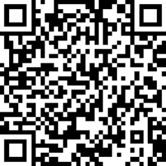
Vision Access
Volume 33 - Number 2
May 2026
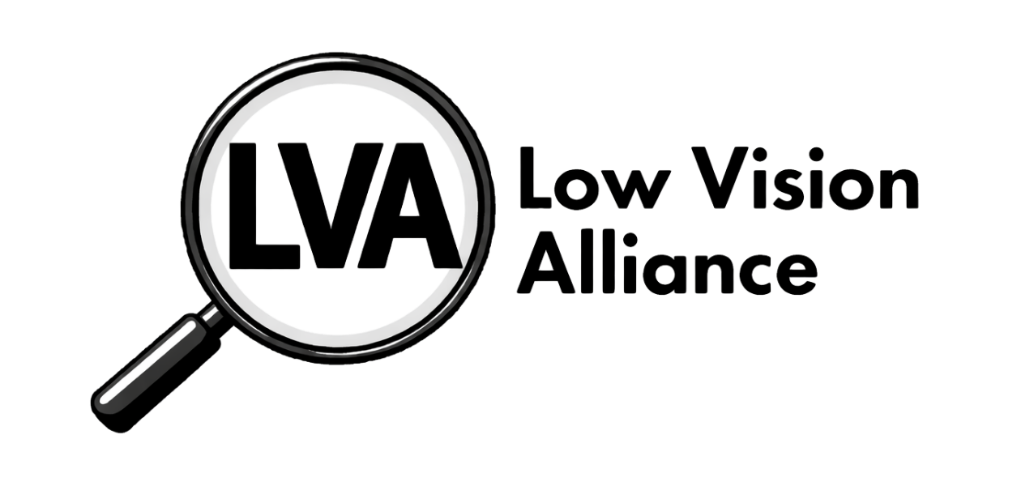
QR Code

(formerly Council of Citizens with Low Vision International)
Vision Access | Vol. 33 – No. 2 | May 2026

Table of Contents
President’s Message 3
Rebranding Committee Update 4
LVA Convention Program Schedule 8
2026 LVA Election Announcement 9
Get Up and Get Moving 11
A Huge Thank You! 12
LVA Affiliates’ Corner 13
DC Leadership Experience 20
Advocacy in Action in Washington, D.C. 24
LVA Book Club 27
Scout’s Corner 29
The Engine Under the Hood: Unleashing the Full Power of AI 32
America 250: History Mystery in Philadelphia plus a Gift for You 37
America 250: Recipe 1 Flag Cake 39
America 250: Recipe 2 Red, White, and Blue Fruit Salad 40
America 250: Coloring Pages 42
Low Vision Alliance Calendar of Events 44
Join Low Vision Alliance’s Email Lists 47
Contact Low Vision Alliance 48
LVA Flyer (Large Print) 49
LVA Flyer (Regular Print) 51
Low Vision Alliance Officers and Directors 53

Cover Art Description
The design features a vertically elongated gray diamond. In the top half of the diamond is the Low Vision Alliance logo, which is a black and white with a depiction of a round handheld magnifier with its handle pointing diagonal left, displaying the letters “LVA” capitalized in bold black font within the magnifying glass. Just below the center of the diamond, stretching across is the text “formerly Council of Citizens with Low Vision International”. The bottom half of the diamond displays the newsletter title “Vision Access,” with “Volume 33, Number 2, May 2026” underneath. A QR code appears in the lower left corner.

President’s Message

In the last issue of Vision Access, I was excited to announce our new name, Low Vision Alliance. As we begin this issue, I’m even more excited to share that we now have a brand-new logo. It’s modern, it’s sleek, and it truly represents who we are.

I don’t want to steal any thunder from our rebranding team, who have worked so hard to bring these changes to life. Their dedication and collaboration have made this transition possible. I’d also like to thank the members who took time to attend our January meeting regarding the name change, as well as those who submitted logo designs and ideas. Your input has been invaluable.

Of course, our work is far from finished. There are still many updates ahead, and it’s inspiring to see everyone involved stepping up and contributing. It’s especially encouraging to watch our committees and teams working on different efforts, both independently and together, to continue strengthening our organization.

Patti Cox, President, LVA

Rebranding Committee Update
by Melanie Sinohui, Rebranding Chair

We have a LOGO!
A lot has happened since the February LVA Board of Directors meeting. Let me catch you up.

In February, we sent another survey to the membership, asking if they wanted to vote on the new logo at the annual business meeting in July or if they were confident in the LVA Board of Directors reviewing and voting on their behalf. 74.4% of our 39 respondents wanted the board to vote. After that, we got to work again. Over the past several years, we gathered, all the submission ideas, both sketches and written descriptions including those we received after the name change in January. And we want to thank everyone for their submissions.

The committee collaborated over many hours, on multiple occasions, reviewing every submission along with the necessary criteria for a logo. We identified common themes and used those insights to inform the logo designs we created or fine-tuned. We also considered how they would be viewed in various formats from advertisements, letterhead, business cards, brochures, our website, etc. We drafted, edit, opined, edited some more and eventually finalized the four designs we put before the board to discuss and vote on at the March 31 board meeting. At the end of this article are those four designs and their alternate text.

What’s Next?
We have very important work to complete before the annual business meeting and the ACB National Conference and Convention this July, which should tie the bow on the whole project. We are creating a branding package which will include various versions of the logo for our leaders to use (black on white, white on black, transparent backgrounds, etc.), letterhead for official documents coming from our organization, updated flyer both in regular print and large print, and a new brochure, to name a few. The Publications Committee is working with the Public Relations Committee to update the flyer, create a new brochure, and design the swag for this year’s convention.

Continue to spread the word by sharing our new web address: https://lowvisionalliance.org/. Currently the page redirects visitors to www.cclvi.org until the full redesign is unveiled this summer.

Thank you again for your participation throughout this exciting process!

Logo 1
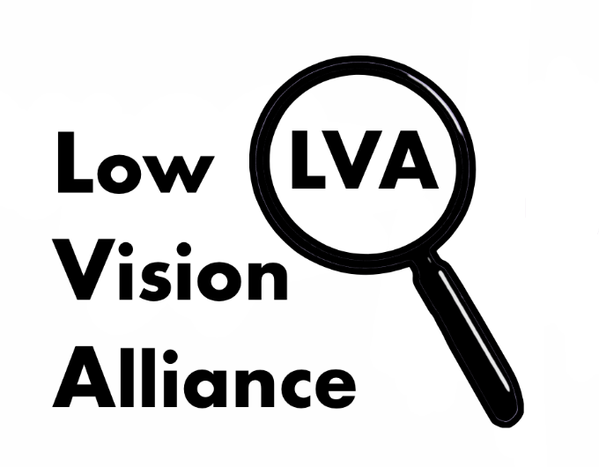
Image Left: A black and white logo with the words “Low Vision Alliance” stacked vertically in bold black font on the left-hand side. On the right side, there is a depiction of a vertically diagonally positioned round handheld magnifier with the capital letters “LVA” displayed within the magnifying glass in black bold font.
Logo 2
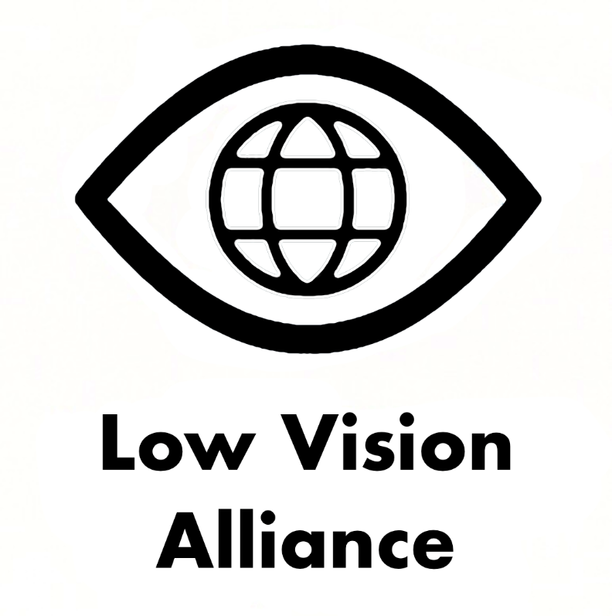
Image Left: Black-and-white logo showing a stylized eye outline with a globe icon inside. Beneath the icon, bold black text reads “Low Vision Alliance”.
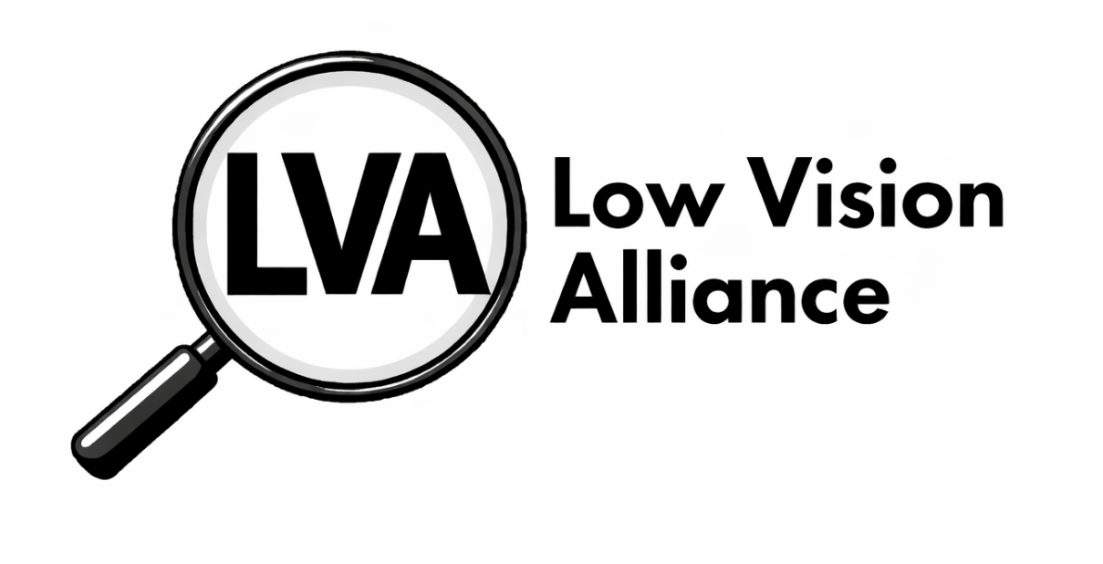
Logo 3 – THE WINNER!
Image Above: A black and white logo with a depiction of a round handheld magnifier with its handle pointing diagonal left, displaying the letters “LVA” capitalized in bold black font within the magnifying glass. To the right, are two lines of text in smaller black font, on the first line are the words “Low Vision” and on the second line the word “Alliance”.
Logo 4
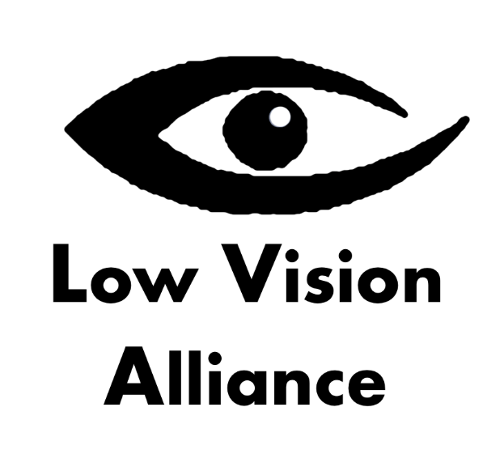
Image Left: A black and white graphic depicting a stylized eye with the outline graduating from thinner lines on the right to thicker lines on the left with the words “Low Vision Alliance” displayed beneath it.

LVA Convention Program Schedule
by Dianna Leonard, Convention Committee Chair

Thursday, July 16
5:30 - 6:45 PM
LVA Presents: The Importance of a Low Vision Evaluation
Join Low Vision Alliance with Carlos L. Grandela, OD, FAAO Optometrist from Mesa, Arizona for an informative session on the importance of a low vision evaluation, what it is, and why you should have one. There will be time for questions.

Saturday, July 18
2:30 - 5:30 PM
LVA Business Meeting
LVA will conduct its Annual Business Meeting including elections to the Board of Directors and committee updates with membership input and Q&A.

Monday, July 27
1:00 - 2:15 PM
LVA Presents: How Do You Do That? Hobbies with Low Vision
Panelists Josh Schneider, Theresa Breeden, and Lindsey Tilden will invite us into the world of playing sports, crafting, and enjoying tabletop games and how they’ve adapted their activities for low vision.

7:00 PM - 12:00 AM
LVA Big Bash
Join LVA for an exciting night! Take fun photos in front of a photo spot, and stay for door prizes. From 7 to 9pm we’ll be playing Outburst, and from 9 until midnight it’s our big bash dance! Dress to impress for the decades in outfits from the ‘70s, ‘90s, or 2020s as we celebrate our name changes throughout the years. There will be costume contests and a cash bar.

Note: All times are in Central Daylight Time

2026 LVA Election Announcement
by Leslie Spoone, Nominating Committee Chair

Low Vision Alliance will be holding its Annual Business Meeting on Saturday, July 18 at 2:30 PM CT. The Nominating Committee presented the candidates slate at the May 12th LVA Board of Directors meeting. Those currently serving are listed next to their position and the

Nominating Committee recommended all for the Slate of Officers and Directors:
- President: Patti Cox
- Secretary: Melanie Sinohui
- Board of Directors: Kathy Farina, Paul Lewis, and Donna Williams

LVA will be holding a Candidate Forum on Tuesday, June 9 at 8:30 PM ET, as well as a first reading of any Low Vision Alliance Constitution and Bylaw amendments.

We look forward to an informative candidate discussion of the issues impacting our low vision community.

If you are interested in running for a position on the LVA Board of Directors as an Officer or Director, please send your information to Leslie Spoone at lesliespoone@cfl.rr.com or call (407) 929-9837 to participate in the Candidate Forum.

Get Up and Get Moving
by LVA Public Relations Committee

Low Vision Alliance, formerly Council of Citizens with Low Vision International, invites you to participate in this challenge.

Get Up & Get Moving Presents: Walk to St. Louis!
March 6 - July 6, 2026

Ready to jump-start your fitness journey or keep your momentum going with some fun, friendly competition? The Get Up Get Moving Committee of ACB invites you to join our Walk to St. Louis Challenge! Lace up, step out, and let your story unfold one stride at a time.

We want to hear about your journey: your miles, your motivations, and your discoveries along the way. Whether you’re strolling through your neighborhood or trekking an imaginary route across the country, every step counts. Tell us your story and share your progress and the moments that keep you moving. Individuals or affiliates have a chance to win, and LVA will be entering as an affiliate.

How to Enter:
If you'd like to be a part of the Low Vision Alliance entry, please send an email with your steps or miles walked to lowvisionoutreach@gmail.com no later than 11:59 PM ET on June 30. LVA might win a $50 gift card and bragging rights! You can send your steps and miles as you complete them to the email address listed above.

Winners will be announced at the ACB Walk on Monday, July 27, 2026!

Take the challenge. Share your story. Walk to St. Louis!

A Huge Thank You!
by Terry Pacheco, Fundraising Committee Chair

I am excited to let you know that thanks to many members and supporters, our Celebration Fun-Raiser Auction on April 11th was a great success. Whether you are a member-at-large, a chapter member, or a supporter of our organization, we want to thank you for your participation.

Remember, every donation and every bid is for the benefit of Low Vision Alliance as a whole. This was demonstrated by the wide variety of items received.
A very special thanks to all who worked so hard to make our celebration such a wonderful event. I am sure our founders would be so proud of where we are today.

LVA Affiliates’ Corner

Florida Council of Citizens with Low Vision (FCCLV) News
by Jeanne Struhar

The FCCLV officers are passing the torch to a new set of officers during the FCB Convention, taking place in Orlando, Florida, May 14-17. Elections will be held at our annual meeting on Saturday, May 16, with all positions open. FCCLV members would like to thank the outgoing officers for their service, dedication, time, and great contributions each made towards keeping the mission of FCCLV alive and moving forward. They worked through the joys and challenges of leading the organization. We would like to name them individually, as each has given to FCCLV using their unique gifts and talents. Thank you - President, Mikey Wiseman, Vice President, Janice Revill, Recording Secretary, Sharon Youngs, Treasurer, Sally Benjamin, and Membership Secretary, Paul Lewis. In the next issue of Vision Access, we will introduce and welcome the new officers.

FCCLV is on social media! You can find us on Facebook at https://www.facebook.com/flcclv/. Follow, like, and share us with others. Connect with us. We would love to have you as part of our Facebook community.

We are always looking for new members. If you live in Florida, we would love to have you join us. FCCLV meets on the 3rd Monday of the month on Zoom from 7:00 PM to 8:00 PM ET. To join, simply go to fcb.org and complete the application form for membership. For more information, contact Paul Lewis, Membership Secretary (Note: Although Paul’s role as Membership Secretary is coming to an end, he has agreed to answer questions and assist those seeking membership during this time of transition to a new membership secretary). Paul’s email address is: lewpil1952@gmail.com and his phone number is (941) 841-9640. Come join us!

So, What’s Happening Here in Kentucky?
by Patti Cox

The Kentucky Council of Citizens with Low Vision (KCCLV) has officially changed its name to the Kentucky Low Vision Alliance. This change reflects our commitment to strengthening connections with the Low Vision Alliance and building a more welcoming community across the state.

The Kentucky Low Vision Alliance offers a variety of monthly meetings designed to bring members together, share ideas, and support one another. We hold two Zoom meetings each month at 8:00 PM Eastern. On the first Wednesday, we have a relaxed, topic-driven discussion, and on the third Wednesday, we have a business meeting where we also plan our next in-person gathering. In addition, we meet in person on the second Saturday of each month, creating a friendly space for connection and hands-on learning.

In recent months, our conversations have focused on building independence for individuals with low vision. We’ve also talked about how family members, housemates, and friends can provide support in ways that still encourage confidence and self-reliance. These discussions will continue throughout the year as we share ideas and learn from one another.

Often, it’s the small, everyday tips that can make life a little easier. For example, at a recent meeting we shared ideas for managing laundry and matching clothing, including using natural sunlight to help tell the difference between similar colors like navy and black.

The Low Vision Now Corner
by Glenda Such, President

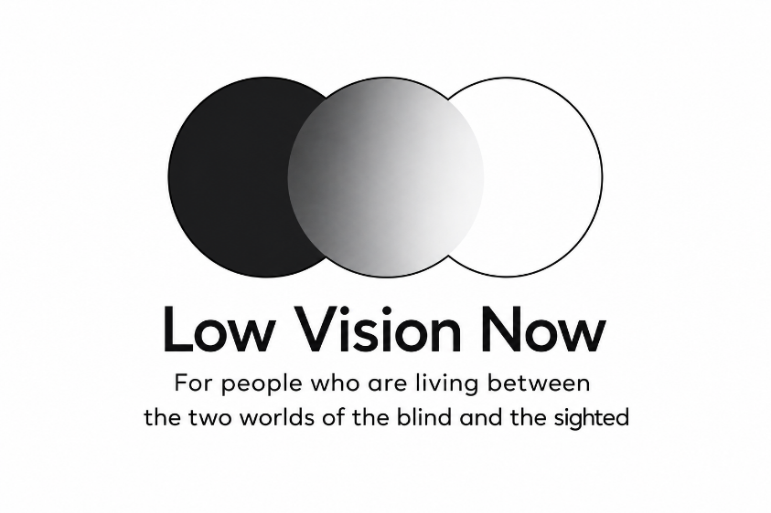
Image Left: Logo for “Low Vision Now” featuring three overlapping circles arranged horizontally like a Venn diagram. The left circle is black, the center circle is a gray gradient blending from dark to light, and the right circle is white. Beneath the graphic, bold black text reads “Low Vision Now.” Smaller text below says, “For people who are living between the two worlds of the blind and the sighted.”

Hello to everyone across the US, Canada and beyond!

We hope you are enjoying the spring weather, flowers, trees, and the songs of the wonderful birds. If you are an allergy sufferer, please accept my condolences for your sinuses, lungs, and eyeballs.

Low Vision Now continues to have great speakers each month. To hear a recording of many of those speakers, you can do so by visiting our website at https://www.lowvisionnow.org. Simply go to the option to listen to previous meetings and you will find a large list from which to choose.

During our February Zoom meeting, Dr. Silverman, Ph.D., Research Division, American Foundation for the Blind (AFB) gave a presentation where she reviewed the various research projects currently in progress at AFB. She also spoke about the results of previous research studies which have now been completed.

During our March Zoom meeting, Sam Seavey of the Blind Life YouTube Channel gave a review of current smart glasses. He provided the pros and cons of each company’s glasses and described new features believed to be on the horizon.

During our April Zoom meeting, Christine Chaikin, President and Owner of Insightful Publications spoke about her resource books for people with low or no vision.

Upcoming Meetings
All Low Vision Now meetings are held via Zoom beginning between 12:45 PM and 12:55 PM ET.
At the end of each month’s speaker presentation, a support group begins, which is open to all. While the speaker portion of our Zoom meetings are recorded, the support group is not. Confidentiality is kept for anything said during the support group.

May 9, 2026 - When using meta glasses, how to ask questions, when to use the Live AI option and when to use the standard Hey Meta feature.

June 6, 2026 - With all the stress in our world, how to decrease and manage stress using Mindfulness practices.

Low Vision Now currently has members in 13 different states and continues to expand. We have no geographic boundaries for membership, making us a group for anyone in the US, Canada and beyond. Our members are people who currently have or previously had low vision, family members or friends, service providers to those with low vision, or anyone just interested in things that affect those with low vision.

We have yearly dues of $25 but if that is a problem at all, we have scholarships to help people out. Those scholarships have been made available by the generous donations from current Low Vision Now members. And if you are already a member of Low Vision Alliance, you need only pay $10 to join LVN for 2026.

Want to speak with a live person to get more information about joining Low Vision Now or answers to questions you might have? Feel free to call us at (484) 566-3619. Or you can write us at lowvisionnow@hotmail.com. You can also check out our website at https://www.lowvisionnow.org.

Attending Zoom Meetings
Join via any device connected to the internet
https://us02web.zoom.us/j/4404653663?pwd=TDdVVG8yVDIvd0JwLzl2d0lGOUxsZz09

Please see the Calendar of Events at the end of this issue for additional Zoom joining information.

News from New York (NYSCCLV)
by Kathy Casey

NYSCCLV has agreed to sign onto a letter that was sent out by the governor’s office to allow Waymo (self-driving cars) to come to New York state. Although some of our members did not agree due to safety concerns, the majority feel that Waymo is another tool in our transportation toolbox.

If you have any questions or are looking for additional information, please email me at Kathycasey623@gmail.com or call (518) 466-4092

I hope everyone has a good spring.

DC Leadership Experience
by Ricardo Salazar

In the place where I grew up, access was not a system, it was a negotiation. In Maturín, a small city in the eastern Venezuelan state of Monagas, there were no organizations like the American Council of the Blind (ACB), no mentorship networks, and no clear pathway toward advocacy or leadership.

My name is Ricardo Salazar. I am 24 years old, and I am the President of ACB Students.

Growing up, a few days a week, I attended a small school for the blind with only four or five teachers. The rest of the time, I was in a mainstream classroom with no formal accommodations. I learned by listening carefully, knowing that anything I missed might not be repeated. My parents met with each teacher individually to explain my situation, but even then, we often had to create or purchase our own materials. Books were not simply read, they had to be transformed. By high school, I had taken on that responsibility myself.

Eventually, the school for the blind shut down as conditions in Venezuela worsened. My father found private tutors to teach me braille. I learned dot by dot using a slate and stylus, without access to a Perkins Brailler. As the situation deteriorated further, we made the decision to leave everything behind.

When we arrived in the United States, everything changed. For the first time, I had access to tools I had never experienced, including computers with screen readers and structured support systems. It was overwhelming, but access did not mean everything worked. There were still gaps.

In school, mobility was a constant challenge, counting hallways and memorizing routes. While accessibility departments provided support, it did not always match my needs. I remember requesting a sighted guide during a period of campus construction because it was unsafe for me to navigate alone, and I was told no due to liability concerns.

In the workplace, the pattern continued. After completing most of the training to become an over-the-phone interpreter, I was denied the position because I used a notetaker, something considered against company policy. Those experiences build quietly until you begin to question where you belong.

I knew I did not want to go through that alone. During my junior year of college, I was contacted by the then-president of ACB Students through an online forum. I hesitated, unsure if I would fit in, but I said yes.

Over time, I began to recognize my own experiences in others’ stories. What I thought were isolated struggles were shared realities. That realization changed everything. I became more involved, and by 2024 I was treasurer. In 2025, I was elected president.

That same year, I attended my first national ACB Convention. For the first time, I was surrounded by people who shared a common purpose: advocacy, independence, and accessibility.

Shortly after, I met Michael Wiseman, President of the Florida Council of the Blind. He encouraged me to attend the D.C. Leadership Conference. I was hesitant, but I went, and that decision changed me.
At the conference, I gained the tools to speak directly with legislators. One moment stood out: a session where all chapter presidents gathered to discuss the future of the organization. I was the youngest person in the room, but when I spoke, people listened. My perspective was taken seriously, and knowing our responses would be shared with the ACB Board made it even more meaningful.

That moment reframed what leadership meant. It is not about age or having all the answers. It is about showing up and contributing.

As I continued in advocacy, I realized something even more personal. I had become the kind of person I once needed. The student who had to fight for access was now helping others navigate those same barriers. The person who once lacked resources was now sharing them.

I left Washington, DC with clarity, confidence, and a sense of responsibility. This journey was not planned. It was shaped by challenges, strengthened by community, and guided by people who believed in me.

Belonging is not something you wait to be given. It is something you build, and once you build it, you have a responsibility to make sure others can find their way into it too.
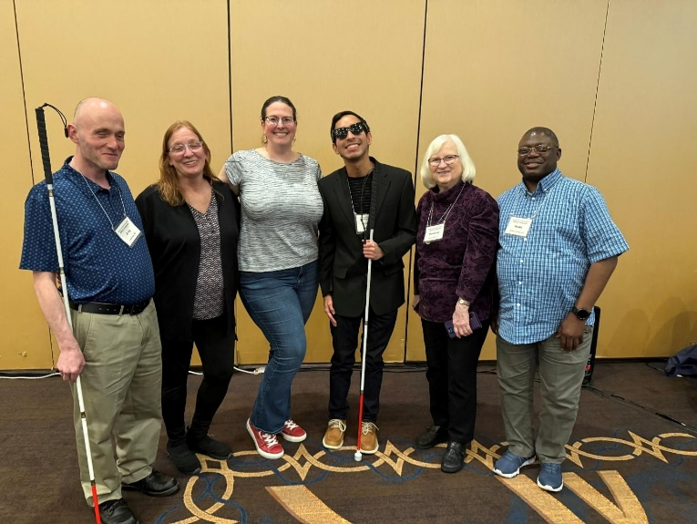
Photo Left: LVA members Joey Couch, Patti Cox, Melanie Sinohui, Ricardo Salazar, Debbie Persons, and Keith Knuckles pose at the end of the 2026 DC Leadership Conference this past March.

Advocacy in Action in Washington, D.C.
by Keith Knuckles, Kentucky Low Vision Alliance member

I had the distinct honor of traveling to Washington, DC, for the 2026 American Council of the Blind (ACB) Leadership Conference. As a member of the Kentucky Council of the Blind and the Kentucky chapter of Low Vision Alliance (LVA), I am also a proud member of ACB. This trip was a powerful reminder of how our local advocacy in Louisville, Kentucky connects directly to a nationwide movement. Representing both my local chapter and our national organization, I was there to ensure our shared mission of independence and accessibility was heard on a national stage.

Bringing Our Voice to the Hill
The heart of the trip was our time on Capitol Hill.
Sitting face-to-face with senators and representatives to discuss three key ACB initiatives was a transformative experience. There is a unique power in sharing our lived experiences with low vision and blindness directly with those who craft our laws. I left those meetings with a genuine sense that we are "moving the needle" on vital legislation regarding website accessibility, specialized devices, and ensuring appropriate public access for all Americans with disabilities. It was powerful to see Congress truly listen and engage with our initiatives.

A Masterclass in Leadership
The conference was expertly organized, and as a first-time attendee, the "new folks" morning orientation was incredibly welcoming. From the impactful speakers to the informative sessions, it is clear that ACB has a strong, sustainable vision for our future.

One of the highlights was the Vendor Hall, which served as a window into the future of assistive technology. Seeing the latest devices and accessibility features was inspiring, and I look forward to sharing these new options with our local Low Vision Alliance members.

Moments of Reflection and Connection
Beyond the meetings, the trip offered several unforgettable experiences. First, A Walk-Through History
I had the privilege of touring the Air Force Memorial with a soldier in uniform. He gave us a full history of the memorial and the cemetery, including the striking spires representing the smoke trails of a jet engine. Second, The View of the Pentagon: While at the Memorial, I had a spectacular, close-up view of the Pentagon. It was a powerful perspective to have while reflecting on the history. Third, Perspective at the Sheraton: Staying at the Sheraton Pentagon City provided a somber but important connection to history, as it was the hotel clipped during the 9/11 attacks. Fourth, The Power of Community: Whether sharing a meal at the hotel restaurant or sitting in on a Senate session at the Capitol, the chance to collaborate with peers from across the country was invaluable.

Final Thoughts
I want to extend my gratitude to the ACB for their incredible hospitality -- from the spectacular meals provided during our sessions to the thoughtful Uber vouchers that helped us navigate the city. This trip reinforced what I already suspected: the ACB is a strong, well-led organization. I returned home to Louisville with a better understanding of our mission and a renewed commitment to ensuring our voices are heard at every level of government.

LVA Book Club
Book Selection for June 29, 2026

Connecting Dots: A Blind Life
- Author: Miele, Joshua A. and Jamieson, Wendell
- Book Number: DB127356
- Reading Time: 9 hours, 36 minutes
- Read by: Greg D. Barnett

BARD Description: “When Joshua Miele was four years old, he answered his front door, and a mentally disturbed neighbor poured a cup of acid over his head, horrifically burning him and blinding him for life. It was a tragedy that could've destroyed him, but instead, Miele--naturally curious, and a born engineer--not only recovered, but flourished, finding increasingly inventive ways not only to help himself thrive in a world built for the sighted, but to help others to do the same. In "Connecting Dots"--a reference to braille and a metaphor for Miele's explorations and discoveries--readers are treated to a memoir that is as illuminating as it is entertaining, and ultimately as triumphant as they come: in 2022, Miele fulfilled a nearly lifelong dream when he won a MacArthur genius Grant. "Connecting Dots" comes at a time when disability is finally starting to get the recognition (and legislation) that it deserves, and entering the popular culture in a huge way, from Coda to Crip Camp and beyond. We are at an inflection point in addressing those who have historically been marginalized--a conversation that must include those with disabilities. This is the moment for a book like this in so many ways, and Miele is, apart from the obvious reasons, the perfect person to write it. He is funny, pragmatic, and direct--with a healthy dose of attitude. In telling his own story-spanning from the 1970s to today—he also speaks to how the world has changed (and how it has not) when it comes to blindness, and to disability and accessibility more broadly. Miele has always considered his challenges to be opportunities, and that is something we can all learn from.”

Scout’s Corner
by Cheryl McNeil Fisher (assisted by AI)
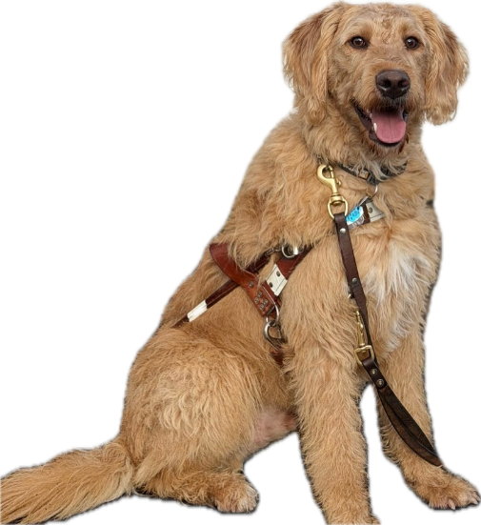
Photo Left: A golden-colored guide dog sits proudly facing the camera, wearing a brown leather guide harness and leash. The dog has curly fur, floppy ears, and an open-mouthed happy expression with its tongue slightly out. The image highlights the dog’s calm, confident posture as a working guide dog trained through Freedom Guide Dogs.

Hello, Vision Access Friends!

I am absolutely loving Freedom Guide Dog School. I’ve learned so much already. Can you believe they actually tried to hit me and my trainer with a car? I know — wild, right? The first time it happened, I stopped dead in my tracks. Of course, I stopped! I didn’t want either of us to get hurt. What I learned later, though, is that my trainer would never have let that happen. It was a controlled situation with one trainer behind the wheel and my trainer walking right beside me. By the second time they tried it, I aced it. And then when a car came around another corner, I stopped before it even got close. I knew exactly what to listen to and look for, because I’m a Doodle — and we Doodles are super smart.

Cheryl taught me to stop at the staircase before going up or down, but things get a lot more serious when someone is holding the handle of my harness. My trainers at Freedom are wonderful. I thought I was going to miss Cheryl terribly, but I am so loved here — played with by my pack friends and the humans on staff. No surprise there, right? Where there are treats, I am there. The trainers always have treats, and I am always ready.

I’ve also learned how to navigate a down curb — you know, where the sidewalk slopes at the end and meets the street? That’s where I stop and wait for my trainer to say, “Scout, forward,” when it’s safe to cross. Halfway across, she says, “Scout, to the curb.” In the beginning, it was a little tricky, but once we hit a real crosswalk, I nailed it. Cheryl had already taught me to stay in crosswalks, but now it’s my job to get my trainer safely across the street. We pause at the other side, she tells me, “Yes, good boy,” and once we’re up on the curb, she slips me a treat. I love this job.

I am so proud to be a guide dog in training. I honestly had no idea what I was signing up for when I arrived. Once I figured it out, I was sometimes so excited that it took a couple of “Scout, sit,” to get my attention. Remember when I told you last year that I love to jump? I can spring straight up on all fours as high as your shoulder — and I can dance on my back legs to check out whatever’s happening around me. Yep. Cheryl definitely needed a lot of patience, never raising her voice, and being consistent. She also had to move the banana basket further back on the counter.

One day, we came into the house, and in a flash, I darted into the kitchen, jumped up, tapped the basket with my nose, and bananas hit the floor everywhere. Cheryl heard the commotion and called, “Scout, come.” I looked longingly at those yummy bananas, but knew that I had better get to her side, or there would be no treats. See, even though I did something wrong, I knew that if I ran back and scooted as close to her side as I could, she would tell me I was a good boy, and maybe give me a treat. After all, she always had some in her pocket.

All part of learning good house manners, I suppose. I’m no longer that little puppy who had a blast testing just how far I could push Cheryl and Ed. Cheryl was definitely the alpha of our pack. When Ed said no, it somehow sounded like, “No… maybe.” But those days are behind me now.

By the next issue, I will be a graduated guide dog. I can’t wait to share the news! Until then, my friends, Love and happy wags, from me, Scout.

The Engine Under the Hood: Unleashing the Full Power of AI
by Cheryl McNeil Fisher (assisted by AI)

In the first part of this series, I shared how I use AI as a collaborator—from character interviews to streamlining my editing workflow. But to truly master these tools, we need to understand how the "engine under the hood" works. Understanding the technology helps move us from fighting with a machine to guiding a brilliant, albeit sometimes literal-minded, assistant.

Patterns, Not Magic
At its core, AI like ChatGPT is a Large Language Model (LLM). It doesn’t "know" facts the way we do, it understands patterns. It has "read" a massive library of human language and predicts the most logical next word based on the context you provide - in your conversation. When I tell it, "Don’t give commentary," or "Act as a developmental editor," I am narrowing the pattern it's allowed to follow. It responds to my specific instructions, becoming more precise the more I guide it.

The Architect’s Apprentice: Research and World-Building
For my next "history mystery" project, I needed to visualize the Revolutionary War landscape of the Hudson Valley. I engaged the AI in a discussion to help me "map" the area from New York City up to Newburgh, one of the last major sites of the war. In seconds, it provided seventeen sites, giving me a "touring map" in my head, similar to how I used physical maps for my Philadelphia research. I won’t use half of the sites, but it gives my husband and me a place to begin mapping out our visits.

The Golden Rule: Trust but Verify
AI is not a historian. It can occasionally "hallucinate" facts or conflate dates. I use AI for the broad strokes to build my itinerary, but I always verify every detail with primary sources, local historical societies, or physical visits. It starts the research, but I finish it.

Preserving Your Vision: Consistent Illustrations
Visuals are often the biggest hurdle for authors using illustrations. I faced a challenge with my “Sister Shenanigan” books when my original illustrator was no longer available. Because I own the copyright to my characters, I have been experimenting with AI as a bridge to maintain continuity.

I tried a second illustrator for the second book, but they don’t have the softer look as the first. The second illustration is bold and vector-like.

By uploading my existing illustrations from “Apple Batter-Up,” I was able to guide the AI. I was thrilled the first time I tried it.

Using the characters I own, I asked the AI to generate an illustration of the girls in the same colors as the original and riding bikes. The AI acts as the "brush," but the vision and ownership remain mine.

The Tenacious Creator
The beauty of this technology isn't that it's perfect—it's that it's tireless. Whether I’m using it to fix a broken button on my website or edit a manuscript chapter-by-chapter, the AI responds to my tenacity.

It doesn't get frustrated when I ask it to "go back and try again," and it doesn't charge by the hour. It is a digital companion that’s always ready to say, "Hello, Cheryl, how can I help you today?"

The Reality of the Craft: Tenacity and Time
If you are just beginning your journey with AI, my best advice is this: be patient. While these tools can work at lightning speed, teaching them to truly reflect your voice is a marathon, not a sprint. I have been working with AI for over a year, spending countless hours in "conversation" to get to this point. My friends and colleagues often call me "tenacious," and that is exactly what this process requires.

Even when I upload a full 20,000-word manuscript into a Project, I’ve learned that the AI works best when we focus on smaller chunks. I might have the whole book there for context, but we work through the edits chapter by chapter. If the AI starts to ramble or lose focus, which it will, don't be afraid to take control. Go to that blank field and type "Stop." Then, give it a firm nudge to refocus.

Whether you are working on a 1,000-word article or a 50,000-word novel, remember that this is a relationship you are building. It takes time, trial, and error to move from a generic response to something that sounds like you. But if you stay at it, you'll find that you aren't just working faster you're working with a new kind of creative freedom. Don't be afraid of it, embrace it!

Author’s Disclosure: The Making of This Article
This piece was crafted through a dynamic partnership between me and AI. It was not generated by a single prompt, rather, it is the result of an extensive back-and-forth conversation. I provided the lived experiences, the historical context of my Hudson Valley home, and the specific creative challenges I've faced. The AI acted as my assistant, helping structure and organize those thoughts. We refined the text through several rounds (twenty-two to be exact) of "discussion" to ensure the final result accurately reflects my voice and my process.

America 250: History Mystery in Philadelphia plus a Gift for You
by Cheryl McNeil Fisher

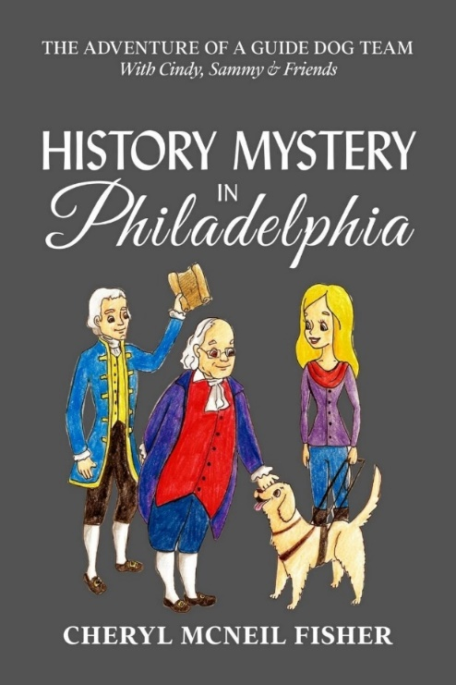
Photo Left: Book cover with a dark gray background titled History Mystery in Philadelphia. At the top, smaller white text reads, “The Adventure of a Guide Dog Team With Cindy, Sammy & Friends.” The illustration shows two colonial-era figures (a man in a blue coat with a scroll in hand and another dressed in red and purple) and a modern blonde woman holds the leash of a light-colored guide dog wearing a harness. At the bottom of the cover is the author’s name, Cheryl McNeil Fisher.

Celebrate Our 250th Anniversary by immersing yourself in your free download of “History Mystery in Philadelphia with Cindy, Sammy, and Friends — The Adventure of a Guide Dog Team.”

The adventure of a lifetime begins when the spirit of Benjamin Franklin taps Sammy and Cindy for a mission of national importance: find Thomas Jefferson’s portable writing desk before its contents are lost to history. From John Hancock’s dressing-down at the Liberty Bell to a secret meeting with Betsy Ross, readers are whisked away to a vibrant, living 1776 Philadelphia.

The author masterfully intertwines fact and fiction through immersive dialogue that makes you feel part of the story. It is a sophisticated, historical journey that adults will find just as engaging as younger readers.

Free downloadable large print PDF or several eBook formats, or just read in your browser. Book Funnel will give you the options, and if you have ANY challenges, contact them. They are familiar with working with individuals with low vision. And you can always contact me at cmcneilfisher@gmail.com

https://cherylmcneilfisher.com/landers/free-ebook-offer-history-mystery-in-philadelphia-with-sammy-cindy-and-friends-the-adventure-of-a-guide-dog-team

America 250: Recipe 1 Flag Cake
Source: Sheila Young Recipe Swap on ACB Community

Ingredients:
1 Yellow cake mix
1 container Cool Whip
1 pkg blueberries
1 pkg strawberries

Instructions:
Step 1: Bake the cake in a 9 x 13 pan
Step 2: When cool, spread Cool Whip over the top
Step 3: Orient the pan horizontally
Step 4: In upper left corner, put a square of blueberries to mimic the blue area of the flag where the 50 stars are
Step 5: Then place strawberries in horizontal rows across the cake to mimic the 13 red stripes on the flag, making sure to leave the white of the cool whip between the rows to mimic the white stripes of the flag.

America 250: Recipe 2 Red, White, and Blue Fruit Salad
Source: Sheila Young Recipe Swap on ACB Community

Ingredients:
2 pkgs raspberry gelatin or 1 pkg raspberry and 1 pkg blueberry gelatin
2 cups hot water
1 pkg frozen raspberries
1 cup liquid coffee creamer
1/2 cup sugar
1 envelope unflavored gelatin
1/4 cup cold water
1 cup sour cream
1 teaspoon vanilla
1 can blueberries with juice

Instructions:

First Layer
Dissolve 1 package raspberry gelatin in 1 cup hot water. Add 1 package frozen raspberries. Pour into a 9 by 13-inch pan. Let set until firm.

Second Layer
Heat 1 cup of liquid coffee creamer and 1/2 cup sugar until hot. Mix 1 envelope unflavored gelatin in 1/4 cup cold water. Add gelatin mixture to warm cream mixture. Add 1 teaspoon vanilla to 1 cup sour cream. Mix well and cool, then add to the top of the first layer. Let set until firm.

Third Layer
Dissolve a package of blueberry or raspberry gelatin in 1 cup hot water. Add 1 can blueberries with juice. Let set until cool, then add to the top of the second layer. Let set until firm. Cut into squares to serve. Serves 12.

America 250: Coloring Pages
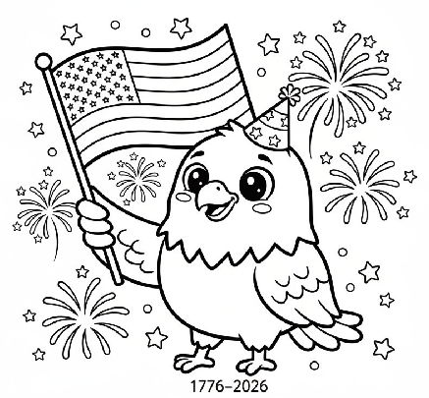
Source: Letsgopixels
Above: A coloring page with a cheerful cartoon bald eagle waves an American flag, surrounded by fireworks and stars. The eagle wears a patriotic hat, and “1776–2026” appears below.
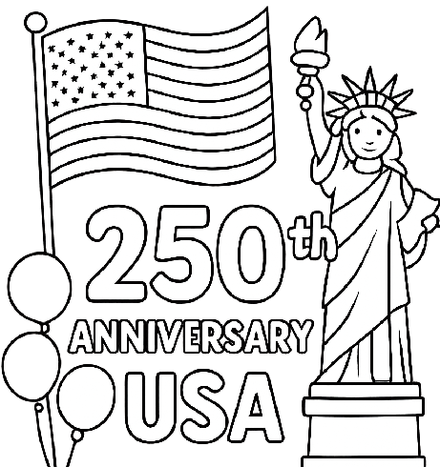
Image Above: A coloring page featuring the Statue of Liberty beside a waving American flag and balloons. Large text reads "250th Anniversary USA.

Low Vision Alliance Calendar of Events
(formerly Council of Citizens with Low Vision International)
Everyone is welcome to attend these events by accessing the Zoom mobile app, visiting the Zoom website at www.zoom.com or calling (312) 626-6799, and entering the appropriate meeting ID and passcode.

Subscribe to our LVA-Info email list to receive weekly meeting reminders and Zoom details by sending a blank email to lva-info+subscribe@acblists.org. In addition, all LVA events, except our business meetings, are listed on the ACB Community Call schedule. Those without email can access that information by calling (800) 424-8666 and following the prompts or typing acb.community into your web browser.

All Monday and Thursday Zoom Events have the same Zoom link, Meeting ID, and Passcode.

Topics and speakers are subject to change. Please reference the weekly LVA emails and ACB Community Call schedule.

LVA Game Night
Second Monday at 8:00 PM ET

LVA Low Vision Peer Support Group
Third Monday at 8:00 PM ET

LVA Tips and Tricks
Fourth Monday at 8:00 PM ET
Topics will rotate. Examples: Members Spotlight, Tips and Tricks, Technology, etc.

LVA Book Club
Fifth Monday at 8:00 PM ET (starting in March)

LVA Board of Directors Meeting
Second Tuesday at 8:30 PM ET
Meeting ID: 829 0433 3824
Passcode: 784688

LVA Let’s Talk Low Vision
First Thursday at 8:00 PM ET
Join our guests for this monthly informative program
Also broadcasted on ACB Media 1
The podcast of the episodes can be found at: https://www.cclvi.org/LetsTalkLowVision

LVA Affiliate Zoom Calls

California Council of Citizens with Low Vision (CCCLV): A Sunday Chat
First and Third Sunday at 7:00 PM ET
Spend part of your Sunday with members of CCCLV and enjoy “A Sunday Chat”. This is a call for those of us who are blind or with low vision and any family and friends, be they near or far. Topics will range from all things low vision to life in general as a person who is blind or low vision.

Low Vision Now (LVN)
First Saturday at 12:45 PM ET (Second in July and Sept.)
The monthly Zoom meeting Low Vision Now is open to all who have an interest in the issues of low vision.
Meeting ID: 440 465 3663
Passcode: 2121

Kentucky Low Vision Alliance (KLVA)
First Wednesday at 8:00 PM ET: Business Meeting
Third Wednesday at 8:00 PM ET: Informative meetings for low vision individuals across the US
Meeting ID: 862 9889 6972
Passcode: 975864

Join Low Vision Alliance’s Email Lists
(formerly Council of Citizens with Low Vision International)

LVA-Info Email List:
This is a two-way list for members and non-members of LVA. Its purpose is to publish the weekly schedule of LVA events, and to provide a place where subscribers can ask questions about low vision. To Join: Send a blank email to lva-info+subscribe@acblists.org

LVA-Members-Only Email List:
This Is a one-way list that contains information and announcements of the annual business meeting, monthly board meetings and minutes, constitutional amendments, resolutions, and other items members need to vote on. To Join: You will be added to this list when your annual membership dues are received. If you unsubscribe, you will not receive important LVA organization information.

LVA-Vision-Access Email List:
This is a one-way list where members receive our newsletter, Vision Access. To Join: You will be added to this list when your annual membership dues are received. If you unsubscribe, you will no longer receive our publication and you will miss out on interesting and informative articles.
VISION ACCESS is published four times a year (February 15, May 15, August 15, and November 15) in large print and email.

Vision Access welcomes submissions from people with low vision, from professionals such as ophthalmologists, optometrists, low vision specialists, and anyone with something substantive to contribute to the ongoing discussion of low vision and all of its ramifications. Submission deadlines are January 15, April 15, July 15, and October 15. Send contributions to publications@lowvisionalliance.org

Accessing Vision Access
Vision Access is available to LVA members via email and large print. Audio versions and archived issues are available at https://cclvi.org/VisionAccess

Contact Low Vision Alliance
(formerly Council of Citizens with Low Vision International)
Address: 5401 Southern Parkway, Louisville, KY 40214
Call LVA: (502) 905 - 0869 from 9:00 AM and 9:00 PM ET
E-mail: lowvisionoutreach@gmail.com
Website: https://lowvisionalliance.org/

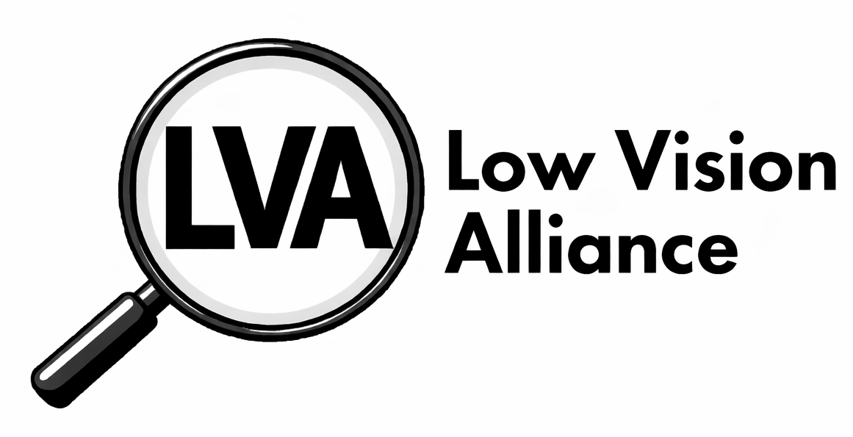

Where Possibilities Come into Focus

Empowering People with Low Vision to Live Fully

Who We Are
Low Vision Alliance is a community dedicated to supporting individuals with low vision through advocacy, education, and connection. Formerly known as the Council of Citizens with Low Vision International, we continue a proud legacy while focusing on the future.

What We Offer
- Community to promote living well with vision loss
- Educational programs and events via Zoom and in-person
- Accessible resources and tools
- Peer support to help foster you throughout your journey
- Advocacy for accessibility and inclusion
- Scholarships for deserving low vision individuals to support higher-education
- Annual award program providing magnification devices
- Quarterly magazine providing relevant information to the low vision community (available in large print, audio, and email)

How to Connect
- Join our email list: send a blank email to LVA-Info+subscribe@acblists.org
- Read our newsletter, Vision Access, at cclvi.org/visionaccess
- Visit our Resources Page at cclvi.org/resources
- Become a member at cclvi.org/join

Join Us. Connect. Thrive.
Become a member today and bring your world into focus.
Website: lowvisionalliance.org
Email: lowvisionoutreach@gmail.com
Phone: (502) 905-0869

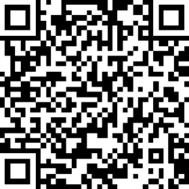

QR Code

Where Possibilities Come into Focus

Empowering People with Low Vision to Live Fully

Who We Are
Low Vision Alliance is a community dedicated to supporting individuals with low vision through advocacy, education, and connection. Formerly known as the Council of Citizens with Low Vision International, we continue a proud legacy while focusing on the future.

What We Offer
- Community to promote living well with vision loss
- Educational programs and events via Zoom and in-person
- Accessible resources and tools
- Peer support to help foster you throughout your journey
- Advocacy for accessibility and inclusion
- Scholarships for deserving low vision individuals to support higher-education
- Annual award program providing magnification devices
- Quarterly magazine providing relevant information to the low vision community (available in large print, audio, and email)

How to Connect
- Join our email list: send a blank email to LVA-Info+subscribe@acblists.org
- Read our newsletter, Vision Access, at cclvi.org/visionaccess
- Visit our Resources Page at cclvi.org/resources
- Become a member at cclvi.org/join
Join Us. Connect. Thrive.
Become a member today and bring your world into focus.
Website: lowvisionalliance.org
Email: lowvisionoutreach@gmail.com
Phone: (502) 905-0869
QR Code

Low Vision Alliance Officers and Directors
(formerly Council of Citizens with Low Vision International)

OFFICERS  President - Patti Cox  2024-2026  1st Vice President -  Zelda Gebhard 2025-2026  2nd Vice President -  Terry Pacheco 2024-2026  Secretary - Melanie Sinohui  2024-2026  Treasurer - Debbie Persons  2025-2027  Immediate Past President -  Leslie Spoone  Publications Chair  Melanie Sinohui | DIRECTORS  #1 Joyce Feinberg  2025-2027  #2 Kathy Farina  2024-2026  #3 Cynthia Hawkins  2025-2027  #4 Paul Lewis  2024-2026  #5 Dianna Leonard  2025-2027  #6 Donna Williams  2024-2026  Webmaster  Joyce Feinberg
© 2026 Low Vision Alliance

