

Vision Access
Volume 32 - Number 4
November 2025
Council of Citizens with Low Vision
International

Vision Access | Vol. 32 – No. 4 | November 2025

Table of Contents

President’s Message 3
Rebranding Committee Update 6
CCLVI Special Membership Meeting 9
Time to Renew Your CCLVI Membership 10
Celebrating International White Cane Day 2025 12
White Cane Safety Day: October 15, 2025 14
The New Talking Book Player from NLS 18
Affiliates’ Corner 20
CCLVI Book Club 23
Latest and Greatest from Scout 26
Why I’m Walking Across Japan: About My 1,400km (870 miles) Journey 30
Sweet & Simple: How to Make a Candy Wreath 42
Holiday Recipes: 1. Citrus and Spice Cranberry Sauce 47
Holiday Recipes: 2. Gourmet Green Bean Casserole 50
Calendar of Events 57
Join CCLVI’s Email Lists 61
Contact CCLVI 62
CCLVI Officers and Directors 63
Front Cover and CCLVI Logo Descriptions
The cover page features a diamond-shaped gray background with a logo prominently centered in the middle with the words Council of Citizens with Low Vision above the logo.

The logo represents CCLVI, a special interest affiliate of the American Council of the Blind and is designed with a pair of glasses. Notably, one lens on the glasses has been replaced with a globe, symbolizing global vision and perspective. The other lens is illustrated with a cross-section pointing at the globe, emphasizing detailed observation and insight.

The glasses frame is formed into an infinity symbol, suggesting endless possibilities and continuous improvement in vision and understanding. In the bottom left corner of the diamond-shaped background, there is a QR code, positioned to provide easy access to additional information or resources related to CCLVI and low vision. Below the QR code, it reads: Vision Access Volume 32 Number 4 November 2025

President’s Message
by Patti Cox

Low Vision During the Holidays: Crockpot Confidence

Do you find yourself invited to Christmas parties with friends or family, and are asked to bring a dish but you hesitate? Maybe you don’t cook often, or you worry your dish won’t look quite right. You want to go, but you don’t want to show up with something store bought.

Here’s a secret: the crockpot is a beautiful thing.

You can make all sorts of dishes in a crockpot, and they almost always turn out looking great. Some people say crockpots aren’t accessible because they’re digital but manual crockpots are still available on Amazon. Just have one delivered and you’re good to go.

For me, desserts are the easiest. They take very few ingredients, and they’re hard to mess up. I’m going to share a basic recipe that you can customize. In just 2 to 4 hours, you’ll have a perfect dessert to take anywhere.

Dump Cakes: Simple, Delicious, and Crockpot-Friendly

Dump cakes are one of the easiest desserts to make and they’re practically foolproof.

Photo Left: Close-up of a spoon holding a serving of warm, golden-brown dessert with a crumbly topping and gooey fruit filling (Photo Courtesy of Patti Cox)

Basic ingredients:
- 2 cans of pie filling
- 1 box of cake mix
- 1 stick of butter

Instructions:
1. Empty the pie filling into the bottom of your crockpot.
2. Pour the dry cake mix evenly over the filling.
3. Slice the butter into pads and place them evenly on top of the cake mix.
4. Cook and serve straight from the crockpot. Add a scoop of vanilla ice cream for extra yum!

Flavor ideas:
- Apple pie filling + spice cake mix + cinnamon
- Strawberry pie filling + chocolate cake mix
- Cherry pie filling + yellow cake mix + almond extract

All dump cakes work with yellow or white cake mix, but feel free to experiment with flavors. You can add spices, extracts, or even chopped nuts for texture.

Cooking time: 2 hours on high or 4 hours on low

This dessert is easy to make, easy to transport, and easy to serve, especially for those of us with low vision. No need to fuss with presentation or worry about perfection. Just scoop, serve, and enjoy the holiday cheer.

Rebranding Committee Update
by Melanie Sinohui, Rebranding Chair

As many of you know, we have been discussing the possibility of rebranding the Council of Citizens with Low Vision, both in name and logo, for quite some time. Over the summer, we dove in, feet first, and are so thankful for the membership that has participated. We received 50 ideas for new names from 14 people.

In August, I was appointed chair of the Rebranding Committee and Patti and I worked hard to ensure this committee was diverse. We wanted a range in the following; tenure with CCLVI, visual acuity, age, gender, geographic location, etc. It was also important this this committee be made up of board members and non-board members, as this is a whole membership decision. The board members we chose represented aspects of the organization where this name change would have large impacts (membership, website, Publications). We also wanted a committee that was not too large and we wanted members who would voice their opinions, be open to others’ opinions, and share what they were hearing among their fellow members. I think we achieved this with Amanda Petrisin, Dianna Leonard, Michael Smitherman, Mikey Wiseman, Ralph Smitherman, Zelda Gebhard, and Patti Cox (ex officio).
We spent hours, on multiple occasions, discussing the submissions, adding our own, making different variations, and ultimately whittling the list down. We took into consideration whether we include ACB in our name, if we keep international or a synonym, what the acronym could be perceived as, looking at similarly named organizations, website URL options, length of the name, etc.

We needed to narrow this list down to present one name before the membership because the motion has to indicate specifically what we would change the name to and has to be presented to the membership ahead of the special membership meeting we would vote in.

We were very thoughtful in our choices of Low Vision Alliance or Low Vision Alliance of ACB and latched on to the definition of Alliance, “An alliance is a union or association of people, organizations, or countries for mutual benefit, protection, or to achieve a common goal.”

We spent a great deal of time researching the D.C. Nonprofit Corporation Act (DC Code), to ensure we were following all the requirements. We also wanted to make sure we heard from you, our members, throughout this process.

Due to the sense of urgency behind this project and the timeline we had in place, we narrowed-down the choices and put those before the membership in the survey in October where 28% of our members participated (75 responses from calls, texts, emails, and the survey). The survey closed on October 31. Low Vision Alliance received 56% of the vote and Low Vision Alliance of ACB 44%.

Based on these results, our next step is to put before the CCLVI Board of Directors on November 11, a resolution to accept this result, and hold a special membership meeting on January 10, 2026, for the membership to vote to amend the Articles of Incorporation by changing the name from Council of Citizens with Low Vision International to Low Vision Alliance. Should the resolution be voted down, the vote will not occur, and the name will not change

Regardless of if the name changes or not, the committee will spend the spring of 2026 working on a new logo and branding package for our organization, with the intent of unveiling at our annual business meeting this summer, so keep a look out as we will continue asking for member input during this next stage of the process.

We cannot thank you all enough for your time, energy, and passion in all aspects of this process. More to come!

CCLVI Special Membership Meeting

CCLVI will hold a Special Membership Meeting Saturday, January 10, 2026 at 4:00 PM Eastern Time via Zoom.

Meeting Purpose
The purpose of this meeting is for the membership of the Council of Citizens with Low Vision International, to vote on an amendment to the Articles of Incorporation changing the name from the Council of Citizens with Low Vision International to Low Vision Alliance.

Join the Meeting
Zoom links will be sent via the CCLVI Members-Only email list on January 9, the day before the meeting. Those without email will be called by phone. We would appreciate everyone who does not receive emails from our CCLVI Members-Only email list to call Zelda Gebhard at 701 - 709 - 0262 to make arrangements to receive the Zoom information for this meeting.

Time to Renew Your CCLVI Membership
By Zelda Gebhard, Membership Chair

No matter what time of the year it is, it’s always a good time to be a member of CCLVI.

If you are a member of one of the following CCLVI Affiliates: California Council of Citizens with Low Vision, Florida Council of Citizens with Low Vision, Low Vision Now, Kentucky Council of Citizens with Low Vision, or New York State Council of Citizens with Low Vision, you will be contacted by your affiliate membership representative to update your information and pay your 2026 dues.

If you are an at-large member, not belonging to one of the above affiliates, you will receive a large print paper renewal form in the mail. Please complete and return along with your dues in the enclosed, addressed envelope, or go to https://cclvi.info/join/member-form/ to complete the form and pay online before February 1st.

At-large members have two great choices:
- Pay dues annually ($15.00 by check or $16.00 by credit card or PayPal) or
- Become a new CCLVI Life Member by paying $150.00 one time. During our 2025 CCLVI business meeting, life member dues were reduced from $300.00 to $150.00, making this option more affordable than ever before.

To help us stay connected, we ask all our current life members to report any changes in your contact information or format preferences for the ACB Braille Forum or Vision Access. Please call Zelda at 701 – 709 - 0262 to update your information.

Some Current Member Benefits:
- Newsletter Vision Access, four issues a year in large print or email. Both formats, plus audio, are also available at www.cclvi.org.
- Two weekly Zoom sessions to connect, share ideas and have fun!
- Monthly Let’s Talk Low Vision session for up-to-date information and education.
- Genensky/Foley Magnification Awards
- Scheigert College Scholarships
- Bernice Kandarian Service Award, Friend of CCLVI Award
- Website with Podcasts and revised Resource Pages
- Opportunities in Leadership as an Officer or on the Board of Directors or as a member of one of our 15 active committees

We are proud of the work accomplished and progress made in 2025 and look forward to another positive year in 2026.

If you have any questions or need any assistance in completing your renewal, please contact Zelda at 701 - 709 - 0262 or cclvimembership@gmail.com.

Thank you for renewing your membership before the February 1st deadline.

Celebrating International White Cane Day 2025
by Adam Ha (as submitted to ACB)

The White Cane: Pride, Dignity, and the Right to Inclusion
The World Blind Union (WBU) marks International White Cane Day by reaffirming the cane’s role not only as a tool for safe and independent mobility, but as a universal symbol of pride, dignity, and the right to inclusion for blind and partially sighted people everywhere.

At a time when diversity and inclusion efforts face renewed challenges across many parts of the world, the white cane stands as a powerful reminder that blind people belong in every aspect of community life. It represents visibility, identity, and the ongoing pursuit of equal rights.

“The white cane is more than a mobility aid. It is a declaration that blind and partially sighted people are here, present in society, and entitled to the same dignity and opportunities as everyone else,” said Santosh Kumar Rungta, President of the World Blind Union. “On this International White Cane Day, we celebrate the courage and resilience of our community, and we recommit ourselves to building a world that respects and values difference.”

The WBU stresses that the struggle for inclusion remains urgent. Across countries and regions, blind and partially sighted people continue to encounter barriers – from inaccessible public spaces and discriminatory attitudes to policy setbacks that risk undermining decades of progress.

“Autonomy and dignity are at the heart of what the white cane represents,” added Cristina Chamorro, WBU First Vice President. “Every blind person using a cane is exercising their right to move freely, to participate fully, and to contribute to their community. This day is not only about recognition but also about action to ensure that inclusion is non-negotiable.”

On this International White Cane Day, the World Blind Union calls on governments, policymakers, and communities worldwide to:
1. Guarantee accessibility in public infrastructure, transport, and digital spaces.
2. Safeguard and strengthen legal protections for the rights of persons with disabilities and
3. Recognize the white cane as a universal symbol of independence and inclusion.

The World Blind Union represents more than 338 million blind and partially sighted people through its network of over 190 member organizations in more than 100 countries. Together, we call for a future where every step taken with the white cane is met with dignity, safety, and equality.

White Cane Safety Day: October 15, 2025
by Jeanne Struhar

On October 15 of every year, we celebrate White Cane Safety Day around the country. Mayors read proclamations. Communities of people who are blind or visually impaired gather and participate in awareness walks or other activities to build awareness and educate everyone on the meaning of the white cane. There is a White Cane Law in all 50 states that says drivers must yield to pedestrians using a white cane, even if they are not in a crosswalk.

There are 3 types of white canes:
- A mobility cane is long and lightweight. It is used for detecting obstacles, steps, uneven surfaces, and navigation.
- A support mobility cane, or assistive cane, in addition to the same purposes as the mobility cane, also provides physical support and stability to those who need it.
- An ID cane is a long white cane that is thinner than the regular mobility cane, not as sturdy, and is primarily used for identification purposes for people with low vision.

The origins of the white cane go back a long way. In Biblical times, people who were blind used a shepherd’s cane to navigate the streets.

In 1921 the first white cane was used when James Biggs, a blind photographer from Bristol, England, painted his cane white to make himself more visible to motorists as traffic increased around his home.

In the United States, the first white cane appeared in 1930 when George A. Bonham of the Peoria Lions Club in Illinois saw a blind man struggling to cross the street with a black cane. He proposed painting it white with a red stripe for visibility, sparking national interest.

In 1944, the Hoover Method was invented when Richard E. Hoover, a World War II Veteran Rehabilitation Specialist, developed the standard technique for using a long cane. His method, swinging the cane side-to-side before each step, is still taught today.

In 1964, the white cane gained national recognition when President Lyndon B. Johnson signed a joint resolution proclaiming October 15 as White Cane Safety Day, honoring the achievements and independence of blind Americans.

Fascinating Facts About the White Cane
- Modern white canes are being equipped with ultrasonic sensors and vibration feedback to detect obstacles for up to several feet away.
- Today’s white canes are made from aluminum, fiberglass, or carbon fiber, weighing as little as seven ounces.
- It’s legal to take a white cane through security at the airport, according to the TSA, but it has to go through the X-ray machine.
- In some states it is illegal for a person who is not legally blind to use a white cane to gain right-of-way while crossing a street. Get caught in Florida, for example, and you’ll face 2nd degree misdemeanor charges and up to 60 days in prison.

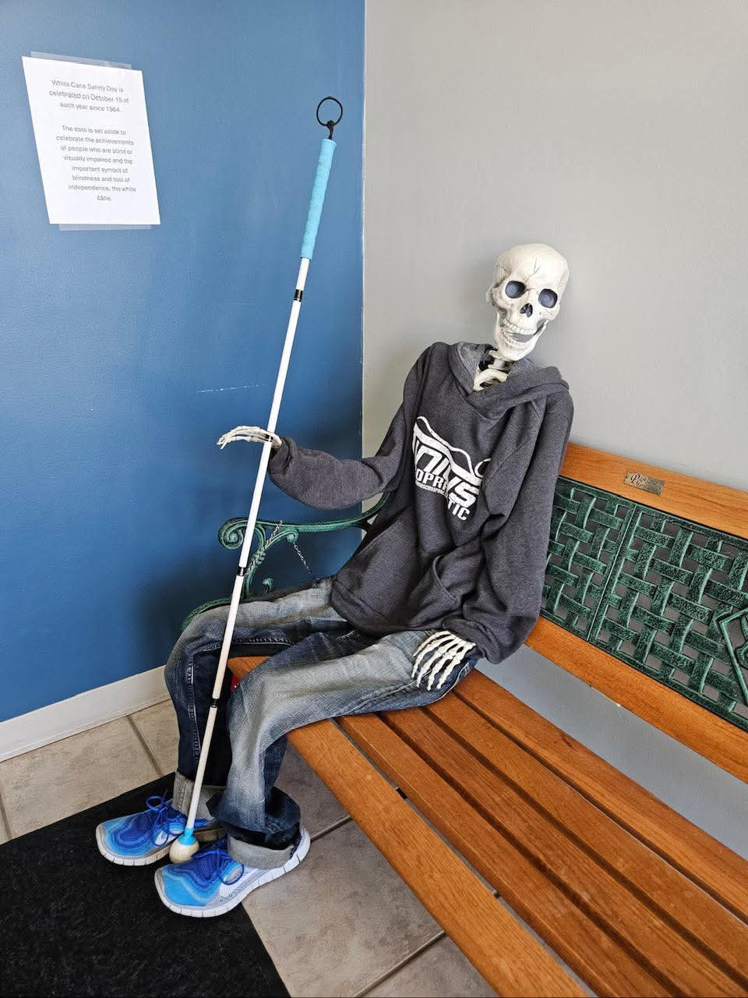
Photo Left: A skeleton dressed in jeans, sweatshirt and tennis shoes sitting on a bench holding a white cane. On the wall is a sign promoting the White Cane Safety Day. (Photo Courtesy of Winter Renfrow)

Let’s celebrate and honor the legacy and future of the white cane, not just on October 15, but every day as we advocate for accessibility and inclusion!

The New Talking Book Player from NLS
by Ralph Smitherman

This is a brief overview about the new player from the National Library Service and my observations.
- The player is sturdy.
- The player’s handle is built-in, which of course makes it easy to carry.
- The direction buttons are easy to read.
- There is a user guide built into the player and it is very helpful.
- There is a key describer mode.
- Tone, volume and speed buttons are easy to find and use. Personally, I like to increase the speaking rate on books I read.
- The Wi-Fi feature is easy to operate, just put in your Wi-Fi code and the player will let you know the connection is successful.
- When you are connected to your Wi-Fi, you can enter your BARD email and your BARD password; once again the player will tell you if you are connected.
- The machine is Bluetooth capable which will allow you to connect a Bluetooth speaker.
- After you are connected to the BARD system, you will use the arrow keys which are prominently displayed. When you find a book to download, press the information key, which is located in the midst of the arrow keys and follow the prompts.
- If you receive books on cartridge, slide the cartridge in the player and the player will tell you the number of books you have on the player. For example, if you have five books on the cartridge and two books you downloaded directly to the player, the player will say you have seven books. As you scroll through the books on the player, it will list them in alphabetical order.
- The adapter cord is separate from the player, and the cord connection is USB. I like that feature because, when you carry the player, the cord does not get in the way.
- There are several voices from which to choose.
- The battery life is sufficient, and you can find the battery status by pressing down and holding the mode key.
- You can plug in a thumb drive that has books on it and the player will acknowledge.

There are many other features within this player, so I encourage you to use the player and enjoy reading!

Affiliates’ Corner

“Low Vision Now” Has Great Speakers
by Glenda Such, M. Ed., President, Low Vision Now

Low Vision Now has had great speakers and will have even more. In September, our speaker was Jule Ann Lieberman, an Assistive Technology Specialist at Tech Owl, the Assistive Technology Access Center at Temple University in Philadelphia. Jule Ann spoke about Tech Owl which is one of the nationwide agencies giving people a chance to try and/or borrow assistive technology for free. During her presentation, we learned about their funding, how they are able to exist in every state, and agency differences that may exist from state to state.

Jule Ann provided in depth information about all aspects of Tech Owl’s services. Some of the services she covered included assessment of someone’s needs, demonstrations of a wide variety of assistive technology which might address their needs, their assistive technology loaning programs, and programs that give certain assistive technology either free of charge or at a greatly reduced price.

Jule Ann also explained eligibility, locations of their satellite offices, services all offices provide, and described the program they have which gives some assistive technology free of charge.

Before ending, Jule Ann offered to assist people to find the agency in their own state.

To find out more about Tech Owl and ways to contact Jule Ann, you can listen to a recording of her presentation.
In addition, you can listen to many of our other previous meetings by doing either of the following:
If viewing this by email, click, tap, or enter on the following link: https://suchasite.com/DVCCLV%20meetings.htm

If viewing this in hard copy, go to our website at: lowvisionnow.org and then go down the page to where it reads: Listen to past meetings and click, tap, or enter on it.

Here is the schedule for the upcoming months:

All events start between 12:45 and 12:55 pm, EST (New York). Presentations are from 1:00 pm to 2:15 pm and the Support Group Session follows the end of the speaker presentation.

November 1, 2025
- Topic: Prevention of Falls for People with Visual Impairment
- Speaker: Steve Kerr, Founder, Fall Prevention Foundation

December 6, 2025
- Topic: What Hadley can offer you
- Speaker: Hadley Institute

January 10, 2026
- Topic: Nutrition
- Speaker: Joni Garcia, private consultant

February 7, 2026
- Topic: Hear what research has been done by the American Foundation for the Blind
- Speaker: Dr. Arielle Silverman, Director of Research, American Foundation for the Blind

March 7, 2026
- Topic: Staying Safe with Technology and Your Information
- Speaker: David Goldfield, Leader in Assistive Technology Field

CCLVI Book Club

November 2025: The Grey Wolf
- Author: Penny, Louise
- Book Number: DB125318
- Reading Time: 14 hours, 23 minutes
- Read by: Louise Penny, Jean Brassard

BARD Description: "The 19th mystery in the #1 New York Times bestselling Armand Gamache series. Relentless phone calls interrupt the peace of a warm August morning in Three Pines. Though the tiny Quâebec village is impossible to find on any map, someone has managed to track down Armand Gamache, head of homicide at the Sãuretâe, as he sits with his wife in their back garden. Reine-Marie watches with increasing unease as her husband refuses to pick up, though he clearly knows who is on the other end. When he finally answers, his rage shatters the calm of their quiet Sunday morning. That's only the first in a sequence of strange events that begin The Grey Wolf, the 19th novel in Louise Penny's #1 New York Times bestselling series. A missing coat, an intruder alarm, a note for Gamache reading "this might interest you", a puzzling scrap of paper with a mysterious list, and then a murder. All propel Chief Inspector Gamache and his team toward a terrible realization. Something much more sinister than any one murder or anyone case is fast approaching. Armand Gamache, Jean-Guy Beauvoir, his son-in-law and second in command, and Inspector Isabelle Lacoste can only trust each other, as old friends begin to act like enemies, and long-time enemies appear to be friends. Determined to track down the threat before it becomes a reality, their pursuit takes them across Quâebec and across borders. Their hunt grows increasingly desperate, even frantic, as the enormity of the creature they're chasing becomes clear. If they fail, the devastating consequences would reach into the largest of cities and the smallest of villages.

December 2025: Christmas Cupcake Murder
- Author: Fluke, Joanne
- Book Number: DB1011401
- Reading Time: 8 hours, 63 minutes
- Narrated by: Suzanne Toren

BARD Description: As December turns Lake Eden into the North Pole, the heat is on in Hannah Swensen's kitchen to honor two Christmas promises: baking irresistible holiday cupcakes and preventing a person who attempted murder from succeeding the second time around! Includes recipes.

January 2026: The First Gentleman: a thriller
- Authors: Clinton, Bill, Patterson, James
- Book Number: DB130125
- Reading Time: 11 hours, 3 minutes
- Narrated by: Collyer, Will, Maarleveld, Saskia, Fouhey, James, King, Aja Naomi

BARD Description: "America has a powerful new president ... And her husband's on trial for murder. Clinton and Patterson are back. And they're better than ever. The President of the United States is up for reelection. Her husband is on trial for murder. Is the First Gentleman a killer? A pair of brilliant investigative journalists set out to answer that burning question about the NFL star-turned-political spouse." From publisher. Unrated. Commercial audiobook.

Please see the Calendar of Events at the end of this publication for meeting information

Latest and Greatest from Scout
by Cheryl McNeil Fisher


Photo Left: A happy golden-colored dog with curly fur, breaks through a torn white paper background. The dog's front paw is extended through the tear, and it has a joyful expression with an open mouth. Above the dog, the text reads "SCOUT'S CORNER" with a rolled-up newspaper icon in the middle. Below the dog, the bold text says "I GOT NEWS!"
Hi Vision Access Friends!

It’s hard to believe fall is here again. Just yesterday I was swimming and having the time of my life in the pool. I know what y’all in the south are thinking: “Well, come on down!” Thanks for the invite but wait until you hear my news!

Speaking of time flying by, it feels like only yesterday when Cheryl and Ed became my people on October 2, 2024. I was so tiny that I curled up in Cheryl’s lap with my head resting on the console for the entire four-hour drive home.

Cheryl slipped a collar on me in the car, but since I’d never worn one before, Ed said, “We don’t need a leash. He’ll be fine. He’ll do his business and head straight to the house.” Ha! That was his first mistake. Then I escaped from my crate within five minutes. It’s been quite the adventure ever since! This fuzzy firecracker bounced, lunged, and pounced at anything and everything that fluttered or flew. So, what’s different now? I can actually focus when I’m on the leash and not fixate on those taunting, twirling leaves. However, all bets are off when I’m running free in the backyard, a canine’s gotta frolic, you know? I go tearing at full speed toward a pile of leaves, hit them nose-first, and flip my head back, sending leaves flying everywhere. Then I hop, twist, and snatch as many leaves in my mouth as possible before pouncing and rolling in the rest of them. Want to play too?

Cheryl continues to recover steadily from her May 19th femoral neck fracture, she says the phrase “broken hip” makes her feel ancient. Thankfully, a couple of epidural injections have provided real relief from the two nerves that were causing pain down her lower back and leg. Although we haven’t been able to take our brisk walks, we had plenty of fun and exercise in the pool until mid-September. And now I have supervised exercise sessions in the backyard every single day. In simpler terms, playtime!

Okay, deep breath… Are you ready for my big news?
Seriously! This is really big!

Freedom Guide Dog School visited us last weekend. Trainer Dave interviewed Cheryl, then took me on a long walk. Cars and trucks passed, lawn mowers roared, and children squealed. Even some dogs tried to get my attention. I just held my head high and sent them a message: “Dudes! Bark all you want. I’m interviewing for an important job!” And no surprise, I aced it!

Cheryl and Ed didn’t bring me home with this purpose in mind. It was the first time they had been dogless. No retired dog and her recent guide had been early released. Cheryl has been a guide dog handler for 30 years and had previously raised a guide dog puppy; she poured all her training into me, Scout. Though I don’t think she’ll ever want another puppy after me! Hmm. Did I tell you that they are ripping up the carpet in their bedroom and putting down hardwood? Yep, another Hmm.

I’ll be attending Freedom Guide Dog Training from late November through early April, when one of the trainers will bring me back to Cheryl and train me in our area as her new guide dog. Pretty awesome, right? I need to pass all my tests and hopefully not get too bored, since I’m a Doodle dog. But I know I’ll be great because I really want this job, and then as Cheryl’s guide dog, I get to go everywhere she goes. No more staying home alone!

Cheryl and Ed won’t be able to visit during training, but I’ll be sure to send an update on how things are going in the next issue. Cheryl and I wish you all a happy holiday season.

Love and happy wags from me, Scout.
And love from our home to yours, Cheryl (and hubby Ed).

Why I’m Walking Across Japan: About My 1,400km (870 miles) Journey
by Tony R. Vega
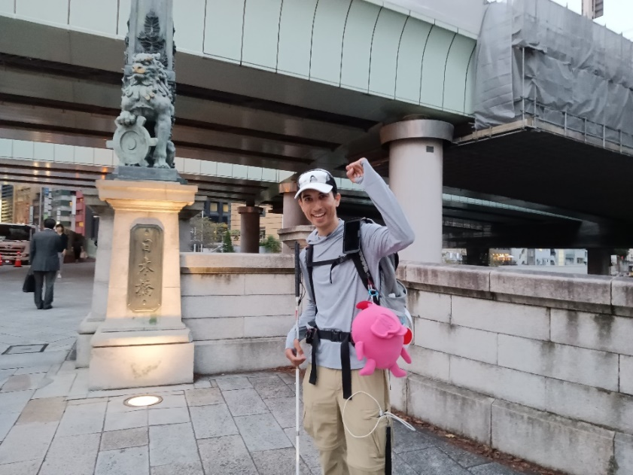
Photo Left: Tony stands beside a stone bridge monument at Nihonbashi in Tokyo, holding a white cane and backpack after walking 500 km from Kyoto at the end of the Tokaido Challenge

In 2023, I decided to do something crazy, something most sane people would never even think to do. I decided to walk Japan's famous Tōkaidō road.

In case you're not aware, the Tōkaidō is one of Japan's most historic and important roads. Literally meaning "East Sea Road," it runs roughly 500 kilometers along the southeastern coast of Japan, connecting the ancient capital of Kyoto in the west to Tokyo in the east. It’s a road with a very long history, but it's most closely associated with the Edo Period, which spanned over two and a half centuries starting in 1603.
During this period, feudal lords were required to make regular visits to Edo (present-day Tokyo). As a result, a network of "post stations" developed along the Tōkaidō, places where travelers could stop, eat, and rest. Between Edo and Kyoto, there were 53 of these post stations. Sadly, most of the old road and its post stations no longer exist in any significant way. Much of the Tōkaidō has been paved over and turned into modern roads. Still, the eastern sea route that connects Kyoto to Tokyo remains one of the most important and heavily trafficked in the country, and it was this road I decided to walk in the fall of 2023.

Before I continue talking about my experiences on the Tōkaidō, and the subsequent 400 km walk I did in 2024, I should share a bit about myself. I am legally blind. I essentially have no central vision. I can't read most street signs, and I miss many of the landmarks sighted people use for navigation. I also have difficulty seeing obstacles on the ground. To get around, I rely on my white cane and Google Maps.

I became legally blind shortly after high school. Up until then, I was fully sighted. I didn’t even need glasses. But within the span of a few weeks, that changed completely. The case of my vision loss was a condition called Leber’s Hereditary Optic Neuropathy, which causes part of the optic nerve to die. There was, and still is, no medical treatment to regenerate nerves, so the doctors could do nothing. I just had to accept the situation and move on with life. Easier said than done.

I’d been interested in Japan for most of my life. In high school, I took Japanese classes and dreamed of studying abroad. But, after losing my vision, I gave up hope. I didn’t think I’d ever make it to Japan. I lost confidence. I genuinely thought I had to give up on my dream.

Eventually, I studied more Japanese. I asked my teacher about studying abroad, and then I did it. I went to Osaka for a year during college. It was an incredible experience. I improved my language skills, learned so much about Japan, and proved to myself that I was still capable of living independently and pursuing my dreams. Ever since then, both my education and career have focused on Japan, and I’ve continued to challenge myself. Which brings me back to my Tōkaidō walk in 2023.

So why did I decide to walk the Tōkaidō in 2023?
After several years as editor-in-chief at a magazine here in Hawaii, the company closed, and I transitioned into full-time content creation and freelance work. In the summer of 2023, I was looking for something unique, something fun that would appeal to both the English-speaking audience of my Japan-focused podcast and my Japanese-speaking followers on X (formerly Twitter). I wanted to do something bold and inspired by my love for Japan. That’s when I came up with the idea to walk the Tōkaidō.

Not only would it be interesting for both Japanese and non-Japanese audiences, but it would also be a way to raise awareness for the blind and visually impaired. I knew walking 500 km across Japan wouldn’t be easy. I would have to traverse rural areas, mountains, and poorly maintained roads, relying only on Google Maps, my white cane, and the kindness of strangers. But, if I documented my journey in real time, I could show that, yes, the visually impaired face many challenges, but with the right tools and persistence, we can overcome them and achieve incredible things.

To be honest, the idea of walking across Japan by myself, with nothing but a cane and Google Maps, was terrifying. But I figured that once I was on the road, I’d find a way to make it work. For me, the bigger problem was how I was going to fund all of this. A flight to Japan, a month in hotels, equipment, transportation within Japan, food, and more, would cost a minimum of $5,000.

The only way I was going to be able to afford to do this was if I could get sponsors to support me. In the end, it was the Hawaii Association of the Blind that stepped up and made the journey possible. They became my sponsor and for that I am eternally grateful.

My walk began in late September 2023. It was lightly raining when I set out from Sanjō Ōhashi, a famous bridge in Kyoto that marks the end of the Tōkaidō. I started there instead of Tokyo simply because, logistically, it made more sense for me.

That first day turned out to be one of the most memorable, and funniest, of the whole trip. Google Maps guided me into a tunnel meant for cars. I didn’t know pedestrians weren’t allowed, so I just went through it. Cars zoomed past me, inches away. It was terrifying.

Around 10 or 15 minutes after I made it through the tunnel, I was stopped by two police officers. They asked if I had walked through the tunnel. I said yes and asked if I wasn’t supposed to. Thankfully, I speak Japanese, so communication wasn’t an issue. They explained the rules, took notes, asked about my white cane, radioed in my name, and then let me go with a reminder to be careful. This wouldn’t be the last time I had an encounter with the police on one of my walks, but every time, once I explained that I was visually impaired and using Google Maps, they were understanding.
Speaking of Google Maps, it's amazing, and I couldn’t have done the walk without it, but it also got me lost more times than I can remember. Sometimes, it bugged out or sent me down the wrong path. Once, it even tried to guide me onto an actual highway. That time, too, someone called the police. Again, they were understanding when I explained my situation.

I got lost nearly every day, often multiple times in a single day. Sometimes it was user error on my part. Other times, Google Maps would take me down very confusing paths. A few times it even tried to get me to go down roads that didn’t exist. One day, I was in a rural area and stuck for nearly an hour. No people around, just rice fields. I heard a machine in the distance and called out, hoping someone would hear me. A farmer eventually came over, and after I explained where I was going, he carefully gave me directions. Turns out, there was a small road neither I nor Google Maps had noticed. Still, I made it to my destination that day.

Throughout the trip, I posted videos and photos to my X account. Some were lighthearted, while others shared my frustrations. For example, one unpleasant experience I shared was the night I was unable to get dinner. I ended up staying in a somewhat isolated and overpriced hotel because there was a major event at the nearby racetrack that weekend, and every hotel room that was remotely convenient or affordable was fully booked. After one of my longest days of walking, I took a taxi from the nearest train station to the hotel, hoping there would be a place to eat inside or nearby. But when I arrived, I realized there wasn’t anything in the immediate vicinity. To make things worse, the area wasn’t well lit, and being tired and uncomfortable walking in the dark in an unfamiliar place, I decided it was best to go without dinner. Instead, I ate a few small snacks a friend had given me days earlier in Kyoto. In the grand scheme of things, it wasn’t a huge deal, but, in that moment, I definitely felt frustrated with myself for not preparing better. Despite that, I shot a video in which I talked about the experience and shared it with my followers on X. Sharing these moments helped me process them. In a way, it helped keep me positive because even if I had to go through uncomfortable situations, I knew that by sharing them, I might be able to educate and inspire others.

Toward the end of the trip, I had what was by far one of my most negative experiences in Japan. After another day of walking, I was on the train heading back to my hotel, using my phone with maximum magnification, holding it up to my nose. Not ideal, but it works for me. When I got off the train, a man confronted me. He accused me of faking blindness. He said if I could use my phone, I shouldn’t have a white cane. I tried to explain that the white cane doesn’t mean someone is totally blind, it signals a visual impairment. But he wouldn’t listen and walked away. I want to be clear: I've lived in Japan and spent a lot of time here. This was the only time I’ve encountered someone like that. Japanese people are generally very respectful, and I’ve met so many kind individuals during my trips. This man was an exception.

Still, I saw it as a chance to educate. I made a video about the incident and explained what the white cane is, and how it isn’t only for those who are totally blind. That post received over 10,000 views and many kind comments.

After about a month, I reached my destination: Nihonbashi Bridge in Tokyo. To my surprise, a group of friends was waiting for me. I recorded a video, thanked everyone, and yes, I teared up. I had done it.

Now, full disclosure: I skipped three parts of the route, mountain passes that would have been too dangerous for me to tackle alone. But, considering how often I got lost, I probably made up the distance in detours anyway!

The final video I posted announcing that I had completed the walk went somewhat viral, getting tens of thousands of views. After returning to the U.S., I did a few podcast interviews, released a video series about the journey, talked about it on my own podcast, and gave a speech at the Hawaii Association of the Blind’s 2024 state convention (available on YouTube). After something big like that, you naturally ask, “What’s next?”

Photo Left: Tony at Sanjo Bridge, the starting point of the Miyajima Challenge. Behind Tony are water, green riverbanks, and buildings under a blue sky.

For me, it was another walk. In fall 2024, I embarked on what I called the Miyajima Challenge, the continuation of my Tōkaidō Challenge. This time, I walked from Kyoto to Miyajima, a picturesque island in Hiroshima Prefecture, about 400 km (248 miles) to the west. It's famous for its “floating” Torii gate, one of the most iconic sights in Japan.

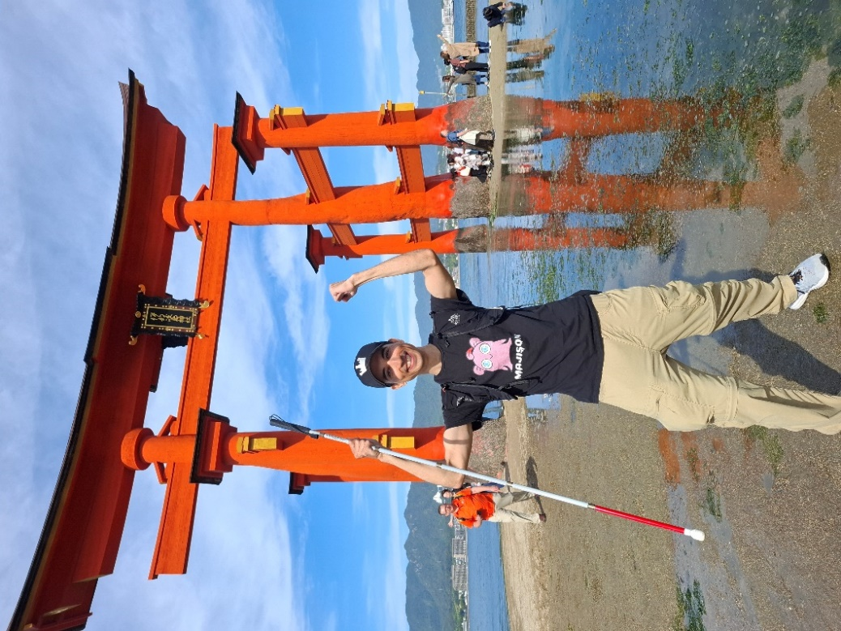
Photo Left: Tony stands in front of a large, bright red, famous Torii gate on the island of Miyajima. He’s holding a white cane and raising his left fist in the air. The ground is wet, reflecting the vibrant gate and people nearby.

Much like the first time, I faced many challenges: getting lost, being stopped by police, walking through very rural areas. One particularly memorable moment was when I had to hitchhike in Okayama Prefecture. I was stuck on one side of a rural highway with no safe crossing and no train stations or stores nearby. To make things worse, it was late in the day and starting to get dark. After trying everything I could to get out of the area, I decided to try hitchhiking. I don’t remember how long it took, but I suspect it was close to an hour. Thankfully, a kind man eventually stopped and, after hearing my situation, offered to drive me, not just to a nearby station, but all the way to my hotel 20 to 30 km away. I later learned the area gets cold at night and is home to wild animals, including boars, so spending the night out there definitely wouldn’t have been safe.

Once again, I documented the walk, this time on both X and Instagram. And once again, I had sponsors who helped fund the roughly month-long trip.

Now, I’m preparing for my third walk: the Kyūshū Challenge. It will start in Iwakuni, about 20 km west of Miyajima, and stretch over 500 km to Kagoshima at the southern end of mainland Japan. If time permits, I’ll try to reach Cape Sata, the southernmost point of mainland Japan. I’ll document the journey on X and Instagram, and the goal remains the same: to raise awareness about the blind and visually impaired, and to show what we’re capable of when given the right tools and opportunities.

As for funding: I’m currently seeking sponsors. So far, I’ve raised $2,600 and secured phone and internet service from the telecommunications company Mobal. But I need at very least $4,000 to cover basic costs. Still, I’m determined to do it.

If you'd like to follow my journey, you can find me on Instagram at @tonyrvega and please visit my website: www.tonyrvega.com.

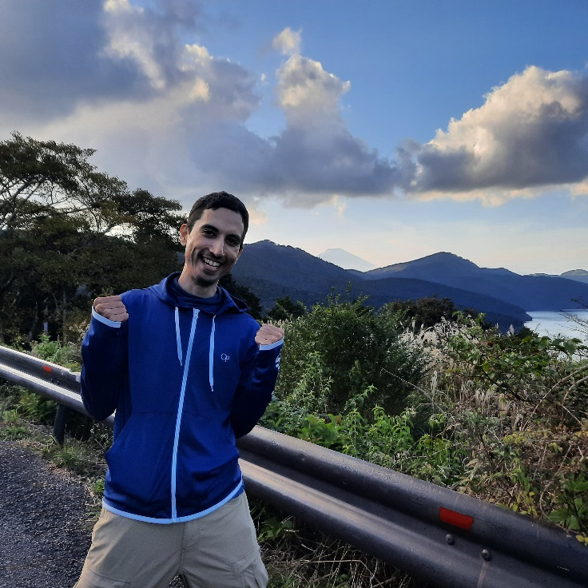
Photo Top Left: Tony smiles with fists raised on a mountain road in Hakone, with Mt. Fuji faintly visible in the background under a partly cloudy sky.


Photo Left: Tony takes a selfie at Fukuyama Castle in Hiroshima. The castle features white walls and ornate, tiled roofs.

Sweet & Simple: How to Make a Candy Wreath
by Cheryl McNeil Fisher

Looking for a festive, fun, and shareable project? A candy wreath makes a cheerful decoration and a delightful gift. The best part is you can make one with items you have at home or with a few simple supplies from the craft store.

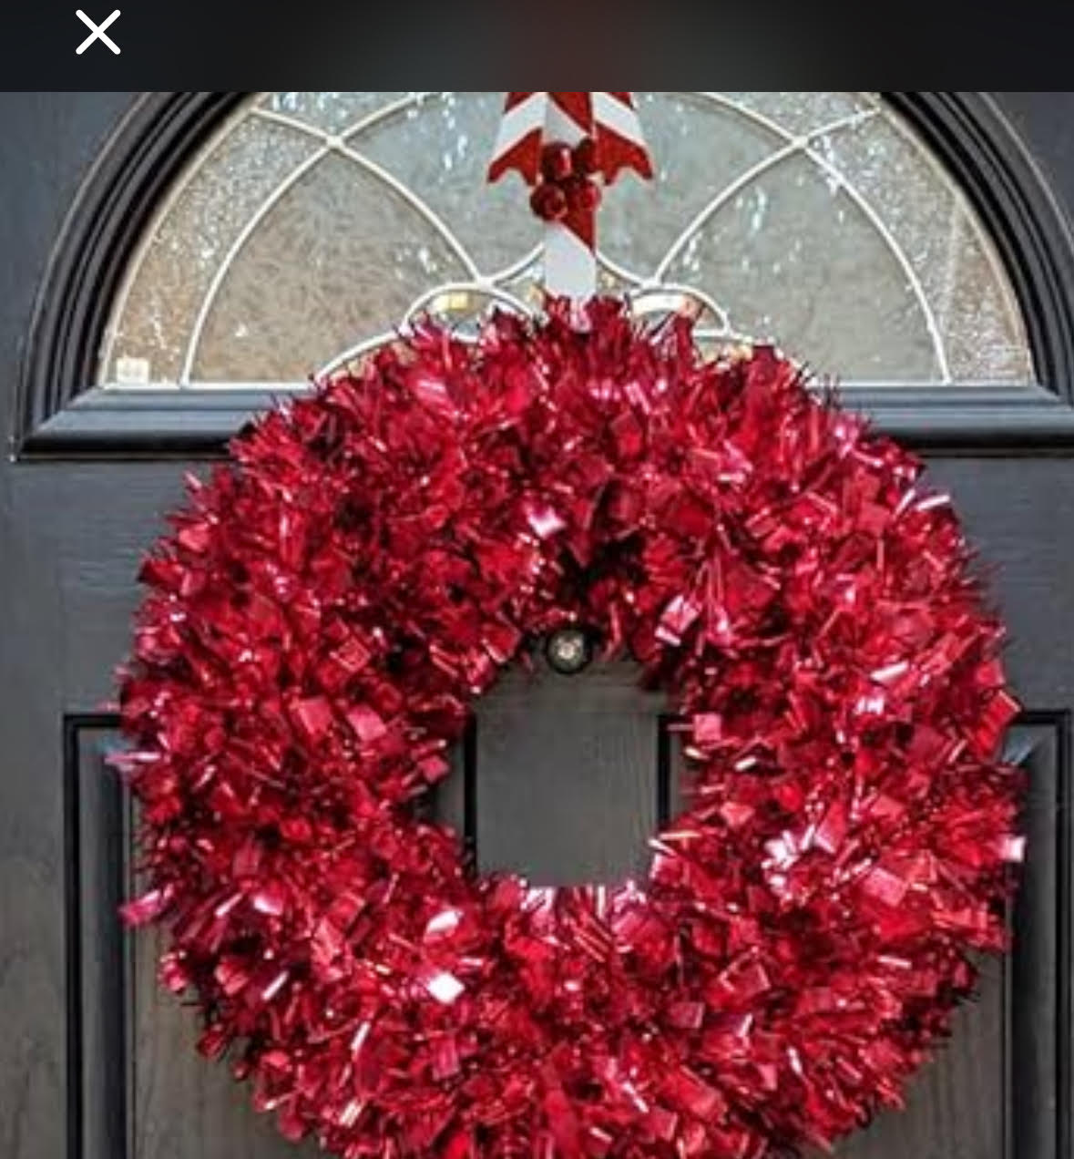



Photos Above: Examples of candy wreaths (Courtesy of Patti Cox and Cheryl McNeil Fisher)

Below are three easy methods: a wire hanger, a purchased wire wreath form, or a foam wreath base. Choose the one that fits your style (and budget), then get creative with candy colors and decorations.

Supplies You’ll Need:
- Wrapped candies (peppermints, chocolates, toffees, lollipops, or candy canes work best)
- Pipe cleaners, twist ties, or zip ties
- Ribbon for wrapping or bows
- One of these bases: wire hanger, wire wreath form, or foam wreath
- Pins (for foam method)
- Scissors

Tip: Always secure candy by the twisted ends of the wrapper or pin over the tail. Never pierce the sealed part of the wrapper.

Method 1: Wire Hanger Wreath - Budget-friendly and Sturdy
1. Shape the hanger: Bend the bottom of a wire hanger into a circle. Keep the hook for hanging.
2. Wrap (optional): Cover the wire with ribbon to make it easier to attach candies.
3. Bundle candies: Hold 2 to 3 candies together by the wrapper ends.
4. Attach: Use a pipe cleaner or twist tie to secure the bundle to the hanger.
5. Fill the wreath: Continue until the circle is complete. Angle candies in different directions for fullness.
6. Finish: Add a bow at the top or bottom.

Variation: For a holiday touch, add mini ornaments, silk greenery, or candy canes tied with ribbon.

Method 2: Wire Wreath Form - Great for a Professional Look
1. Choose a form: Craft stores sell 12” to 16” wire wreath forms with several rings.
2. Optional base: Wrap with ribbon or add loops of deco mesh for volume.
3. Make bundles: Gather 2 to 3 candies and line up the wrapper ends.
4. Attach: Tie bundles across two rings or to a crossbar with pipe cleaners or zip ties.
5. Layer: Work around the wreath, alternating inner and outer edges for depth.
6. Finish: Add a bow or themed accents.

Variation: Wrap candies in cellophane squares before attaching for a glossy, gift-wrapped look.

Method 3: Foam Wreath Base - Dense and Polished
1. Wrap the base: Cover the foam with ribbon so pins hold firmly.
2. Attach candies: Pin through the wrapper tails, overlapping candies like shingles.
3. Fill edges: Cover the inner and outer edges for a neat, full look.
4. Finish: Add a bow and a ribbon loop for hanging.

Variation: Create “elastic belts” around the foam and tuck candies underneath. This makes it easy to refill later.

Decorating Ideas
- Monochrome: All red or all gold candies for an elegant style.
- Rainbow: Arrange candies in color bands.
- Holiday: Add candy canes, ornaments, or greenery.
- Kid-friendly: Use only twist ties, skip pins and glue.

More Ways to Use Candy Wreaths
Candy wreaths don’t have to stay on the wall; they also make wonderful centerpieces. Try one of these ideas:
- Mason jar magic: Place a jar filled with tulle and Hershey’s Kisses in the center of the wreath.
- Light it up: Add battery-operated fairy lights inside a mason jar for a glowing display.
- Candle charm: Set a large candle in the middle for simple, elegant decoration.
- Mini tree delight: Place a small foam cone or a mini Christmas tree in the center and decorate it with candies, tiny ornaments, and ribbon. (I especially love adding extra ribbons for color and texture!)

You can attach candies using Scotch tape, double-sided tape, or even an Elmer’s glue stick, always on the wrappers, never directly on the candy itself.

Display & Storage
Hang your wreath on a sturdy hook or door hanger. For gifting, wrap it in clear cellophane and tie with ribbon. Store in a cool, dry place, especially if you use chocolate.

Holiday Recipes: 1. Citrus and Spice Cranberry Sauce
by Debra Erickson (from The Blind Kitchen)

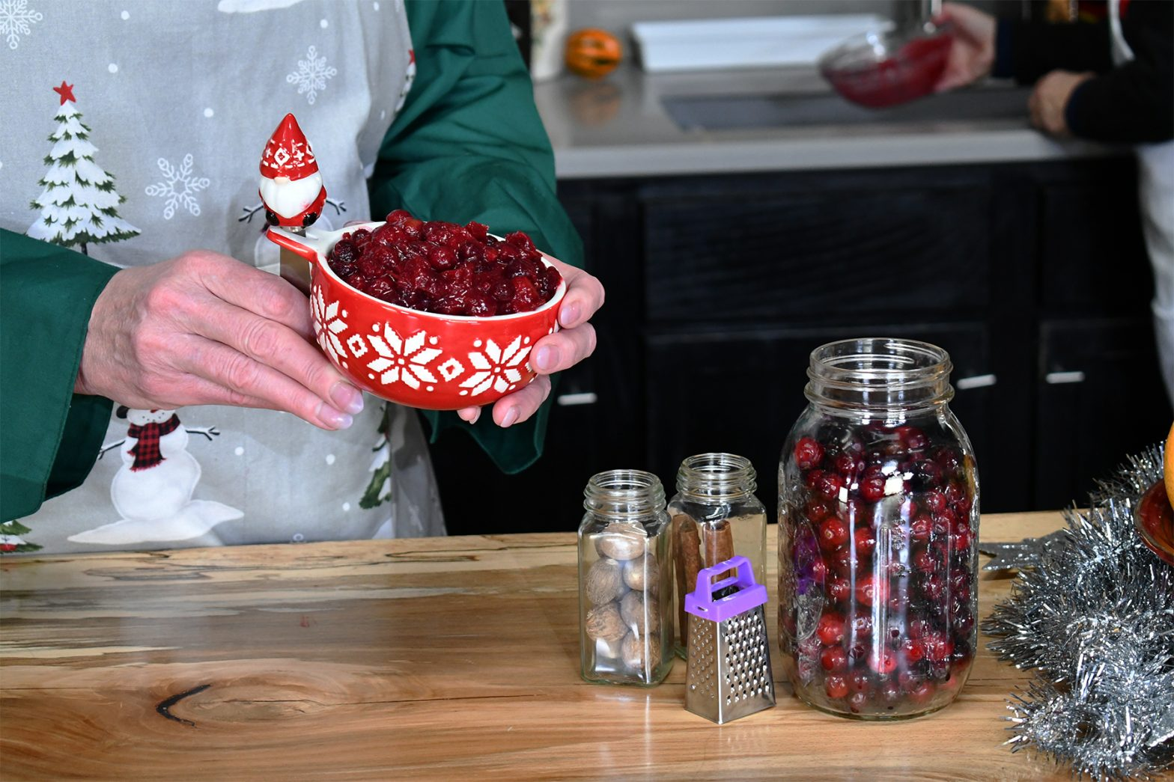
This delicious cranberry sauce and relish comes together quickly. It can be made up to a week in advance and stored in the refrigerator in a sealed container.

Yield: About 5 cups. If serving size is 2 tablespoons, it will feed up to 40 people.

This recipe has 3 sections:
- Zest and juice citrus
- Peel, core and chop apple
- Cook and allow to cool.
Ingredients:
2 12-ounce bags fresh whole cranberries (24-ounces in total)
2 cups granulated sugar
1/2 cup brown sugar
2 Granny Smith apples
1 orange
1 lemon
1 small grapefruit
1 lime
1 cinnamon stick or 1 1/2 teaspoon ground cinnamon.
1/2 teaspoon salt
1/2 teaspoon allspice
1/4 teaspoon nutmeg

Instructions:
Step 1: Zest and juice lemon, lime, orange and grapefruit.

Note: Because fruit sizes vary, you should have about one teaspoon of zest from each fruit for a total of 4 teaspoons of combined zest. You should get about 2 tablespoons of juice from each fruit for a combined 1/2 cup of juice.

Step 2: Peel, core and cut the apples into small pieces. Place in a bowl of water to prevent oxidation.

Step 3: In a heavy bottom pan over medium low heat, cook cranberries, granulated sugar, brown sugar and 1 1/2 cups of water for about 5 minutes or until you hear the cranberries breaking their skins in the pan.

Step 4: Add the apple pieces and stir for 2 more minutes until well mixed.
Step 5: Add the juices and zests and cook, stirring constantly.
Step 6: Add the cinnamon stick or ground cinnamon, ground allspice, nutmeg and salt; stir well

Step 7: Cook, stirring constantly 15 more minutes until mixture is thick and hot. Remove pan from the heat source and let cool.

Holiday Recipes: 2. Gourmet Green Bean Casserole
by Debra Erickson (from The Blind Kitchen)
Photo Above: Chef Debra’s Gourmet Green Bean Casserole coming out of the oven

Ingredients:
1 1/2 pounds fresh green beans
4 tablespoons butter
1 large or 2 small shallots
1/2 red bell pepper
12 ounces fresh mushrooms
1 teaspoon black pepper
1/4 teaspoon nutmeg
1 teaspoon Worcestershire sauce
1 teaspoon soy sauce
2 large cloves of garlic (or 4 small) grated
Dash of cayenne (optional)
4 tablespoons flour
1 1/2 cup vegetable broth
1/2 cup half and half
1/2 cup grated Gruyere cheese
2 cups Crispy Onion Strings (link to recipe on theblindkitchen.com)

Instructions:
Step 1: Cut and measure all of the ingredients before you start to cook. Some are added quickly, one after the other (for example, the vegetable stock to the flour/butter roux). A delay in measuring the stock can result in the roux being cooked too long and losing some of its thickening power.

Step 2: The same goes for sauteing the fresh vegetables: they are added in a relatively quick orderly sequence and if you are slicing the mushrooms, the diced shallots being cooked in the pan will probably burn before you can finish. I like a well-planned “mise en place” which translates to “everything in its place” and is my mantra for a more relaxed cooking experience.

Step 3: Arrange all ingredients on a work tray before you start to cook.

Step 4: Fill a sink with hot soapy water for quick immersion of your hands (learn more about this cooking tip in “Start with soapy hot water” article on The Blind Kitchen website and use a towel clip to keep a clean cloth handy at all times.

Step 5: Use a salad spinner to plunge your green beans after they are steamed. It works as a drainer and you can give them a quick spin to dry them further so that the delicious white sauce is in their nooks and crannies, not flavorless water.

Step 6: Rinse 1 and one-half pounds of fresh green beans, trim the ends and cut in half, or into 2 to 3-inch pieces. Set aside.

Step 7: Clean and thickly slice 12 ounces of mushrooms.

Step 8: Peel and fine dice 2 small or one large shallot. Set aside.

Step 9: Clean, deseed, and medium dice one-half red bell pepper.

Step 10: Peel and grate 2 large cloves of garlic or 3 small cloves.

Step 11: Grate one-half cup of Gruyere cheese.

Step 12: Par cook the green beans.
Step 13: Steam the green beans for 3 to 4 minutes to start the cooking process. They should be a bit softer than raw, but still be a bit crispy. They will cook more later. Immediately plunge them into an ice bath to stop the cooking and retain their color. Drain and set aside.

Step 14: In the same (now empty) pan, over medium heat, add 2 tablespoons of olive oil after you know that the pan is hot. Use your finger to quickly “tap” the top rim of the pan. If the top of the pan is hot, you can be sure that the bottom of the pan is hot too. This “tap” movement also helps you to know exactly where the pan is and if it is centered on the burner. The secret to not getting burned is to tap quickly and pull the finger back immediately.

Step 15: Sauté the diced shallots, diced red bell peppers, and sliced mushrooms for 4 to six minutes. You should just barely hear it sizzling.
Step 16: Add in the grated garlic and cook for one minute more. Remove all from the pan and set aside. Do not clean the pan.

Step 17: Make a roux-based white sauce. In the same pan melt 4 tablespoons of butter over medium heat. You should just barely hear it sizzling. Use the whisk to check if the butter is fully melted. The smell of the butter will change to a “nutty” aroma. That is a good thing.
Step 18: Add 4 tablespoons of flour to the melted butter and whisk constantly.
Step 19: Cook and whisk constantly for 2 to 3 minutes until well combined and the raw flour smell is cooked out.

Step 20: Add 1 1/2 cup vegetable broth and continue to whisk for 4 minutes. Whisk constantly to avoid lumps from forming. The flour wants to stick together, but if you whisk it well, you will coat each grain with slippery butter and it will not be able to stick together. Remove pan from heat.

Step 21: Add the following to the cooling pan:
- 1 teaspoon Worcestershire sauce
- 1 teaspoon soy sauce
- 1 teaspoon black pepper
- 1/4 teaspoon nutmeg
Step 22: Stir until well combined.
Step 23: Add in par-cooked green beans.
Step 24: Add 1/2 cup half and half. You do this while the pan is off the heat to prevent curdling or the cream from separating, commonly referred to as a “broken sauce”. No broken sauces in The Blind Kitchen!

Step 25: Put the pan back on the stove over medium heat stirring gently and constantly. Cook for about 5 minutes until well mixed and hot. You do not want it to boil. Remove from heat.

Step 26: Preheat the oven to 350 degrees.

Step 27: Grease an 8 to 12 cup oven-safe dish with butter or oil.
Step 28: Add one-half of the Crispy Onion Strings to the mixture cooling in the pan and mix gently.

Step 29: Pour the mixture into the oven-safe baking dish and spread to an even layer. Do not press it down firmly so that the heat can circulate through as much of the food as possible.

Step 30: Bake at 350 degrees for 25 minutes until the bean mixture is hot and bubbling. Remove from the oven.

Step 31: Sprinkle the grated Gruyere cheese on top

Step 32: Sprinkle the remaining Crispy Onion Strips over the bean mixture. Do not stir. They will brown on the top.

Step 33: Put the dish into the oven under the broiler for three to four minutes until the onions are sizzling and become crispy brown. Stay near the oven as it broils. You will hear them begin to sizzle and they will soon begin to smell more cooked. Once you hear them sizzle, they will start to burn in minutes so remove them soon after you hear the sound; you have about 30 seconds

Step 34: Remove from oven and cool for 10 minute.

TheBlindKitchen.com offers adaptive tools, helpful strategies, and specialized knowledge to blind and visually impaired people who want to cook safely, confidently, and independently. Our collections are available online as are our short instructional videos. Shipping is always free!
Everyone has a place at the table in The Blind Kitchen!

Calendar of Events
Everyone is welcome to attend these events by accessing the Zoom mobile app, visiting the Zoom website at https://zoom.us or calling 312 - 626 - 6799, and entering the appropriate meeting ID and passcode.

Subscribe to our CCLVI-Info email list to receive weekly meeting reminders and Zoom details by sending a blank email to cclvi-info+subscribe@acblists.org In addition, all CCLVI events, except our business meetings, are listed on the ACB Community Call schedule. Those without email can access that information by calling 800 – 424 - 8666 and following the prompts or typing acb.community into your web browser.

All Monday and Thursday Zoom Events have the same Zoom link, Meeting ID, and Passcode.

CCLVI Low Vision Discussion – Friends and Family
First Monday at 8:00 PM ET

CCLVI Game Night
Second and fourth Mondays at 8:00 PM ET

CCLVI Low Vision Peer Support Group
Third Monday at 8:00 PM ET
CCLVI Speaker or Themed chat - Fifth Monday at 8:00 PM ET

CCLVI Board of Directors Meeting
Second Tuesday at 8:30 PM ET
Meeting ID: 829 0433 3824
Passcode: 784688

CCLVI Let’s Talk Low Vision
First Thursday at 8:00 PM ET
Join our guests for this monthly informative program
Also broadcasted on ACB Media 1
The podcast of the episodes can be found at: https://www.cclvi.org/LetsTalkLowVision

CCLVI Table Talk Thursday
Second, fourth, and fifth Thursdays at 8:00 PM ET
Weekly calls on a variety of topics related to low vision

CCLVI Monthly Book Chat
Third Thursday at 8:00 PM ET

CCLVI Affiliate Zoom Calls

California Council of Citizens with Low Vision (CCCLV) – A Sunday Chat
First and Third Sunday at 7:00 PM ET
Spend part of your Sunday with members of CCCLV and enjoy “A Sunday Chat”. This is a call for those of us who are blind or with low vision and any family and friends, be they near or far. Topics will range from all things low vision to life in general as a person who is blind or low vision.

Low Vision Now (formerly Delaware Valley Council of Citizens with Low Vision)
First Saturday at 12:45 PM ET (Second in July and Sept.)
The monthly Zoom meeting Low Vision Now is open to all who have an interest in the issues of low vision.
Meeting ID: 440 465 3663
Passcode: 2121

Kentucky Council of Citizens with Low Vision (KCCLV) - Low Vision Support Calls
First Wednesday at 8:00 PM ET: Business Meeting
Third Wednesday at 8:00 PM ET: Informative meetings for low vision individuals across the US
Meeting ID: 862 9889 6972
Passcode: 975864

Note: Topics and speakers are subject to change. Please reference the weekly CCLVI emails and ACB Community Call schedule.

Join CCLVI’s Email Lists

CCLVI-Info Email List:
This is a two-way list for members and non-members of CCLVI. Its purpose is to publish the weekly schedule of CCLVI events, and to provide a place where subscribers can ask questions about low vision. To Join: Send a blank email to cclvi-info+subscribe@acblists.org

CCLVI-Members-Only Email List:
This Is a one-way list that contains information and announcements of the annual business meeting, monthly board meetings, minutes of these meetings, constitutional amendments, resolutions, and other items that members need to vote on. To Join: You will be added to this list when your annual membership dues are received. If you unsubscribe, you will not receive important information about CCLVI.

CCLVI-Vision-Access Email List:
This is a one-way list where members receive our newsletter, Vision Access. If you unsubscribe, you will no longer receive our publication and you will miss out on some interesting and informative articles. To Join: You will be added to this list when your annual membership dues are received.
VISION ACCESS is published four times a year (February 15, May 15, August 15, and November 15) in large print and email.

Vision Access welcomes submissions from people with low vision, from professionals such as ophthalmologists, optometrists, low vision specialists, and everyone with something substantive to contribute to the ongoing discussion of low vision and all of its ramifications. Submission deadlines are January 15, April 15, July 15, and October 15. Send contributions to CCLVIVisionAccess@gmail.com

Accessing Vision Access
Vision Access is available to CCLVI members via email and large print. Archived and podcasted issues are available at www.cclvi.org/VisionAccess

Contact CCLVI
Council of Citizens with Low Vision International
Address: 5401 Southern Parkway Louisville, KY 40214
Call CCLVI: (502) 905 – 0869 between 9am and 9pm ET
Email: lowvisionoutreach@gmail.com
Website: www.cclvi.org

CCLVI Officers and Directors

OFFICERS  President - Patti Cox  2024-2026  1st Vice President -  Zelda Gebhard 2025-2026  2nd Vice President -  Terry Pacheco 2024-2026  Secretary - Melanie Sinohui  2024-2026  Treasurer - Debbie Persons  2025-2027  Immediate Past President -  Leslie Spoone  Publications Chair  Melanie Sinohui | DIRECTORS  #1 Joyce Feinberg  2025-2027  #2 Kathy Farina  2024-2026  #3 Cynthia Hawkins  2025-2027  #4 Paul Lewis  2024-2026  #5 Dianna Leonard  2025-2027  #6 Donna Williams  2024-2026  Webmaster  Joyce Feinberg

