
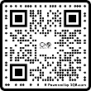
Council of Citizens with Low Vision
Vision Access
Volume 32 - Number 1
February 2025
Vision Access | Vol. 32 – No. 1 | February 2025

Table of Contents

President’s Message 3
Membership Renewal Reminder 4
2025 CCLVI Election Announcement 5
Let’s Say Thank You 5
CCLVI Scheigert Scholarships 2025/2026 7
The Genensky/Foley Magnification Award Application Period Opens Soon 8
2025 DKM First-Timers and JPMorgan Chase Leadership Fellows Awards 9
Registration is Now Open for the D.C. Leadership Conference! 12
Constitution, Bylaws & Resolutions Committee (CBL/R) Update 14
Affiliates’ Corner 16
CCCLVI Book Club 22
Monthly Zoom Events 23
Emergency Preparedness 25
Making the Decision: A Guide Dog Journey 31
The Kitchen Corner 34
Message from Scout: Meta Glasses and Be My Eyes 40
Why is Vision Rehabilitation Necessary 44
Convenience Meets Sophistication: Where Style Meets Accessibility 47
Calendar of Events 52
Join CCLVI’s Email Lists 56
Contact CCLVI 57

Logo Description from Front Cover
The CCLVI logo - A pair of glasses. One eye which has been replaced with a globe and the other depicting a cross section of an eye pointed at the globe. The glasses themselves depict an image of an infinity symbol.

President’s Message
by Patti Cox

Dear CCLVI Members,

The CCLVI Board has decided to rebrand our organization. One reason is that almost everything has moved online, and most forms only allow 40 characters per field. We would like this proposal to be brought to the membership at our 2025 annual meeting.

Several ideas are being discussed by the CCLVI Board:
- Lessen the number of characters in our name.
- Incorporate ACB into our name because CCLVI is an ACB affiliate.
- Change the logo to incorporate the new name.

How can you as members help with this project? You can suggest names for the organization and a logo. You do not have to suggest both. You can submit multiple entries! All suggestions will be considered. Please send your suggestion(s) by March 31, 2025 to cclvivisionaccess@gmail.com or call 502-905-0869.

The rebranding team looks forward to your input!

Membership Renewal Reminder
by Zelda Gebhard, Chair, Membership Committee

Please pay your dues by March 1. If you are an At-Large member, complete and mail your renewal form and check for $15 to CCLVI, 5401 Southern Pkwy, Louisville, KY 40214.

At-Large members have an option to renew online by completing the form at https://cclvi.info/join/member-form/ and paying at https://cclvi.info/join/pay2022/
Members of CCLVI affiliates will pay their affiliate representative directly.

Life Members need not pay dues, but we ask you to call 701-709-0262 to update your information.

If you have any questions or would like assistance, please contact Zelda Gebhard at the above number or at cclvimembership@gmail.com.

Renew your CCLVI membership and help us thrive in 25.

2025 CCLVI Election Announcement
by Leslie Spoone, Chair, Nominating Committee

Hi CCLVI Family,

Happy New Year! If you are interested in running for an office or a board director position, please contact Leslie Spoone at lesliespoone@cfl.rr.com or call 407-678-4163 by April 1, 2025.

The Positions that are up for nomination are:
- First Vice President
- Treasurer
- Three Board of Directors Seats

Let’s Say Thank You
by CCLVI Awards Committee

Where would any organization be without volunteers? They give freely of their time, talents, and resources. They are selfless, loyal, and supportive. That is why we need to recognize and acknowledge their efforts.

CCLVI has always appreciated its volunteers. However, formal recognition in the form of an awards program began with board approval in November 2021.

The two awards include the Bernice Kandarian Service Award and the Friends of CCLVI Award. See below for the purpose and criteria for both awards.

Bernice Kandarian Service Award:
The purpose of this award is to provide acknowledgement of a member who demonstrates exceptional service to our organization. it may be awarded annually. That member will be recognized for long-term service to CCLVI according to the following criteria:
- Years of membership;
- Offices and other elected leadership positions held;
- Service as chairperson or active member of a standing committee; and
- Overall donation of time and talent to the organization.

Friend of CCLVI Award:
The purpose of this award is to acknowledge an individual, organization, or business outside the organization (not a CCLVI member) who has been supportive of our members, programs, or generalized support of our organization. it may be awarded annually to an individual, business or organization who has made an exceptional impact. Criteria includes:
- Description of the individual, organization, or business;
- Supportive connection to CCLVI, our members, or programs; and
- Extraordinary service rendered or impact made.

Nomination Process
Any dues-paying member may submit nominations for either award. Please send a nomination letter to cclvimembership@gmail.com by April 1, 2025

Thank you for helping us acknowledge and recognize those who have made a positive impact.

CCLVI Scheigert Scholarships 2025/2026
by CCLVI Scheigert Scholarship Committee

The Council of Citizens with Low Vision International (CCLVI) annually awards four scholarships in the amount of $3,000 each to fulltime college students. Scholarships are awarded to Freshman, Undergraduate, and Graduate students. All of whom must be low vision, maintain a strong GPA and be involved in school/local community activities.
Application materials must be received by 11:59 pm Eastern Time February 15, 2025. Scholarship monies will be awarded for the 2025 -2026 academic year. To access the guidelines and application, visit http://cclvi.org and click on the Scholarships link.

Applications will be available to complete and submit online from January 1, 2025 to the February 15 deadline. Questions may be directed to 844-460-0625. Incomplete applications will not be considered.

We look forward to receiving your application materials.

The Genensky/Foley Magnification Award Application Period Opens Soon
by Donna Williams, Chair, Genensky/Foley Committee

Coming in March!

Starting on March 1 you can apply for The Samuel Genensky/Carl Foley Magnification Award.

This annual award is in honor of Samuel Genensky, an innovator in low vision technology who was the founding president of CCLVI, and Carl Foley, a very caring distributor of magnification devices, who attended many ACB conventions and took great care in providing the correct magnification device for each person he served.

This year CCLVI is obtaining various magnification devices to be awarded to the winners. To be considered for this award, applicants must have low vision, and need the device to magnify print for educational, work, or independent living purposes.

Applications are being accepted from Saturday, March 1st through Tuesday, April 15th 11:59pm Eastern Time. For more information, or to apply, please visit the Genensky
/Foley Award Web Page at: https://cclvi.info/magnifier/ Please note: the updated page will not be available until March 1, 2025.

2025 DKM First-Timers and JPMorgan Chase Leadership Fellows Awards
by Durward K. McDaniel Fund Committee

If you’re looking to take a positive step in your leadership journey or if you’re a leader looking to experience a higher level of responsibility, connection, and achievement, the following opportunities might be just for you.
The Durward K. McDaniel (DKM) Fund Committee seeks to identify two ACB members (one from east of the Mississippi River and one from west) as DKM First-Timers and five ACB members who wish to expand their leadership skills as JPMorgan Chase Leadership Fellows
Experience personal growth by participating in the many convention activities while you learn and connect with others during the 64th Annual ACB Conference and Convention from Friday, July 4 through Friday, July 11 in Dallas, Texas. And as a DKM First-Timer or JPMorgan Chase Leadership Fellow, you will have the opportunity to connect with previous recipients and other leaders in ACB.

To be eligible for consideration for either award, you must be age 18 or older, blind or visually impaired, and a current ACB member. To be eligible for the DKM First Timer Award, you must have never attended an in-person ACB Conference and Convention either as a member or non-member, and you must be a member for at least two consecutive years of an ACB state or special interest affiliate, or an ACB Member At Large serving on an ACB committee. To be eligible for the JPMorgan Chase Leadership Fellows Award, you must be a member for at least three consecutive years of an ACB state or special interest affiliate, or an ACB Member At Large serving on an ACB committee.

If you meet the above requirements, you are ready to complete the online application form. A recommendation form must also be completed online on your behalf by the president of your referenced qualifying ACB state or special interest affiliate, or if you are an ACB Member At Large, by the chair of the ACB committee on which you serve.

Both the application and recommendation forms must be received by the deadline of April 1, 2025.

The next step includes a 30-minute interview with a team from the DKM Committee in mid-April.

ACB provides recipients round-trip air travel and supporting transportation, hotel accommodations (double occupancy), per diem allowance for meals and incidentals, reception, banquet tickets, the general convention registration fee, and other activities determined by the committee. Funding for tours and other optional activities are not included in the program.

If chosen, you must arrange for all necessary accommodations that allow for your attendance and full participation in the entire week of in-person convention including attendance at all general sessions and active participation in other predetermined events as well.
Selection by the DKM Committee will occur in late April following the review of the application and recommendation forms and interviews. You will be notified shortly thereafter. The process will conclude with two recipients being selected as DKM First-Timers — one from east and one from west of the Mississippi River.

The DKM Committee reserves the right to recognize two recipients from the east or west if there are no qualified applicants from one of the specified areas. All questions should be sent to DKM Committee Chair Zelda Gebhard at zgeb@drtel.net or 701-709-0262.

We encourage you to take your next step in ACB and apply to become a DKM First-Timer or a JPMorgan Chase Leadership Fellow.

Registration is Now Open for the D.C. Leadership Conference!
Source: acb.org

The 2025 American Council of the Blind (ACB) Leadership Conference will be a hybrid event. ACB’s Board Meeting, Presidents’ Meeting, Legislative Seminar, and Capitol Hill visits will take place March 14th-18th, at the Sheraton Pentagon City Hotel in Arlington, VA.

Visit our conference page for details: https://www.acb.org/acb-2025-leadership-conference

To register, log into your ACB member account at https://members.acb.org/. To register by phone, or if you need assistance, call our Minnesota office at 612-332-3242. Please note that we are unable to accept any in-person registrations this year. The deadline to register is Friday, February 28, 2025.

This year’s Leadership Conference will feature a tour of the National Library Service for the Blind and Print Disabled (NLS) at the Library of Congress on the afternoon of Friday, March 14, 2025. Space is limited, so reserve your spot today!

You can book your room at the Sheraton Pentagon City now. The room block cutoff date is Monday, February 17, 2025. For more information, click here: https://www.acb.org/2025-acb-leadership-conference.

In-Person Schedule of Events
- Friday, March 14: Afternoon Tour (12:45 pm - 2:30 pm ET)
- Saturday, March 15: Board Meeting (9:00 AM – 5:00 PM ET) & Evening Welcome Reception
- Sunday, March 16: Presidents’ Meeting (including luncheon) (9:00 AM – 5:00 PM ET) & Evening Dine Around in Pentagon City
- Monday, March 17: Legislative Seminar (including luncheon) (9:00 AM – 5:00 PM ET)
- Tuesday, March 18: Attendees may visit Capitol Hill to meet with their representatives.

We hope you can join us!

Constitution, Bylaws & Resolutions Committee (CBL/R) Update
By Paul Lewis, Chair, CBL/R Committee

Have you been wondering what’s been happening with the Constitution, Bylaws & Resolutions Committee? If so, I am here to tell you that this past fall, Constitution & Bylaws and Resolutions were merged into one committee. That really makes for a long committee name, so please use the anagram, CBL/R to identify this committee in your documents.

ACB reached out to President Patti Cox two years ago as a representative of the low vision community for her input on the Name/ID badges to be used at the national convention. Patti felt that there were definite improvements that could be made to the badges that would be more inclusive for all members of ACB. However, there were no significant changes made to the badges at the 2024 convention.

In the fall of 2024, Patti asked that a resolution be written to require changes to the Name/ID badges that would make them more inclusive for all members of the ACB community. This would require that some of the text on the badges be increased and would allow those members with low vision who had sufficient remaining sight to be able to read the names on these badges as they meet other attendees at the national convention. CCLVI will propose this resolution to ACB for possible adoption at the 2025 annual convention with the goal of making ACB more inclusive.

If there are any other ideas for resolutions that this committee should consider, please contact me, or forward them to me.

Beginning with our February meeting, CBL/R will begin to review the CCLVI Constitution and By-laws for possible revisions. We have already had some input from our committee members and our President. Again, CBL/R encourages input from the membership on changes to these documents for committee consideration.

CBL/R holds its monthly meetings on the fourth Sunday of the month at 8 PM Eastern time. If there are any members who would like to attend, please contact me and I will be able to provide you with the link.

I look forward to your participation.

Affiliates’ Corner

Kentucky Council of Citizens with Low Vision
by Ristoria Ross-Jackson

The Kentucky Council of Citizens with Low Vision (KCCLV) meets three times monthly. The first Wednesday is our business meeting on Zoom. the second Saturday is our in-person “Focus on Your Future with Low Vision” session, and the third Wednesday we are virtual.
At our business meeting, we cover what we will do during our in-person session, and on the third Wednesday, we often have a speaker. Since many of our members do not live in Louisville, this third meeting provides an opportunity to recap the in-person session and allow non-attendees to discuss the relevant issues.

Our in-person sessions have been a success because we have added new members and there is a consistent turnout each month. This may be because we usually start with something to eat, drink, and plenty of cheerful conversation. At these sessions, members bring in their adaptive gadgets, giving others a chance to hear their presentation and have an opportunity to try out the product. This is an important step because we see differently even though most of us have some vision. We also set aside time for individuals to get help using devices they have purchased or show them how the device can be used. These sessions have been a learning experience for the group. With technology constantly changing, there is always something in that area to discuss.

It also gives members a chance to share about their low vision journey, thus giving the group information that may help when discussing with their physician what is going on with them. This helps in bringing us closer as a group.

Questions come up, and we are not always able to answer them, but someone in the group is always willing to research them and give the result at the Zoom meeting or in-person.
From the desk of the president of the NYSCCLV
by Kathy Casey

The New York State Council of Citizens with Low Vision (NYSCCLV) is starting to work on legislative activities for the 2025 season. An issue that we have been working on over the past 30 years is the licensure of orientation and mobility and vision rehabilitation specialists. This project has proven to be a significant challenge.

Secondly, we are working on the adaptive living program. Thirdly, we are working with independent pharmacies to create accessible prescription labels. Importantly, two of our members approached their Assemblyperson in Cohoes, NY about this legislation, and he has agreed to sponsor a bill.

I hope everyone has a good winter and spring; and if anyone is going to the national legislative weekend, please be safe.

Low Vision Now is Still on the Go
by Glenda Such, President, Low Vision Now

Hello to all from Low Vision Now. We are pleased to let you know we continue to have Zoom meetings each month. All are welcome to attend.
Over the last two years, we have broadened our audience and membership to anyone in the United States and Canada. Of course, if someone from another country would like to attend or join, please know you are more than welcome to do so.

Our Zoom meetings are at 12:45pm ET on the first Saturday of the month. If there is a holiday observed in the United States on or close to the first Saturday, we meet on the second Saturday of that month instead. Zoom information and upcoming topics can be found in the Calendar of Events at the end of each issue of Vision Access.

New for Low Vision Now
Recently Low Vision Now has added a new section to each month’s Zoom meeting. In response to a need we saw for our meetings to provide more than a guest speaker or a discussion on a specific topic, we now set aside time specifically for support, casual conversations, general networking, and information sharing. As a result, we have added at least 30 minutes to our meetings. It occurs after the speaker or targeted group discussion has been completed. The new section is not recorded and things said by specific people are to remain confidential.

A few months ago, when we added the non-recorded section, we began to hear questions and low vision stories from new attendees. Without mentioning names or meetings in which they occurred, some things that have been discussed were:
- Issues they have with their type of low vision,
- Some problems or successes they have when trying to do tasks with their low vision,
- Talking to other members about how they themselves live with low vision,
- A chance to talk honestly about living with low vision, and
- A time to share information and resources with each other.

With the addition of that new section, our Zoom meetings last approximately two to two and a half hours.

If you would like to attend but might be late or might have to leave early, please come anyway. At Low Vision Now, we want to be there for you for however long you can attend.

While joining Low Vision Now is not required to attend our Zoom Meetings, we ask you to consider joining anyway. Our dues are $25 for 2025. If, however, you are a Lifetime Member or an At-Large Member of CCLVI, your dues are only $10 for 2025.

If you would like to join, please email the following information to lowvisionnow@hotmail.com or ibadancer@comcast.net
- Your full name
- Full address
- Phone number(s
- Email address
- Visual status (low vision or fully sighted)
- Eye condition, and
- Publication preference (email or hard copy)

You can pay your dues by check, Zelle, or PayPal.

Make your check payable to Karin Surkin and send it to:
Karin Surkin
213 Shady Brook Drive
Langhorne, PA 19047

Zelle:
Send to Karin Surkin using phone number 215-630-2725

PayPal:
Send to Karin Surkin using email address ibadancer@comcast.net

Any way you select is great -- join Low Vision Now!

CCCLVI Book Club

March 2025: Red Earth, White Earth
- Author: Weaver, Will
- Book Number: DB 25264
- Reading time: 12 hours, 59 minutes
- Narrated: Bob Askey

Bard description: After several successful years in Silicon Valley, Guy heads home to his ailing grandfather and begins an odyssey into his childhood at the family's Minnesota farmstead. He teams up with his "blood brother," Tom Little Wolf, and helps with a Native American Tribe’s struggle to reclaim their land.

April 2025: The Italian Secretary: A Further Adventure of Sherlock Holmes
- Author: Carr, Caleb.
- Book Number: DB 63029
- Reading time 7 hours, 30 minutes
- Narrated by Robert Sams

Bard Description: Detective Sherlock Holmes and Dr. Watson investigate two deaths at the royal palace in Edinburgh, once home to Mary, Queen of Scots. Holmes's brother, Mycroft, fears these killings are part of an assassination plot while Sherlock links them to the three-centuries-old murder of Mary's confidante, Italian secretary David Rizzio.

Monthly Zoom Events
by CCLVI Zoom Team

There’s no need to be bored on a Monday or Thursday evening. Whether you’re in the mood for fun and games or peer support, we have you covered! Remember, we are all on our low vision journey regardless of our current level of vision.

Our typical schedule includes:

Mondays at 8:00PM ET, 5:00PM PT
- 1st week, Friends & Families
- 2nd week, Game Night with Patti
- 3rd week, Peer Support
- 4th week, Game Night, more fun with Patti

Thursdays at 8:00PM ET, 5:00PM PT
- 1st week Let’s Talk Low Vision: professionals in the low vision field are featured. This production is also presented on ACB Media 1, and available as a podcast on www.cclvi.org
- 2nd week: various topics of interest
- 3rd week: Monthly Book Club
- 4th week: various topics of interest

The links to the above sessions are available on the CCLVI-info list, the ACB Community Daily schedule, and several other email lists.

We also hold a variety of committee meetings throughout each month. If you are willing to learn more or lend your skills, please contact Terry Pacheco at: zoom1cclvi@gmail.com for the links.

Emergency Preparedness
by Jeanne Struhar

As I watched the evening news tonight, a reporter was interviewing a woman who barely escaped the devasting wildfire raging through portions of southern California. The woman was describing her experience of moving through the thick, dark smoke as the fire raced closer and closer to her. She said, “I couldn’t see more than three feet in front of me.” How many of us can relate to that statement? Some of us certainly can, and we do not have a raging fire chasing us!

No matter what part of the country you live in, chances are good that you will experience some type of natural disaster. Hopefully, it will not be as tragic as the large wildfires of southern California. There are facets of emergency preparedness that need to be considered by people living with low vision. It is important to be prepared and knowledgeable for whatever is coming your way. Whether your area experiences hurricanes, tornados, earthquakes, floods, or fires, there is information available to help you. Here are some ideas and resources I hope will be helpful.

Know Your Risk Level
Much of what you need to know may be general knowledge you already have. If you have recently moved, are on vacation, or are staying in a different part of the country for a period of time, are you aware of what natural disasters could occur?

Do You Know What to Do?
Most every local area has an Emergency Management Coordinator you might contact for information and helpful tips. They may be available to come to your church group, or other small group setting to talk to your group and provide information you might find useful.

Be as Independent and Self-Sufficient as Possible
Much of what you are reading may sound like it is meant for someone living by themselves. You may be thinking, “I live with a spouse or someone who drives and could help me if I need to evacuate in a hurry.” And you may very well have someone you can count on in a time of an emergency. That is great, except when the unexpected happens and that person is not able to assist you. This happened to me a couple of years ago when my husband, who was able to drive, was staying in a rehabilitation center during hurricane season.
I live in Florida, and knew a hurricane would come and I had to be prepared myself. It forced me to think about what I would do, who I would call, how I would evacuate if needed. Ever depend on a friend or family member to pick you up to go somewhere? Then, you receive a call from them saying, “I’m sorry, I can’t pick you up today because…”? I have. It is a good idea to have a back-up plan, a Plan B, just in case the person you are expecting to help you is unable to do so.

Have Adaptive Aids Handy
It is common knowledge to have a go-bag ready to grab in case you need to leave in a hurry. Do you have an old cane for your go-bag? How about an extra magnifier? You have extra batteries for a flashlight. How about batteries for that magnifier with a light? Do you have a printed or Braille contact list for your bag? If you are like me, you no longer have a phone book or paper copy of a list of contacts. If power goes out, cell phone towers are down, you will be unable to charge your phone and will not have access to contacts on your phone.

Evacuation
Most importantly, make sure you have a Plan B to get out quickly if evacuation orders are called for in your area. As mentioned previously, do not depend on only one person only for a ride. Your friend across the street informs you her car is still in the repair shop, and she cannot take you. Your neighbor next door said he would give you a ride to your sister’s house in the next town, but in his own frenzied panic, he has already left to pick up his father. Make a plan for alternative transportation. Sometimes people are tempted to stay where they are when mandatory evacuation orders are called. They think they will be fine in a familiar setting.

Please leave if an evacuation is ordered for your area. Keep in mind that rescue workers may not be able to get to you, or could take a long time to reach you, should you need to be rescued. Keep in mind that in natural disasters, familiar landmarks are destroyed or shift and are no longer where you expect them to be. The strong wind from a hurricane knocks over the tree you used as a landmark. In a flood, swiftly moving waters wash away those large stones you use as a clue to where you are. Think about what if you had to leave the house immediately and no one was around to help you. Could you navigate around to get yourself to safety?

Medication
You will want to make sure you have enough eye drops and any other medications you take. If you don’t need to evacuate, your pharmacy may be closed for a period of time. After the natural disaster has passed your area, cleanup efforts will be taking place and possibly roads will be closed. You may be unable to get to your pharmacy. Do you have medications that need to be kept cold? Consider having a cooler handy at home. You can fill it with ice if there is a power outage and you will have a place to keep your medications cold. Think about getting ice packs and a small insulated bag to keep medications cold if you evacuate.

NOAA Weather Radio
The meteorologists in my local area describe visuals such as maps and indicate directions such as north, south, east, and west. They name the streets where a tornado has been spotted and where it is headed. They name the towns where the strongest winds and heaviest rains are expected to hit. In the event of a weather emergency and they are rushing to communicate many pieces of information as fast as possible, the normally good descriptions provided may not happen. You may hear a forecaster say, “As you can see from this map…” or “Looking over here.” A weather radio would provide a better description of visuals. You may want to consider purchasing one. NOAA has accessible weather radios on Amazon. The NOAA weather radio I have was given to me years ago by my mother. I was moving to Florida, and she wanted me to have something I could listen to when a hurricane was forecasted. It is a small radio with an antenna. The newer, upgraded radios have flashlights on them and other convenient features needed in a weather emergency. Check them out on Amazon.

Thinking about what could happen in a natural disaster can be scary. It is not the intention of this article to scare you. It is simply to encourage you to be prepared, to be knowledgeable, to develop a plan, to decide on how you will evacuate if needed, to collect and have handy items you will need to quickly grab and go, and to make sure you have a way to remain informed during and after the weather emergency. Do not wait until you are in the middle of a natural disaster to become proactive.

For additional information, here are some websites with information, resources, and support.
- Federal Emergency Management Agency: http://www.fema.gov
- If you need help following a disaster: http://www.Disasterassistance.gov
Hadley has a series of workshops called Safety Basics, focusing on ideas and tips for people living with low vision. You can find the workshop series by visiting: https://hadleyhelps.org/workshops/safety-basics-series

Making the Decision: A Guide Dog Journey
by Kathy Farina and Cheryl McNeil Fisher

Kathy’s Story
Should you get a guide dog if you have low vision? That depends. As someone who has been legally blind since birth due to retinopathy of prematurity, I (Kathy) did not make this decision lightly. Until my vision changed a few years ago, I was content as a cane user, hesitant about trusting a guide dog.

If you are considering this life-changing decision, here are crucial questions to ask yourself:

Are You Truly a Dog Person?
A guide dog is a 24/7 commitment. They need regular exercise, multiple daily outings, consistent grooming, and ongoing veterinary care. Beyond the financial responsibilities of food and medical care, they require daily affection and attention.

Can You Trust the Dog?
Guide dogs navigate differently than a cane user would, often cutting closer to obstacles while safely guiding you around them. You must resist the natural urge to steer the dog around things you might partially see.
Do You Have Solid Orientation and Mobility Skills?
Remember: the dog does not decide when to cross streets or choose destinations, that is your responsibility. While your guide may recognize familiar locations along your route, you remain in charge of navigation and decision-making.

After careful consideration and research, I chose to become a guide dog user, which transformed my experience. My confidence soared, and I could finally enjoy looking ahead instead of constantly watching my feet.

Cheryl's Story
My journey to getting a guide dog took a different path. When my retina detached in my left eye, requiring multiple surgeries and I had already lost sight in my right eye, my first thought was crystal clear: I was getting a guide dog. I felt divinely guided toward this decision despite never having encountered one before.

My surgeon dismissed the idea, insisting I would not need one. While I hoped he could save my sight, the prospect of a guide dog comforted me during an uncertain time.

When I received my first guide dog, my vision was complex. My right eye was completely blind, and my left eye was legally blind with no peripheral vision. During eye exams, I would lean forward, squint, and move my head around, sometimes managing to decipher letters on the twenty-eighty line. My ophthalmologist would smile, gently push my shoulder back, and say, "No cheating!"

I was classified as "high-partial," though this meant little to me: legal blindness is legal blindness. At Guiding Eyes for the Blind, the professional staff understood how vision can fluctuate with lighting and other factors. I remember a classmate, blind since birth, asking me with genuine curiosity why I needed a guide dog if I could see objects on the table. This highlighted an important truth: legal blindness manifests differently for everyone. Put five legally blind people in a room, and you'll get five different interpretations of what they see.

The moment I first held that harness was transformative, representing freedom beyond my wildest dreams. While I move slowly with a cane, my guide dog helps me navigate three times faster. This decision to get a guide dog is deeply personal: it starts with you, extends to your family, and finally involves the school you choose to apply to. If you are legally blind and have orientation and mobility skills, you are eligible for a guide dog.
Never hesitate to ask those of us with guide dogs about how they enhance our lives. We love sharing stories about our magnificent companions. Whether you are like Kathy, who made a careful, measured decision, or like me, who felt an immediate calling, the key is making the right choice for you.

The Kitchen Corner
Cutting Safety: The Bridge Method
by Debra Erickson

There is no one best method to cut foods. Foods vary in size, density, and shape. This month is focused on the “Bridge” method which is helpful for several situations.
First, and most importantly, for safety for cooks with and without sight loss, is it allows the cook to safely cut round foods in half. This is crucial knowledge, because any food with a flat surface is going to be safer to cut than food that can roll out of the cook’s grip.

It is especially helpful for larger, firmer foods and keeps the fingers and thumbs safely out of the way of the blade while allowing plenty of time to place the knife blade precisely where the cook wants to cut. Many times, the recipe will call for the cook to “large dice potatoes” or” julienne the carrots.”
The goal of such cuts is to allow for even cooking times and attractive shapes of the food. But many cuts start with cutting round foods and the bridge method is the safest way.
A chef’s knife is the best tool for this method unless the food is small, like a radish or cherry tomato. A blade length of six to eight inches (not including the handle) will work for most cooks. If the food is small, a paring knife is a good choice.

The Blind Kitchen (TBK) recommends that you wear a “Cut Glove” on the hand that is holding the food that will be cut. It is quite flexible and is made of cut resistant threads that cannot be cut by your knife. https://theblindkitchen.com/product/cut-glove/

The Bridge Method
Step 1: Place the clean food you want to cut onto your cutting surface. We recommend a rimmed cutting surface such as a “Work Tray” so the cut pieces will be contained in a defined area. Hold the food in your non-dominant hand.


Photo Above: Step 1: Holding the food between your thumb and fingertips, guide the tip of your knife safely under the bridge formed by your hand and fingers and place on top of the food to be cut.

Step 2: Have your non-dominant hand form a bridge shape, with four fingers slightly apart to accommodate the food to be cut with all four of your fingertips touching the cutting board on one side of the food. Your palm should be facing downward as you place your thumb with the tip of it touching the cutting surface on the other side of the food. The thumb side of the bridge should be closest to your body with the fingertips on the other side. Your hand will naturally form a “bridge” over the food.

Photo Above: Step 2: Place pressure on the handle to push the knife forward with a bit of downward pressure. Chef Debra demonstrates with a tomato.
Step 3: Gently bring your fingertips and thumb tip towards each other so the food is trapped between your fingertips and thumb tip, but still in contact with the cutting surface.

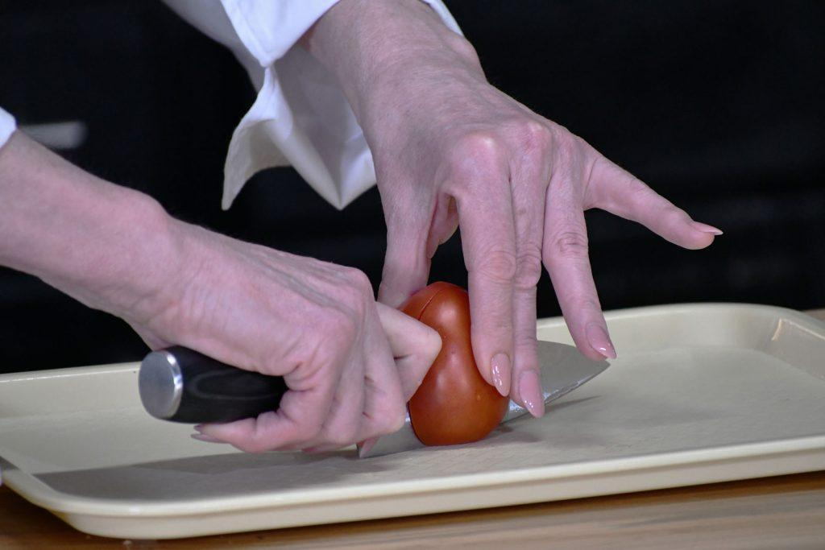Photo Above: Step 3: Safely draw the knife backward, keeping it in the slit you have cut while keeping a gentle downward pressure to continue the cutting until the food is halved. Chef Debra demonstrates this technique using a tomato.

Step 4: Guide the tip of your knife safely under the bridge and place the blade where you want it on top of the food to be cut. For example, if you are cutting a potato, remember the first goal is to cut it in half so you will have a flat surface on both halves of the potato. Maneuver your non-dominant hand to be able to hold the food firmly so it cannot roll.

Step 5: Once the food is firmly secured, place pressure on the handle to push the knife forward while keeping the blade in constant contact with the food. You will not push straight down as it is much easier to push forward with a bit of downward pressure, rather than muscling the knife blade straight downward (which is never a safe strategy). The motion is much like an airplane that is landing. An airplane touches the ground with its front wheels first: the back of the plane’s wheels will catch up with touching the ground as it still moves forward (reducing or eliminating a hard jolt). When the blade runs out and the fingers that are gripping the knife handle and the back of the blade come close to the food, you can safely draw the knife backward, keeping it in the slit you have cut while keeping a gentle downward pressure to continue the cutting. Repeat this step until the food is halved.

Step 6: Now you can safely lift your non-dominant hand straight up into the air away from the food and the knife blade.

Note: It is not the purpose of this article to teach how to large dice, julienne or otherwise fabricate food into specific shapes or sizes.
If learning this is of interest to you, email me at info@theblindkitchen.com and let me know what you would like for me to make a video or write about in the future.

Message from Scout: Meta Glasses and Be My Eyes
by Cheryl McNeil Fisher

Photo Left: The image shows a
close-up of a fluffy,
light reddish brown
(called Fox red) dog
with a wavy coat.
The puppy has a sweet
expression with dark eyes
and a black nose.

Hi friends,

I’m sharing this story because, well… I might have caused a little mischief. You see, Cheryl gave me some ice cubes, and I decided to have some fun. One by one, I took an ice cube from my bowl, trotted it into the kitchen, and dropped it on the floor. When Cheryl bent down to find it, I ran back for another.

“Don’t you drop that,” she warned.

But here’s the thing I’m a Labradoodle. My dad is a Standard Poodle, and poodles can dance! So, naturally, I danced across the kitchen and spit out my ice cube, sending it skidding across the floor. Then I ran back, grabbed another, and stood on my hind legs to dance and toss another cube.

You can guess what happened next: Cheryl took the ice cubes away from me. And that’s when she put on her fancy glasses and called someone named Be My Eyes.

One of the stand-out features of the Ray-Ban Meta Glasses is the ability to be hands-free while connecting with Be My Eyes, making daily tasks even more accessible.

Have you ever chased an ice cube around the kitchen floor? Just when I think I have it, it slips away again! This might seem minor to some, but when I drop three cubes and don’t want water all over my floor, a Be My Eyes volunteer is there to help. In fact, the volunteer I connected with was surprised by how tricky it can be to find a runaway ice cube!

How to Use Be My Eyes with Meta Glasses

Connect or Disconnect Your Glasses
- Open the Meta View app and go to settings to connect or disconnect Be My Eyes.
- If you’re having trouble connecting, double-check your settings in the Meta app.

Start a Call Hands-Free
- Put on your glasses and say, “Hey Meta, Be My Eyes.”
- This initiates a call to a volunteer

Start a Call from the App
- Put on your glasses and press the “Call a Volunteer” button in the Be My Eyes app.
- Then, double-tap the capture button on the top of the right arm of your glasses.
- Your glasses will notify you when the call is active.
Switch Cameras During a Call
- If you start a call using the Be My Eyes app, you can switch to your glasses’ camera.
- Simply double-tap the capture button on the right arm of your glasses to toggle between your phone and glasses cameras.

Go Hands-Free
- Put your phone away and use the built-in camera and microphone on your Meta glasses to communicate with a volunteer.
- They will see through your camera, and you will hear them in your ears.

End a Call
- Double-tap the touchpad on the right arm of your glasses to end the call.

This incredible collaboration between Meta and Be My Eyes makes life more accessible. Do you have a story to share? Vision Access would love to hear how your Meta glasses enhance your life! If you need help putting your story into words, reach out and someone will gladly assist.

Why is Vision Rehabilitation Necessary
by Lori Scharff

The field of education of blind children and the rehabilitation of adults with blindness or low vision dates back to the 1800’s in the United States. Historically, the rehabilitation and education of adults and children have not been part of the medical system.

Vision rehabilitation services are provided by individuals who have specialized training and often hold masters-level degrees and certifications in their field of training. Many of the professionals in the blindness field are duly certified within the field of blindness rehabilitation.

What are the professions within the blind and low vision rehabilitation system?

Certified Low Vision Specialist - assesses the remaining vision someone has and makes suggestions on lighting, hand-held or video magnification or assistive technology.

Certified Orientation and Mobility Specialist - teaches adults and children how to safely and independently navigate, using senses other than vision to orientate and navigate within their environment. They teach how to use a long white cane for protection and obstacle detection indoors and outside.

Certified Vision Rehabilitation Therapist - teaches adults and children with vision loss adaptive techniques for daily living, communication skills such as touch typing and braille, nonvisual ways to identify and take prescription medications, and the use of high tech and assistive technology - to name a few areas. They also often provide social casework support as they have training in how to work with individuals experiencing and adjusting to vision loss or vision changes. They can perform functional vision assessments to learn about how lighting, magnification, and other needs impact on the ways someone uses their vision. They also instruct individuals on safe ways to navigate indoor environments. Additionally, they can work with the family to learn how to support someone with vision loss in areas such as appropriate human guide technique.

Certified Assistive Technology Instructional Specialist - assesses the needs of someone as a result of their blindness or low vision. They make recommendations on software and hardware that might be of assistance to an individual experiencing vision loss in the academic or vocational rehabilitation systems.

Each of the above professions have their own certifications that are maintained by the Academy for Vision Rehabilitation and Education Professionals (ACVREP). ACVREP has a proposal to allow Occupational Therapists to provide blindness and low vision training to individuals who are blind or low vision.

They will require that the Certified Vision Rehabilitation Occupational Therapist have some kind of formal training, but it will not be anything compared to the education current vision rehabilitation professionals receive.
For example, they will not have training to teach orientation and mobility or braille, nor will they have training in working with individuals who are deafblind or with youth.

As a consumer of vision rehabilitation services, you can ask what credentials someone has to work with you in areas associated with your vision loss. Also, the support of fellow CCLVI members or your local state chapter members can be important in walking along in your journey of vision loss.

Convenience Meets Sophistication: Where Style Meets Accessibility
by Cheryl McNeil Fisher

In the world of assistive devices, functionality often takes precedence over aesthetics. However, today's market offers solutions combining both, proving that practicality and style coexist beautifully.

Magnifier Pendants
Imagine a sleek pendant hanging effortlessly around your neck, always within reach, and no more fumbling through pockets or purses. These pendants come on stylish chains and leather lanyards, ensuring you have the clarity you need at your fingertips precisely when needed.

While luxury options in this category can reach up to $499, there are excellent, affordable alternatives that don't compromise quality. Among the standout choices are:
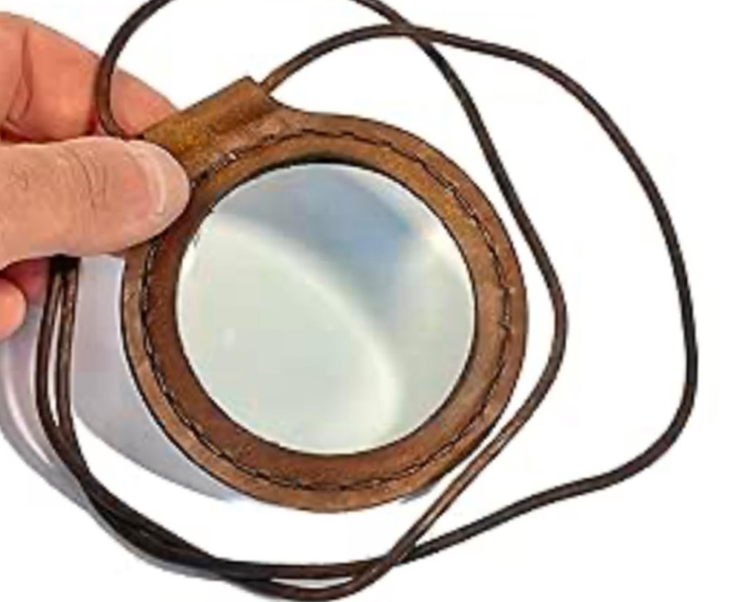
Photo Left: A unisex three-inch diameter magnifier offering 10x magnification, complete with a leather lanyard, available on Amazon for $14.99
https://amzn.to/4a73j17

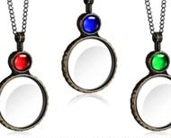
Photo Left: A versatile set of three pendants with varying magnification levels (4x to 10x) and an included chain, priced at just $9.99 https://amzn.to/3W9dhJm

The Evolution of Accessible Time Pieces

My journey with accessible timepieces began with a black Seiko talking watch, provided when I lost the majority of my sight. While functional, a friend's gold-tone braille watch opened my eyes to new possibilities. The larger face of a men's watch proved easier for learning braille timing, and once comfortable with the interface, I transitioned to a women's watch that better suited my
chic professional style.

This shift revolutionized how I managed time in social settings. With a subtle flip of the watch face, I could discreetly check the time while maintaining a natural conversation flow. This was a game changer for professional and social interactions.

This watch is found on Maxi-Aids at https://www.maxiaids.com/category/braille-watches
They range from $39 to hundreds. Shop around.

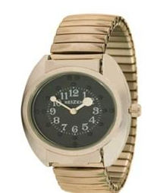
Photo Left: The image shows a watch with a gold-toned, expandable metal band. The watch face is black with white numerals and dots marking the hours and has white hands. The overall look is classic and simple.

Personal Journey and Modern Solutions
The braille watches served me well despite occasional forgetfulness about removing them before swimming, which caused multiple replacements throughout the years. You would not believe how often I’d be in the pool and realize, “Not again.” Sometimes, a bag of rice and Mr. Sun kept it working until the next time. I now wear the smaller Apple iWatch. And, of course, now that I have a waterproof watch or can wring out the water, I never forget to take it off.

Amazon carries a wide range of braille watches, but beware: Wearing one while having aquatic adventures is not recommended.
Blending Function with Fashion
Today's market provides options for every style preference and budget, ensuring that assistance does not come at the cost of personal expression.

*Note: Product prices and availability are subject to change. The items mentioned represent a snapshot of current market offerings*.

Calendar of Events
Everyone is welcome to attend these events by accessing the Zoom mobile app, visiting the Zoom website at https://zoom.us or calling (312) 626-6799, and entering the appropriate meeting ID and passcode.

Subscribe to our CCLVI-Info email list to receive weekly meeting reminders and Zoom details by emailing CCLVIWebmaster@gmail.com. In addition, all CCLVI events, except our business meetings, are listed on the ACB Community Call schedule. Those without email can access that information by calling 1-800-424-8666 and following the prompts.

CCLVI Low Vision Discussion
Themed chats—First Monday at 8:00 PM ET
Speaker or Themed chat - Fifth Monday at 8:00 PM ET
Meeting ID: 896 8650 7068
Passcode: 225846

CCLVI Game Night
Second and fourth Mondays at 8:00 PM ET
Meeting ID: 896 8650 7068
Passcode: 225846

CCLVI Low Vision Peer Support Group
Third Monday at 8:00 PM ET
Meeting ID: 896 8650 7068
Passcode: 225846

CCLVI Board of Directors Meeting
Second Tuesday at 8:30 PM ET
Webinar Meeting ID: 829 0433 3824
Passcode: 784688

Let’s Talk Low Vision
Join our guests for this monthly informative program
First Thursday at 8:00 PM ET
Meeting ID: 874 7608 2312
Passcode: 225845

CCLVI Table Talk Thursday
Weekly calls on a variety of topics related to low vision
Thursdays at 8:00 PM ET (except for Book Chat week)
Meeting ID: 828 1584 6310
Passcode: 225848

CCLVI Monthly Book Chat
Third Thursday at 8:00 PM ET and the following Friday at 11:00 AM ET
Meeting ID: 898 0359 8659
Passcode: 225843
CCLVI Affiliate Zoom Calls

California Council of Citizens with Low Vision (CCCLV) – A Sunday Chat
Spend part of your Sunday with members of CCCLV and enjoy “A Sunday Chat”. This is a call for those of us who are blind or with low vision and any family and friends, be they near or far. Topics will range from all things low vision to life in general as a person who is blind or low vision.
First and Third Sunday at 7:00 PM ET
Webinar Meeting ID: 859 2669 0965
Passcode: 282367

Low Vision Now(formerly Delaware Valley Council of Citzens with Low Vision)
The monthly Zoom meeting Low Vision Now is open to all who have an interest in the issues of low vision.
First Saturday at 12:45 PM ET
(2nd Saturdays in July and September)
Webinar Meeting ID: 440 465 3663
Passcode: 2121

Saturday, March 1, 2025
Speaker: Glenda Such, M.Ed., Assistive Technology Specialist.
Topic: Apps and computer tips for people with a visual impairment.
Saturday, April 5, 2025
Group discussion facilitated by Sarita Kimble, M. S.
Topic: TBD

Kentucky Council of Citizens with Low Vision (KCCLV) - Low Vision Support Calls
First Wednesday at 8:00 PM ET: Business Meeting
Third Wednesday at 8:00 PM ET: Informative meetings for low vision individuals across the US
Meeting ID: 862 9889 6972
Passcode: 975864

*Topics and speakers are subject to change. Please reference the weekly CCLVI emails and ACB Community Call schedule.

Join CCLVI’s Email Lists

CCLVI-Info Email List:
This is a two-way list for members and non-members of CCLVI. Its purpose is to publish the weekly schedule of CCLVI events, and to provide a place where subscribers can ask questions about low vision.
To Join: Send a blank email to cclvi-info+subscibe@acblists.org

CCLVI-Members-Only Email List:
This Is a one-way list that contains information and announcements of the annual business meeting, monthly board meetings, minutes of these meetings, constitutional amendments, resolutions, and other items that members need to vote on.
To Join: You will be added to this list when your annual membership dues are received.

CCLVI-Vision-Access Email List:
This is a one-way list where members receive our newsletter, Vision Access. If you unsubscribe, you will no longer receive our publication and you will miss out on some interesting and informative articles.
To Join: You will be added to this list when your annual membership dues are received.
VISION ACCESS is published four times a year (February 15, May 15, August 15, and November 15) in large print and email.

Vision Access welcomes submissions from people with low vision, from professionals such as ophthalmologists, optometrists, low vision specialists, and everyone with something substantive to contribute to the ongoing discussion of low vision and all of its ramifications. Submission deadlines are January 15, April 15, July 15, and October 15. Send contributions to CCLVIVisionAccess@gmail.com

Accessing Vision Access
Vision Access is available to CCLVI members via email and large print. Archived and podcasted issues are available at www.cclvi.org/VisionAccess.

Contact CCLVI
Council of Citizens with Low Vision International
Address: 5401 Southern Parkway Louisville, KY 40214
CCLVI Toll-free Information Line: 844-460-0625
Email: lowvisionoutreach@gmail.com
Web site: www.cclvi.org

OFFICERS  President - Patti Cox  2024-2026  1st Vice President –  Zelda Gebhard 2023-2025  2nd Vice President –  Terry Pacheco 2024-2026  Secretary - Melanie Sinohui  2024-2026  Treasurer - Debbie Persons  2023-2025  Immediate Past President  Leslie Spoone  Publications Chair  Melanie Sinohui | DIRECTORS  Cynthia Hawkins  2023-2025  Kathy Farina  2024-2026  Joyce Feinberg  2023-2025  Paul Lewis  2024-2026  Cassie Trosper  2023-2025  Donna Williams  2024-2026  Webmaster  Joyce Feinberg

