
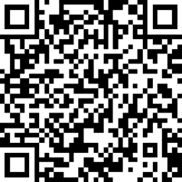
Vision Access
Volume 32 - Number 3
August 2025
Council of Citizens with Low Vision
International

Vision Access | Vol. 32 – No. 3 | August 2025

Table of Contents

President’s Message 3
CCLVI Annual Business Meeting Recap 5
2025-2026 CCLVI Board of Directors 7
2025 CCLVI Awards Recipients 17
A Tribute to Alexa Poli-Scheigert 20
Meet the 2025 Scheigert Scholarship Winners 21
CCLVI at the 2025 ACB Conference and Convention 24
News from the Genensky-Foley Award Committee 26
Affiliates’ Corner 29
CCLVI Book Club 31
Kentucky Talking Book Library 32
Message from Scout 34
The Kitchen Corner 39
Summertime Hacks for the Beach or Pool 39
Red Light Therapy Glasses: A New Hope for Aging Eyes? 41
Calendar of Events 45
Join CCLVI’s Email Lists 49
Contact CCLVI 50
CCLVI Officers and Directors 51

Front Cover and CCLVI Logo Descriptions
The cover page features a diamond-shaped gray background with a logo prominently centered in the middle with the words Council of Citizens with Low Vision above the logo.

The logo represents CCLVI, a special interest affiliate of the American Council of the Blind and is designed with a pair of glasses. Notably, one lens on the glasses has been replaced with a globe, symbolizing global vision and perspective. The other lens is illustrated with a cross-section pointing at the globe, emphasizing detailed observation and insight.

The glasses frame is formed into an infinity symbol, suggesting endless possibilities and continuous improvement in vision and understanding. In the bottom left corner of the diamond-shaped background, there is a QR code, positioned to provide easy access to additional information or resources related to CCLVI and low vision. Below the QR code, it reads: Vision Access Volume 32 Number 3 August 2025

President’s Message
by Patti Cox

A fabulous convention!

The convention did not disappoint. CCLVI started with our virtual convention. On Thursday of virtual week, we had a great speaker, Doctor Joern Soltau who talked to us about different eye diseases, and the research that he and his team are doing. Audience members asked questions about their individual eye disease(s) and whether there are new developments that might give them more vision or vision for a longer period of time.

On Saturday of the virtual convention, we had our business meeting with reports from our committee chairs. We considered three constitution and bylaw changes -- all of them passed. We held elections, all were incumbents, and all were re-elected.

The in-person convention was also a great success. We met new people who have low vision. All four of the scholarship winners attended, and it was so great to meet them. We had three in-person sessions: the dance, a craft-making event, and game night. An additional session was held in a hybrid format. At that event, Sandi Owens “knocked it out of the park.” She led a session on using different apps that can help you with either your daily living or as a small business owner.

In my opinion, there is nothing like an in-person convention. Meeting people face-to-face that you’ve never met except on Zoom or by phone is very special. Having dinner with others (either new acquaintances or old friends) is a special time. These times bring us closer together and feel more like a big family.

I’m looking forward to the next year in CCLVI. It will be really busy. Some of our future tasks are: setting a timeline for the rebranding project, assigning new projects to committees, and tasking committees with improving those projects that we have every year.

If you are interested in joining any of our committees (from advocacy to public relations and beyond), do not hesitate to contact me at patticacb@gmail.com. Let me know what you are interested in and I will get you connected a committee chair (the complete list is on our website): https://cclvi.info/leadership/committees

We need you, as members, to be involved and to lead this organization through the work of our committees.

CCLVI Annual Business Meeting Recap

CCLVI’s Annual Business Meeting was held virtually on June 28, 2025. A review of the year was presented by each committee and elections were held for two officers and three directors with the following results:
- 1st Vice President (1-year term): Zelda Gebhard
- Treasurer (2-year term): Debbie Persons
- Director 1 (2-year term): Joyce Feinberg
- Director 3 (2-year term): Cynthia Hawkins
- Director 5 (2-year term): Dianna Leonard

Constitutional Amendment

5.4: Terms and term limits
Section 5. Election of officers and directors
Purpose: The amendment moves the election of the 1st Vice President from odd years to even years to align with the election of President. Whether the President has termed out or has chosen not to seek reelection, having the election for the President and 1st Vice President at the same time may create a better transition.
Constitutional Amendment Passed

Bylaw Amendments

2.2: Life membership
Purpose: This bylaw lowers the amount of life membership from $300 with up to three yearly payments to a one-time payment of $150.
Bylaw Amendment Passed

3.0: Standing Committee’s Duties and Responsibilities
Purpose: This amendment creates easier accessibility by alphabetizing the standing committees. It also includes additional information in the description of the Genensky-Foley Committee by including a phrase about Carl Foley. thus, providing more consistent reference to both namesakes of the committee.
Bylaw Amendment Passed

2025-2026 CCLVI Board of Directors

Patti Cox - President
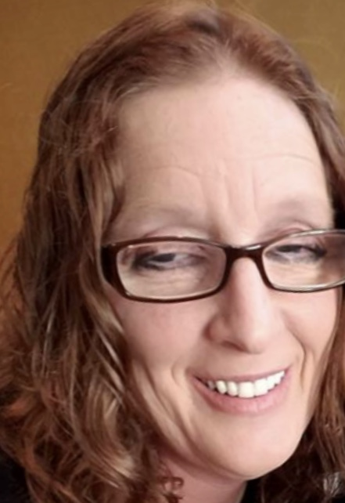
Patti Cox is President of CCLVI and the Kentucky Council of the Blind. She is a third-generation member out of four of ACB and a second-generation member of CCLVI. She grew up in a family with grandparents and a mother who were totally blind and a father who was visually impaired. She has one brother who is retired from the Air Force. Patti lives in Louisville, Kentucky with her husband, children, and grandchildren. She has Anirida, which is the absence of the iris. She is a high partial and a bioptic driver. One of her goals in life is to help anyone and everyone with their vision loss journey.

Zelda Gebhard - 1st Vice President
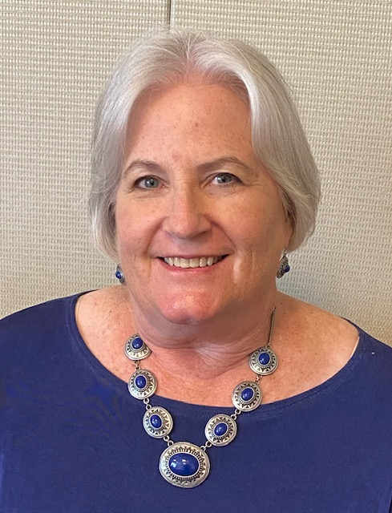
Zelda Gebhard of rural Edgeley, North Dakota, is a dedicated advocate for people with vision loss. Diagnosed with Stargardt's at 34, Zelda turned personal challenges into opportunities for service. A retired medical transcriptionist and healthcare administrator, she’s now a full-time volunteer with the North Dakota Association of the Blind, the Council of Citizens with Low Vision International, and the American Council of the Blind, and serves in numerous leadership roles. Her faith and family are her cornerstones. She enjoys cooking, gardening, sewing and reading. Her journey reflects resilience, gratitude, and a passion for helping others live fully with vision loss.

Terry Pacheco - 2nd Vice President
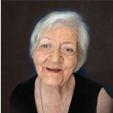
Terry Pacheco is the 2nd Vice President of CCLVI and Co-Chair of the e-Communications Committee. She has had low vision all of her life, and her husband is totally blind. Their son also has low vision due to Agent Orange exposure by his birth father in Vietnam. Their vision experiences run the gambit. She first joined CCLVI in 1979 and helped start its first two local chapters. Since that time, she has served in several positions, both in ACB and its affiliated organizations and she currently serves on the ACB Board of Directors.

Melanie Sinohui - Secretary
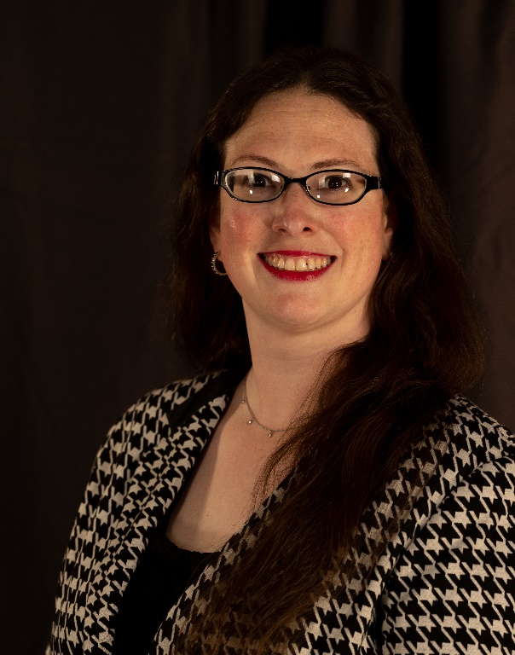
Melanie Sinohui has been involved in ACB since the mid-1990s in Texas, West Virginia, California, and Arizona. She was elected as a Director for ACB of Texas at age 19, and was the 2005 DKM First-Timer for the West. She resides in Phoenix and is President of the Arizona Council of the Blind. She is Secretary and Publications Chair of the Council of Citizens with Low Vision, Vice-Chair of the ACB Durward K. McDaniel Fund Committee, and a member of ACBs Employment and Media Support Committees. Melanie holds a B.A. in Journalism – Public Relations and an M.S. in Project Management. She is currently a Senior Process Engineer at Wells Fargo. Melanie and her husband enjoy cooking, traveling, wine tasting, and spending time with “framily”.

Debbie Persons - Treasurer
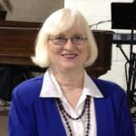
Debbie Persons grew up in rural southern Indiana. In school, she was an award-winning track star, participated in many 4-H horse competitions and was a cheerleader. Debbie attended college at Indiana State University. She became a certified Emergency Medical Technician and later worked in medical offices for decades. She was church Treasurer for many years. She became involved with the Kentucky Council of the Blind in 2008 when the ACB Convention was in Louisville. Debbie has albinism and is a bioptic driver and appreciates the inventor of the monocular and word processing programs that allow the use of large print. Her favorite pastime is researching genealogy.

Leslie Spoone - Immediate Past President
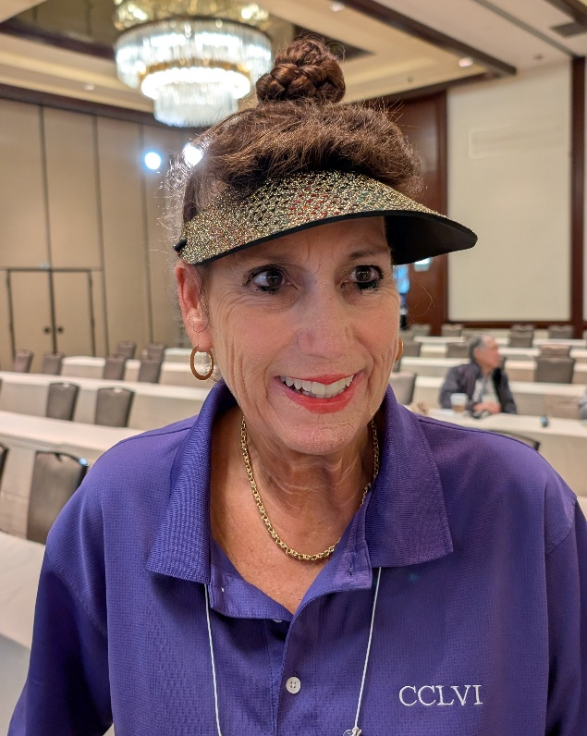
Leslie Spoone has lived in Orlando, Florida for 28 years with her husband Dan Spoone and has Retinitis Pigmentosa (RP), a degenerative eye disease that leads to blindness. She had usable vision for most of her life and appreciated the support she received from CCLVI. She was 2nd Vice President of CCLVI from 2014 to 2016 and President from 2016 to 2018. She is a certified aerobics instructor and certified personal trainer. She teaches exercise classes on the ACB Community since the community started in 2020. She offers classes in yoga, resistance, cardio and circuit each week. She owned a women’s gym for five years in Orlando, where she taught classes, was a personal trainer, and learned a lot about relationships.

Joyce Feinberg – Director #1
Joyce Feinberg began her career in medical technology, later becoming a technical specialist for a leading equipment manufacturer. She lost her vision due to undiagnosed diabetes, but adapted and thrived. Since joining the American Council of the Blind in 2003, she’s contributed extensively to its affiliates, especially after the pandemic. Now active with the ACB Media team, she edits and posts audio content, and volunteers with CCLVI, building accessible websites and supporting community engagement.

Kathy Farina – Director #2
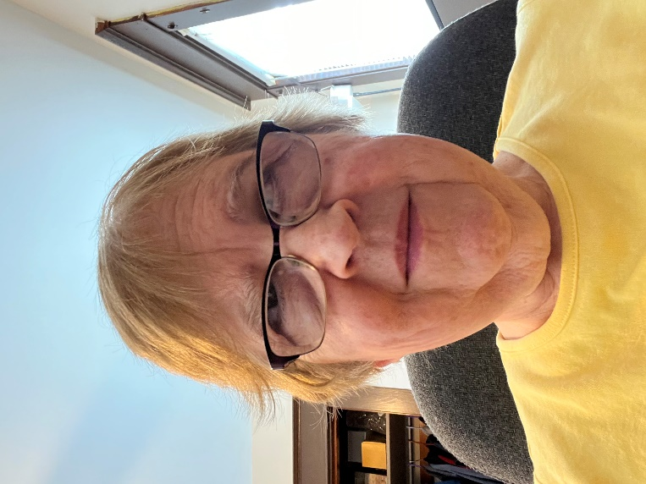
Kathy Farina is retired, married, and lives in Albany, New York with her husband and two guide dogs. She has been legally blind since birth. Although she has been a member of the Council of Citizens with Low Vision International since the mid-1990’s, she first got actively involved in 2012 when she joined the Fred Scheigert Scholarship Committee. She has served in various positions on the CCLVI board since 2016 and is currently Chair of the CCLVI Fundraising Committee.

Cynthia G. Hawkins, Esq. – Director #3
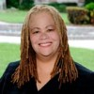
Cynthia Hawkins has been involved in CCLVI since losing much of her usable vision in 2016 due to a surgical emergency. She was born with low vision due to prematurity. She is the past Chair of the CCLVI Constitution & ByLaws Committee and remains as a committee member. She also serves on the Publications Committee. Cynthia is the current 2nd Vice President and Board Member of the American Association of Visually Impaired Attorneys (AAVIA), a member of the ACB Resolutions Committee, and a former Board Member and Secretary of the Guide Dog Users International (GDUI). She grew up in Washington, D.C. and currently splits her time between Florida and New York, with her son, and her guide dog Venture. She has recently retired from a lengthy and successful career as an attorney, Judge, and law professor. In her new-found spare time, Cynthia enjoys latch-hooking, quilting, audiobooks, word games, and is learning to crochet.
Paul Lewis – Director #4
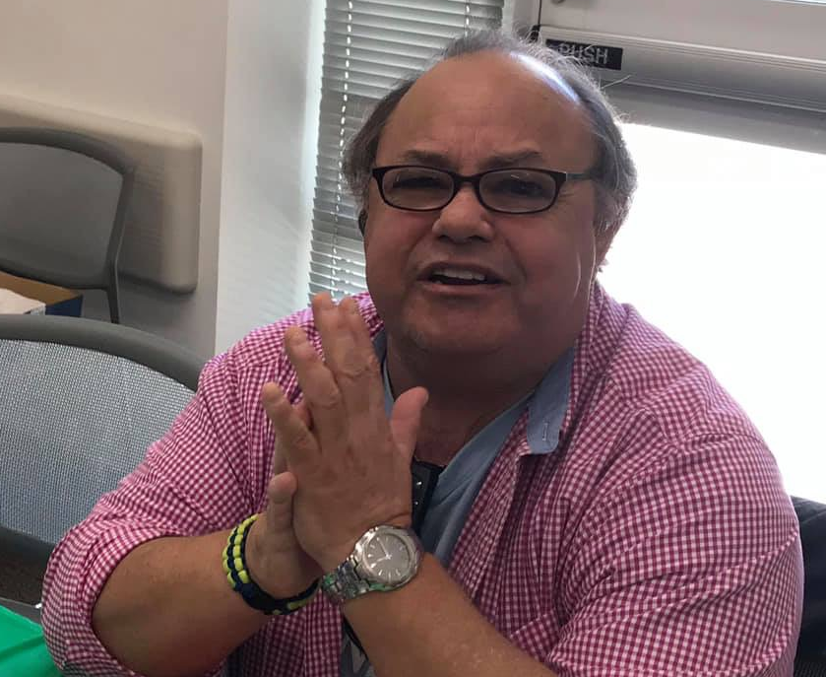
Paul Lewis is a baby boomer who grew up in the D.C. Metro area and in 1991 relocated to southwest Florida. In the early 80’s, he was diagnosed with diabetes, the cause of most of his medical issues, including vision loss. In 2008, he joined the local ACB affiliate and attended his first state convention. It was there that he first became a member of CCLVI and its Florida affiliate. It was important to him to become part of an organization dedicated to the low vision community. Since that time, he has been part of the leadership team and committees. He currently chairs the Constitution, ByLaws & Resolutions Committee. Paul is a committed and dedicated member of FCCLV and CCLVI.

Dianna Leonard – Director #5
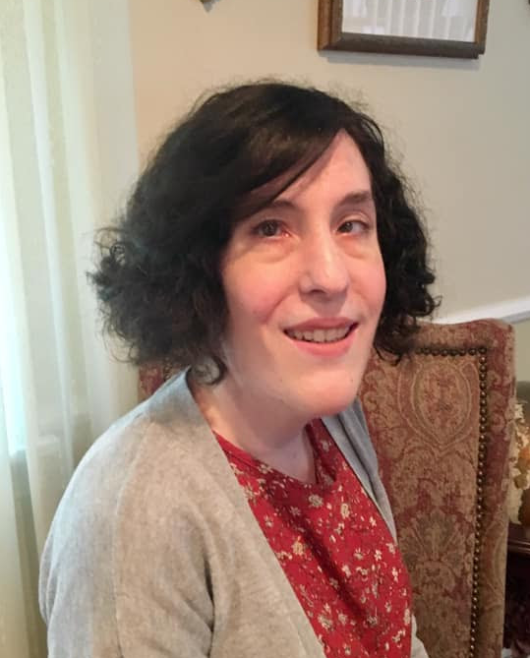
Dianna Leonard has been visually impaired since birth due to Retinopathy of Prematurity. She grew up in Massachusetts and has a Bachelor of Arts degree in English and Communications and several years of professional experience in copy editing and social media marketing. In her spare time, Dianna runs a rapidly-growing gaming channel on YouTube. She also enjoys reading, and has been working on writing a young adult fiction novel. For physical activity she enjoys swimming, yoga, and going for walks, and has a background in martial arts and figure skating from when she was younger.

Donna Williams – Director #6
Donna Williams lives near Philadelphia, Pennsylvania. She was born with cataracts in both eyes and now has Glaucoma. One of her passions is helping others. She has volunteered for and held various jobs at nonprofit organizations serving the disability community. In her spare time, she’s all about books, music, and playing games with family and friends. She’s been a life member of CCLVI for many years and currently serves as Chair of the Genensky-Foley Magnification Award Committee. She also serves on the CCLVI Scholarship, Membership, and e-Communications Committees.

2025 CCLVI Awards Recipients
by Jeanne Struhar and Zelda Gebhard

The CCLVI Awards Committee is proud to announce the recipients of the 2025 CCLVI Awards.

Glenda Such
CCLVI Bernice Kandarian Service Award
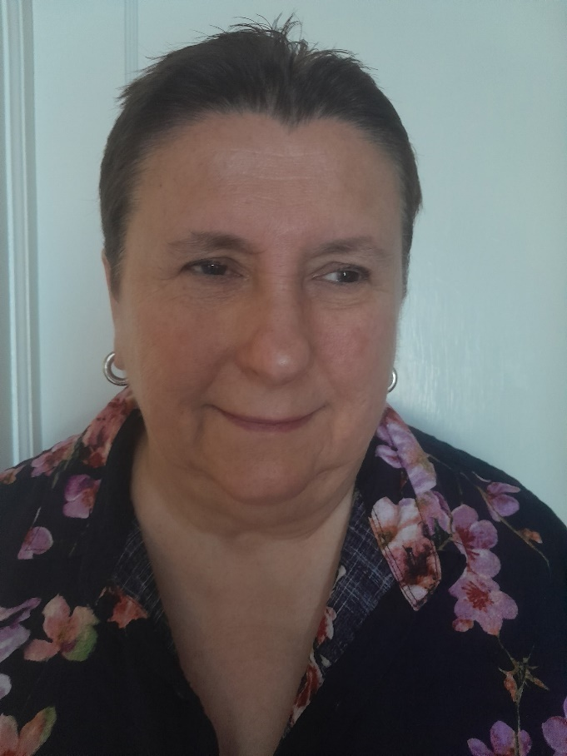
Glenda Such of Yardley, Pennsylvania has been a dedicated member of CCLVI since 1985, and has served in numerous leadership roles, including President of Low Vision Now, an affiliate of CCLVI. With over 39 years of experience in Vision Rehabilitation and Assistive Technology, her impact spans advocacy, education, and innovation. Glenda has also served on the FDA’s Ophthalmologic Devices Panel, championing the needs of consumers nationwide. Her lifelong commitment to advancing services and opportunities for people with low vision makes her truly deserving of this honor. Glenda’s passion for helping to empower people with low vision stems from an early personal experience. She possesses the desire to “support others and teach them to do what they don’t know they can do.” Outside her volunteer work, Glenda’s interests include nature photography, pencil sketching, and fencing.

Zelda Gebhard
CCLVI Bernice Kandarian Service Award
Our second 2025 Bernice Kandarian Award recipient is Zelda Gebhard of Edgeley, North Dakota. Zelda is a dedicated advocate for people with vision loss. Diagnosed with Stargardt's at age 34, Zelda turned personal challenges into opportunities for service. She serves in numerous leadership roles, including 1st Vice President of CCLVI, Chair of both the Membership and Credentials Committees, and is a member of several other committees.

Zelda’s volunteer work doesn’t stop there. She is actively involved with the North Dakota Association of the Blind, and the American Council of the Blind. In her spare time, Zelda enjoys cooking, gardening, sewing, and reading. Faith and family are her cornerstone. Her journey reflects resilience, gratitude, and a passion for helping others live fully with vision loss. Zelda’s greatest inspiration for serving is the phone calls she receives from people newly experiencing vision loss. Talking to them, providing encouragement, and letting them know they are not alone is what gives Zelda purpose. What keeps her continuously giving of herself for so many years and in so many ways? Zelda states, “Knowing I helped someone and made it a little easier for them, that’s my pay.”

Alexa Scheigert
Friend of CCLVI Award
We are honored to posthumously recognize Alexa Scheigert with the Friend of CCLVI Award. A Life Member of CCLVI and long-time supporter through the New York State Council of Citizens with Low Vision, Alexa was the widow of Fred Scheigert and carried forward his legacy with heartfelt dedication. Following Fred’s passing, she generously funded the Fred Scheigert Scholarships, expanding the number of recipients and ensuring their future through a planned estate gift. Her unwavering commitment and generosity will continue to transform the lives of individuals with low vision for years to come.

A Tribute to Alexa Poli-Scheigert
by Patti Cox
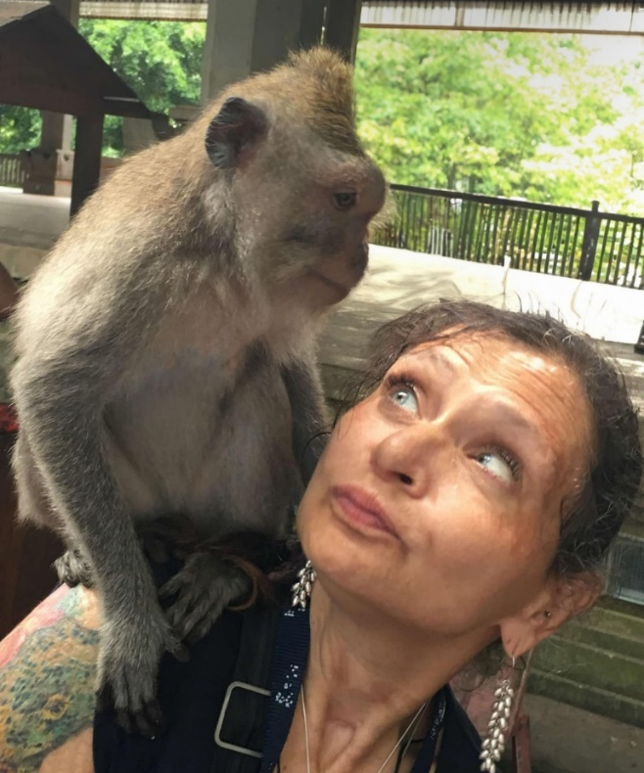
Alexa Poli-Scheigert lost her battle with cancer on January 11, 2025. She was raised in Queens, New York. She and Fred Scheigert were married on August 17, 2013, and lived in Saratoga Springs, NY.

Fred, for many years, provided CCLVI with $3,000 scholarships for those with low vision to aid in attending college. After Fred’s passing, Alexa made certain the scholarships continued and even increased the number of scholarships.

Over the past few years, I got to know Alexa and we became friends. Last year, Melanie and I had the opportunity to meet Alexa in person. It was a short visit but a wonderful one. It was great to be able to spend a bit of time speaking with such a fantastic person.

Alexa, you were a special person and will be greatly missed.

Meet the 2025 Scheigert Scholarship Winners

Leen Khraisat - Freshman
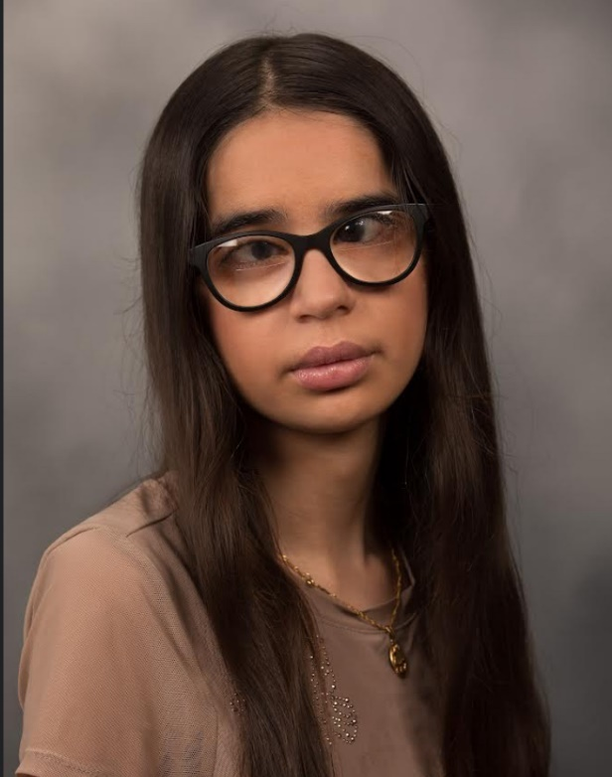
Leen Khraisat resides in Pittsburgh, PA. This fall, she will be an incoming freshman at Duquesne University, double majoring in Finance and Accounting. She plans to pursue her CPA and build a career in the business world. Outside of academics, she enjoys volunteering and community service. In her free time, she loves reading, listening to music, and baking. She is also a strong advocate for the blind and visually impaired community. She hopes to continue working with organizations that empower the blind and visually impaired and to contribute to their mission through her own efforts.

Noor Khraisat - Undergraduate
Noor Khraisat lives in Pittsburgh, Pennsylvania. She is double majoring in Political Science and History at the University of Pittsburgh because she believes in the power of policy to create tangible and lasting change. Her passion for these fields is deeply rooted in her lived experiences as a blind student and as an advocate for accessibility.

Daniel Solomon - Undergraduate
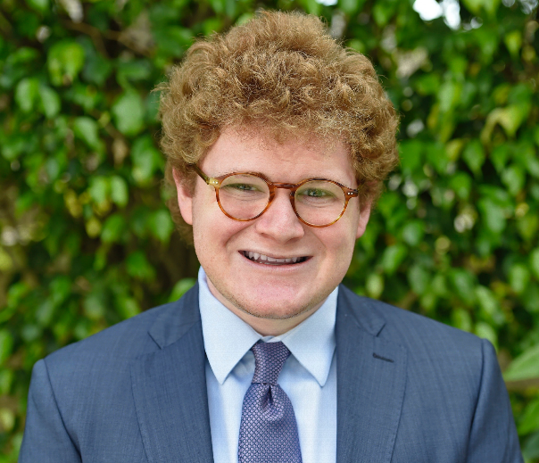
Daniel Solomon, a Miami native, is a junior at Brown University concentrating in urban studies and political science. An advocate for civil rights, the arts, and education, Solomon serves as president of the American Jewish Committee (AJC) Campus Global Board, an international advisory council on antisemitism and democracy. Legally blind since birth, Daniel is creator and project director of The Blind Urban Subject, through which he created Civic Vision (2024), an interactive public art installation developed at Brown and the Rhode Island School of Design (RISD). The exhibition, an urban simulation of common forms of blindness, debuted in June 2025 in New York City’s SoHo neighborhood.
Muhammad Sohaib - Graduate

Muhammad Sohaib is a dedicated educator, disability rights advocate, and Ph.D. student in Special Education at the University of North Texas. With over a decade of experience in accessibility, inclusive education, and community leadership, Sohaib is committed to advancing opportunities for individuals with visual impairments. His academic work focuses on inclusive language education and assistive technology for visually impaired learners. Outside the classroom, he is an avid mountaineer, hiker, and traveler, challenging perceptions about what blind individuals can achieve. A former Fulbright Foreign Language Teaching Assistant, Sohaib also brings a passion for cultural exchange and language teaching. His aspiration is to build a world where accessibility is not a privilege but a right, and where every student, regardless of ability, can thrive, explore, and achieve their full potential in education and beyond.

CCLVI at the 2025 ACB Conference and Convention
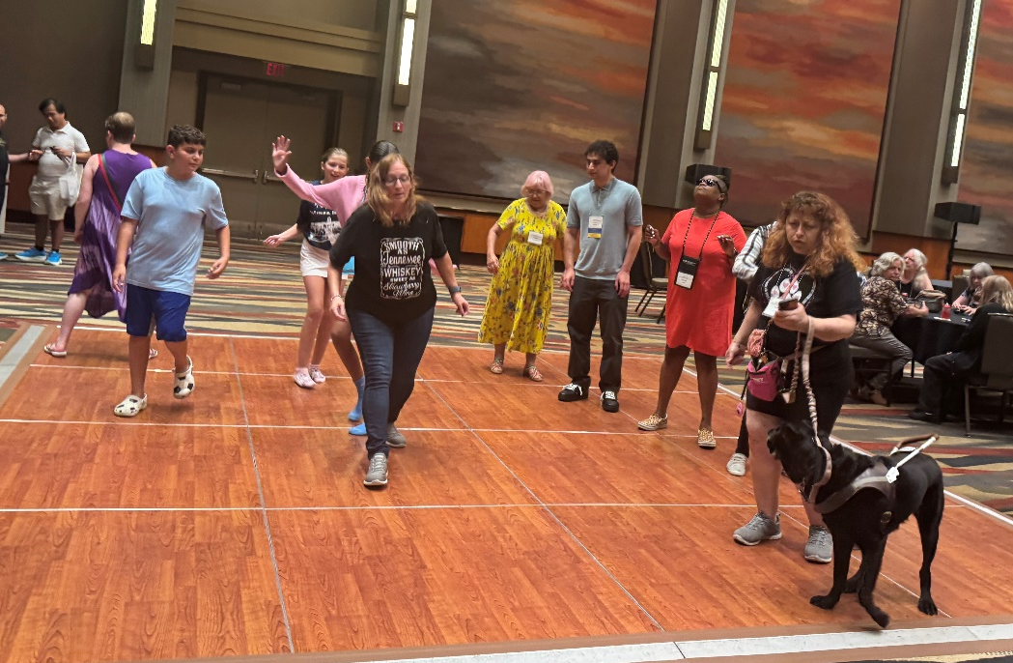
Photo Left: A group of people of various ages is gathered on the dance floor in a large, well-lit room with colorful abstract wall art. Some individuals are dancing, while others observe.

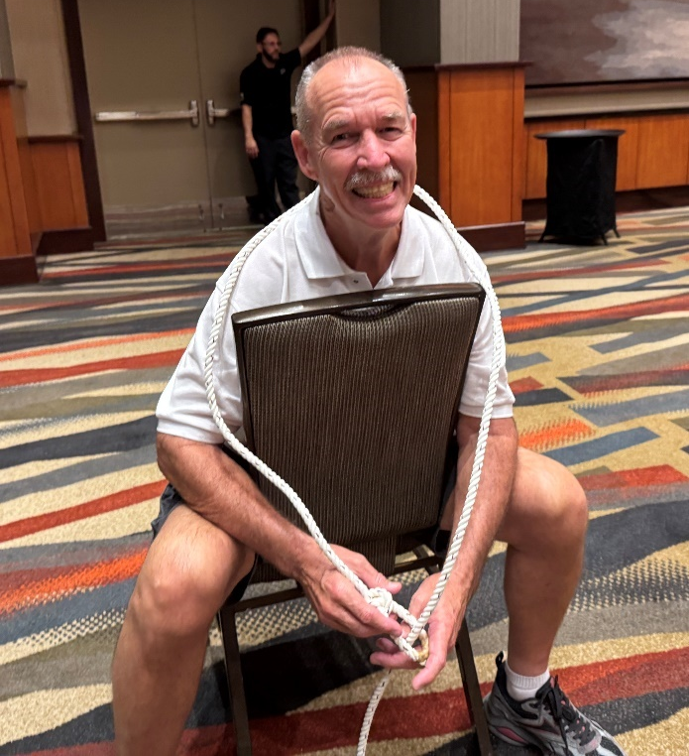
Photo Left: Tim Stone is smiling while sitting on a chair in a large room with patterned carpet. He is wearing a white polo shirt, shorts, and sneakers. A white rope is loosely draped around his shoulders, after he was lassoed during a game at the western-themed dance.
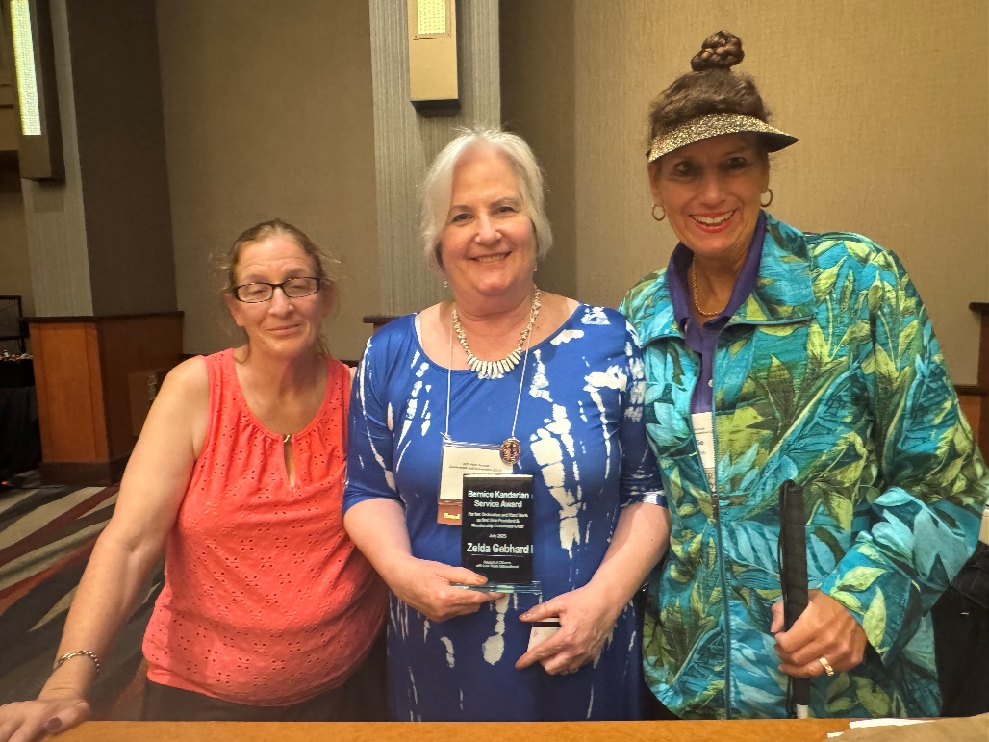
Photo Left: Patti Cox (left) and Leslie Spoone (right) present Zelda Gebhard (center) with the Bernice Kandarian Service Award.

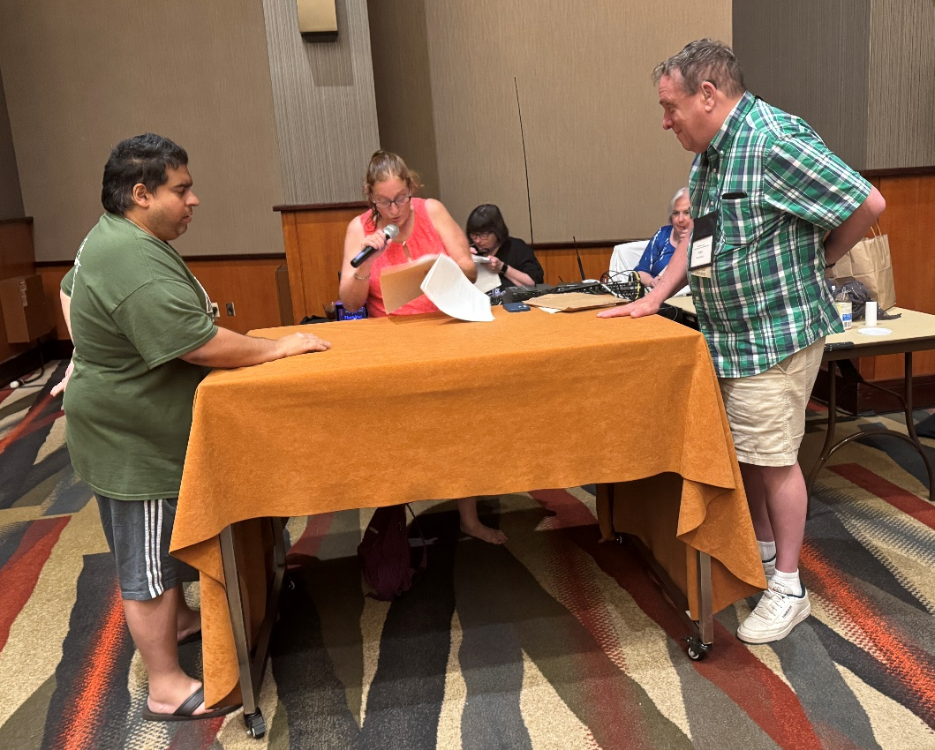
Photo Left: Niral Sheth and Carl Richardson stand at opposite ends of a table with their hands flat, ready to “buzz” in, while Patti Cox stands between them hosting this year’s Family Feud game.

News from the Genensky-Foley Award Committee
by Donna Williams, Chair

The Genensky-Foley Award Committee is pleased to share the following information with you. This year, instead of giving out iPads, the committee sought donations of magnification devices. We were fortunate to receive seven donations, 14 applications, and awarded three devices. The Clearview CCTV donated by Envision Dallas was awarded to Lucia Mueller from Goshen, Ohio. The Mano 6 hand-held electronic magnifier donated by C Tech Low Vision was awarded to Patricia Koch from West Lafayette, Ohio. The 32x HD Video Magnifier donated by Terry Pacheco was awarded to Mason Tornes from Tomball, Texas. The remaining donations will be awarded in the coming year(s).

Below you will find a brief bio for each recipient. Two of our recipients were minors and their parents submitted information on their behalf.

Lucia Mueller (from Lucia's mother, Laura):
"Lucia is a 15-year-old girl from Goshen, Ohio, who was born with a rare eye condition that causes low vision. Lucia was thrilled to be selected as a recipient of a CCTV device, a gift that will help her tremendously.

One of Lucia’s favorite hobbies is photography and scrapbooking. She loves capturing special moments with her family and friends, then turning them into beautiful scrapbook pages. Thanks to the CCTV, she can now enjoy this hobby more independently and in greater detail.

Lucia is also an avid reader and now has access to even the smallest print. In addition to reading, Lucia enjoys watercolor painting and playing both the piano and guitar. She’s excited to explore how the CCTV will enhance her experience with these activities as well. This device will provide her with endless possibilities and we will be forever grateful!"

Mason Tornes (from Mason's father, Brandon):
“Mason was born into this world a healthy baby to his two loving parents and older sister. At 6 days old, Mason and his family’s life changed in a way that they never dreamed of. Mason’s parents got a phone call from the Colorado Children’s Hospital saying that there was something identified through his newborn blood screening. They determined that he had a rare genetic metabolic disorder called Cobalamin C. With Cobalamin C doctors typically see cognitive delays, speech issues, macular degeneration and several other issues. Shortly thereafter, they confirmed he had Macular Degeneration.

We let Mason try everything he’s interested in, and we just accommodate as needed. He’s been a baseball all-star with the Miracle League and is currently an Arrow of Light Webelo in his local cub scout pack!

Mason struggles reading books at home and at school. This new tool will be a great way for him to read amazing stories about his favorite characters such as Mario and Luigi, Sonic the Hedgehog, and Lego Ninjago. Making it easier to read will expand his skills and knowledge as well as helping him become more independent in life. Thank you so much!”

Patricia Koch
Patricia Koch is a self-employed certified vision rehabilitation therapist from West Lafayette, Ohio. She is currently a doctoral candidate. Patricia's low vision was caused by Retinopathy of Prematurity. Receiving a hand-held video magnifier will allow her to read on-the-go as she works on research projects and continues her education.

Affiliates’ Corner

Low Vision Now Sets New Record for Listeners
by Glenda V. Such, M. Ed.

On June 7, 2025, Low Vision Now set a new record for the number of participants in our Zoom meeting. The Zoom meeting focused on the Meta Ray Ban smart glasses. The Meta Ray Ban smart glasses are “normal looking” glasses that have a computer inside allowing for AI assistance.

Erin Kramer, Ph. D. and Glenda Such, M. Ed. explained what the glasses do, how they look and operate, and their various controls. An extensive interactive demonstration was provided. Specifically, the demonstration highlighted the features which make the glasses such a valuable tool for those who have low or no vision.

Features include:
- Ability to describe in great detail any photo or scene surrounding the user.
- Ability to view a restaurant menu and isolate specific foods such as chicken or vegetable dishes.
- Ability to view a shirt and provide a detailed description of its patterns, color, and potential discolorations.
- Ability to view two items side by side and describe which is what, such as two different cans of soup, different seasonings, and more.
- Ability to view standard mail and provide a summary of its contents.
- Ability to view and read instructions, tell prices, and identify sizes on labels.
- Ability to make and receive telephone calls.
- Act as a sound system for playing music or described audio movies and shows.

With the electronic sharing of the recording of that meeting, there were over 500 views in only 5 weeks. More than 77 people participated in the meeting with an additional number of listeners who logged in while the meeting was in progress.

We hope to have you attend one of our meetings and if you find we offer something of interest, you might join Low Vision Now as one of the affiliates of CCLVI. We meet on the first Saturday of each month. All are welcome to attend. Please see the Calendar of Events at the end of this publication for Zoom information.

To join Low Vision Now, please visit our website at:
https://www.lowvisionnow.org

To listen to the recording of the Zoom meeting about the Meta Ray Ban glasses, please use the link below:
https://us02web.zoom.us/rec/share/PgPzBHB0duTOV8eTdbIZ1u6bc-zP2zX7ewr3yokx0vdV8qy-l8SvwBLOH8ROR4pe.SzbVlm95PYQ3s2jW?startTime=1752340315000

CCLVI Book Club

August 2025: The Measure, a novel
- Author: Erick, Nikki
- Book Number: DB 109475
- Reading Time: 11 hours, 3 minutes
- Narrated by: Julie Whelan

BARD Description: Eight ordinary people, one extraordinary choice. When you open up your door, waiting for you is a small wooden box. This box holds your fate inside: the answer of the exact number of years you will live.

Please see the Calendar of Events at the end of this publication for meeting information

Kentucky Talking Book Library
by Evan Hatter, Information Officer II, Talking Book Library

The Kentucky Talking Book Library (KTBL) was founded in 1969 to serve people throughout the Commonwealth of Kentucky with print disabilities, including low vision. KTBL is a network library of the National Library Service for the Blind and Print Disabled (NLS), which is a part of the Library of Congress.

We provide free audio and braille book service to any person within the state of Kentucky who is certified to have a visual disability like low vision, a physical disability that would prevent someone from holding a book or turning the pages, or even a reading disability like dyslexia.

Our collection is very similar to a public library, spanning a wide variety of books for all ages and interests. We have more than 125,000 titles in audio and 20,000 in braille ranging from cookbooks and health books to children’s books and national bestsellers. In Kentucky, we have an audio recording studio where we record local books by, about, and for Kentuckians. We also invite local authors, such as Kentucky Poet Laureate Kathleen Driskell, Bryan Collier, Kim Michele Richardson and Frank X Walker to record their works in our studio.

Patrons who sign up for Talking Books may receive their audiobooks on cartridge through the mail or they can choose to download them onto their personal device using the Braille and Audio Reading Download (BARD) mobile application.

Additionally, we have a lively and well-attended virtual book club that meets every month with patrons from every corner of the state.

While our program serves the folks in Kentucky, all U.S. citizens, including Puerto Rico, Guam, the U.S. Virgin Islands, and citizens living abroad, have access to these materials through their state’s regional or subregional libraries. For more information, visit https://www.loc.gov/nls/find-your-library/

Message from Scout
by Cheryl McNeil Fisher

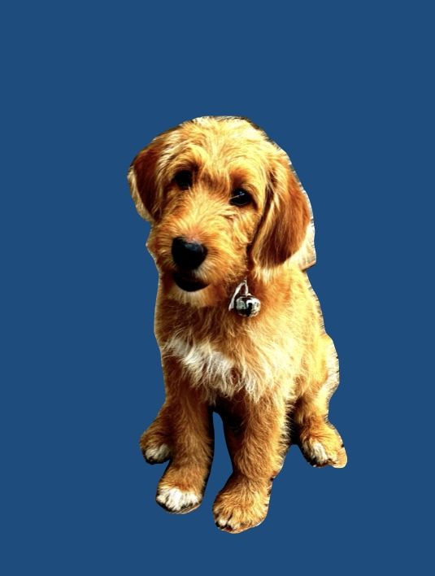
Photo Left: The image shows a
close-up of a fluffy, light reddish brown (called Fox red) dog with a wavy coat. The puppy has a sweet expression with dark eyes
and a black nose.

Hi Friends. Scout here.

Guess what? I turned one year old on July 13th! Cheryl says I’m a natural swimmer, and boy, am I having a blast. Instead of just telling you how Cheryl introduced me to the pool, we’re sharing an excerpt from Surprise Sammy! It’s Your Birthday! The Adventure of a Guide Dog Team, written with a 7th grader.

Excerpt: “Here I come…!”

I cry as I leap into the pool by the stairs. SPLASH. I do my doggie paddle a bit, then I remember what Cindy taught me. I use my long strokes, keeping my paws under the water. Stroke. Stroke. I glide over to Nellie. Daisy hurries out of the pool for another jump. And here comes Bella down the tunnel slide.

“Weeee…!” SPLASH.

Bella comes up sputtering. “Here you go Bella,” says Frank. He slips a float under Bella.

Bella smiles and sighs, “I love that guy!”

“You’re a good swimmer Sammy,” says Nellie.

“Thanks! My Cindy taught me.”

“Really?” asks Nellie.

“How did she teach you to swim?” asks Bella.

“When we first started, I was pretty shaky. Cindy would hold me against her, allowing me to put all four of my paws on her legs while she crouched in the low end of the pool. Her encouragement and calmness made my fear of the water begin to lessen.”

“Tell them how she accomplished that, Sammy?” Max calls from the side of the pool.

“She would patiently hold me, allowing me to perch on her legs while she crouched in the pool. We’d stay like that for about five minutes with Cindy talking softly to me the entire time. Then she would wrap her arms around my belly. As soon as my paws began to splash on top of the water, she pulled me down just enough to get my paws back under the water. With patience and encouragement, she helped me see how much easier it is to swim with my paws under the surface of the water. Each day we practiced five times. Then, we had playtime. Cindy tossed my toy in the water for me to fetch. It has taken a few weeks to get the hang of not just paddling under water, but swimming long strokes.”

“Why is swimming with your paws under water so important, Sammy?” asks Duke.

“It’s less tiring, Duke.” When Cindy would toss a toy in for me, I loved jumping in to get it, but I’d panic. I’d snatch the toy in my teeth, then splash-paddle like crazy back to the stairs to get out. I wanted to do it again and again, but I wiped myself out because I splashed so hard. And I never went in the deep end. No way!

I used to watch Cindy’s retired guide dog, Gregg, glide through the water. He was so graceful. I longed to swim like him. Gregg was able to stay in the water, having fun with Cindy and her friends.

“Wow Sammy. That is awesome. Did Cindy teach you how to put your front legs over the noodle so you could float?” Nellie asked.

“Yes. It also has helped to build my confidence in the water.”

“Whoa Sammy, that is really awesome,” adds Bella.

“Did Mark show you how to use the noodle too, Daisy?”

“He sure did. I get to stay in longer when I use the noodle to rest and hang out.”

“Do you think Cindy could teach Duke to swim?” Nellie asks.

“Not sure. What do you think, Duke?”

“I don’t think so, Sammy. Besides, I really have no interest in swimming. I’m happy laying on that first step over there. It’s just enough water to cool me off, while watching my friends have fun!” (End of excerpt)

Now back to me, Scout! I was a natural, and by the third day, I was leaping in, grabbing my toy, and swimming around with Cheryl and Ed. Then Cheryl would encourage me to head to the stairs for a break. I hop out, shake off, drop the toy in Cheryl’s hand—and I’m ready to go again! I think a fifteen-second break is plenty, don’t you?

Safety first! I can jump from the third step into the pool or slip in with my smooth Labradoodle glide. But I always use the stairs and stay away from the sides—Cheryl says we don’t want to scratch the liner. After all, I’m a smart pup.

I also have to be extra careful with my Cheryl. She had an operation and has some other stuff going on, so we make sure pool time is safe and playful. And yes—it’s also “obedience training.” I’m getting better every day! I love to zip around the house and jump, but when Cheryl calls me, I race to her, snuggle up to her left leg, and give her my best “Yes?” look.

We wish you a safe, splashy summer—and we’ll see you in our next update!

Paw-sitively yours,
Scout

The Kitchen Corner
Knife Safety: Know Where Your Sharps Are!
by Debra Erickson, MS, Executive Chef and Founder, The Blind Kitchen

Keeping track of knives, scissors, peelers and other sharp kitchen tools is a priority as one cooks. This is especially true if people who share a kitchen do not share vision loss. One tip to make sure both the blind and sighted cooks are safe is to have a predictable system of where the sharp tools will be kept, both when dirty and clean. In The Blind Kitchen, any sharp that is not in use at the time is placed in a long thin basket at the top of the work area. Another basket is at the back of the sink so, if the sharp tool is dirty, it can safely wait for a time to be cleaned and never left in the bottom of a sink or on a counter.

Summertime Hacks for the Beach or Pool
by Cheryl McNeill Fisher

Here are a few quick summer tips you’ll be glad you know!

Let’s start with a beach essential: baby powder and a glove. Trust me; this is a fast, easy way to get all that clingy sand off before you head home.
I also always use a large tote bag which makes it easier to carry everything in one trip instead of juggling multiple bags. Inside the bottom of my tote, I place one or two square gift boxes (the kind that are about three inches wide and come with a lid). They’re the perfect size to hold my Contigo travel mugs and yes, I often have one hot and one cold. These boxes are also great for keeping sunscreen and lotions upright and leak-free.

Another tote essential? A purse organizer. The small pockets are ideal for lip balm with SPF, mini lotions, wipes, and all those little odds and ends. I also use zip-top bags to group similar items together. It makes everything easier to find and keeps your tote from turning into a black hole.

And then there’s those inexpensive plastic shower curtain rings. They may not look like much, but these little clips are super handy. Use them to keep your towel in place by clipping the towel to the top of your beach chair—it stops the breeze from blowing it off every five minutes. You can also clip one to the handle of your tote and hook the bag to your chair, keeping it off the ground.

They may seem simple, but I promise—everyone around me ends up glad I have them. Everything handy, cheap, and surprisingly versatile!

Red Light Therapy Glasses: A New Hope for Aging Eyes?
by Cheryl McNeill Fisher

Red light therapy glasses, such as the 2025 Upgraded Red Light Therapy Glasses from Lukirch, represent a novel approach to supporting eye health, particularly for older adults experiencing changes in vision. But do they really work? Here's what you need to know.

Anecdotal Evidence and Scientific Backing
While I haven't personally tried these glasses, I've spoken with individuals who have reported positive experiences. Jim, who has been using them for two months, claims to have noticed an improvement in his vision. Mary, another user, reports enhanced definition in her surroundings after using the glasses for just three minutes each morning for a month.

Jim's interest in red light therapy glasses stemmed from extensive research following a doctor's recommendation of a similar treatment costing $6,000 per session. After six months of investigation and conversations, he decided to try these glasses. These anecdotal accounts align with the science behind the glasses.

How They Work: Energizing Your Retina
These glasses utilize deep red light at a specific wavelength of 670 nanometers (nm). This wavelength is believed to energize the retina by stimulating the mitochondria, the energy producers within your eye cells. As we age, these mitochondria become less efficient, particularly in the retina, impacting vision quality.

Wearing the glasses for a few minutes daily, especially in the morning, may help improve how your eyes process light and contrast. A study from University College London demonstrated that just three minutes of 670 nm red light could enhance color contrast sensitivity in individuals over 40, with results lasting up to a week after a single use.

The red light is thought to stimulate enzymes in the eye, boosting energy production and reducing stress in retinal cells.

What the Glasses Offer: Comfort and Convenience
The Lukirch glasses are designed with user comfort in mind and include features such as:
- Timed sessions ranging from 3 to 15 minutes
- Gradual light intensity increase
- Automatic shut-off
***It's important to note that these glasses are not medical devices and are not intended to treat or cure eye diseases.

Who Might Benefit?
Red light therapy glasses may be beneficial for:
- Adults over 40
- Individuals experiencing age-related vision fatigue
- Anyone interested in exploring light-based wellness for eye health

Important Considerations
- These glasses do not treat eye diseases such as macular degeneration or glaucoma.
- Consult with your eye doctor before using light therapy, especially if you have light sensitivity or a pre-existing eye condition.
- Morning use is recommended, as evening use may disrupt sleep patterns.

Bottom Line
Red light therapy glasses offer a potentially safe and convenient way to support aging eyes. While further research is warranted, initial studies show promise. As always, consult with your eye care professional before trying any new treatment.
Learn More
- Product page: https://lukirch.com/products/2025-upgraded-red-light-therapy-glasses-670nm-for-eye-health-and-improving-vision
- Study summary (UCL): https://www.ucl.ac.uk/news/2021/nov/morning-exposure-deep-red-light-improves-declining-eyesight
- Article from Verywell Health: https://www.verywellhealth.com/are-light-therapy-glasses-right-for-me-4161293

Calendar of Events
Everyone is welcome to attend these events by accessing the Zoom mobile app, visiting the Zoom website at https://zoom.us or calling (312) 626-6799, and entering the appropriate meeting ID and passcode.

Subscribe to our CCLVI-Info email list to receive weekly meeting reminders and Zoom details by sending a blank email to cclvi-info+subscribe@acblists.org In addition, all CCLVI events, except our business meetings, are listed on the ACB Community Call schedule. Those without email can access that information by calling 1-800-424-8666 and following the prompts or typing acb.community into your web browser.

All Monday and Thursday Zoom Events have the same Zoom link, Meeting ID, and Passcode.

CCLVI Low Vision Discussion – Friends and Family
First Monday at 8:00 PM ET

CCLVI Game Night
Second and fourth Mondays at 8:00 PM ET

CCLVI Low Vision Peer Support Group
Third Monday at 8:00 PM ET
CCLVI Speaker or Themed chat - Fifth Monday at 8:00 PM ET

CCLVI Board of Directors Meeting
Second Tuesday at 8:30 PM ET
Meeting ID: 829 0433 3824
Passcode: 784688

CCLVI Let’s Talk Low Vision
First Thursday at 8:00 PM ET
Join our guests for this monthly informative program
Also broadcasted on ACB Media 1
The podcast of the episodes can be found at: https://www.cclvi.org/LetsTalkLowVision

CCLVI Table Talk Thursday
Second, fourth, and fifth Thursdays at 8:00 PM ET
Weekly calls on a variety of topics related to low vision

CCLVI Monthly Book Chat
Third Thursday at 8:00 PM ET

CCLVI Affiliate Zoom Calls

California Council of Citizens with Low Vision (CCCLV) – A Sunday Chat
First and Third Sunday at 7:00 PM ET
Spend part of your Sunday with members of CCCLV and enjoy “A Sunday Chat”. This is a call for those of us who are blind or with low vision and any family and friends, be they near or far. Topics will range from all things low vision to life in general as a person who is blind or low vision.

Low Vision Now (formerly Delaware Valley Council of Citizens with Low Vision)
First Saturday at 12:45 PM ET (Second in July and Sept.)
The monthly Zoom meeting Low Vision Now is open to all who have an interest in the issues of low vision.
Meeting ID: 440 465 3663
Passcode: 2121

Kentucky Council of Citizens with Low Vision (KCCLV) - Low Vision Support Calls
First Wednesday at 8:00 PM ET: Business Meeting
Third Wednesday at 8:00 PM ET: Informative meetings for low vision individuals across the US
Meeting ID: 862 9889 6972
Passcode: 975864

Note: Topics and speakers are subject to change. Please reference the weekly CCLVI emails and ACB Community Call schedule.

Join CCLVI’s Email Lists

CCLVI-Info Email List:
This is a two-way list for members and non-members of CCLVI. Its purpose is to publish the weekly schedule of CCLVI events, and to provide a place where subscribers can ask questions about low vision. To Join: Send a blank email to cclvi-info+subscribe@acblists.org

CCLVI-Members-Only Email List:
This Is a one-way list that contains information and announcements of the annual business meeting, monthly board meetings, minutes of these meetings, constitutional amendments, resolutions, and other items that members need to vote on. To Join: You will be added to this list when your annual membership dues are received. If you unsubscribe, you will not receive important information about CCLVI.

CCLVI-Vision-Access Email List:
This is a one-way list where members receive our newsletter, Vision Access. If you unsubscribe, you will no longer receive our publication and you will miss out on some interesting and informative articles. To Join: You will be added to this list when your annual membership dues are received.
VISION ACCESS is published four times a year (February 15, May 15, August 15, and November 15) in large print and email.

Vision Access welcomes submissions from people with low vision, from professionals such as ophthalmologists, optometrists, low vision specialists, and everyone with something substantive to contribute to the ongoing discussion of low vision and all of its ramifications. Submission deadlines are January 15, April 15, July 15, and October 15. Send contributions to CCLVIVisionAccess@gmail.com

Accessing Vision Access
Vision Access is available to CCLVI members via email and large print. Archived and podcasted issues are available at www.cclvi.org/VisionAccess

Contact CCLVI
Council of Citizens with Low Vision International
Address: 5401 Southern Parkway Louisville, KY 40214
Call CCLVI: (502) 905 – 0869 between 9am and 9pm ET
Email: lowvisionoutreach@gmail.com
Website: www.cclvi.org

CCLVI Officers and Directors

OFFICERS  President - Patti Cox  2024-2026  1st Vice President -  Zelda Gebhard 2025-2026  2nd Vice President -  Terry Pacheco 2024-2026  Secretary - Melanie Sinohui  2024-2026  Treasurer - Debbie Persons  2025-2027  Immediate Past President -  Leslie Spoone  Publications Chair  Melanie Sinohui | DIRECTORS  #1 Joyce Feinberg  2025-2027  #2 Kathy Farina  2024-2026  #3 Cynthia Hawkins  2025-2027  #4 Paul Lewis  2024-2026  #5 Dianna Leonard  2025-2027  #6 Donna Williams  2024-2026  Webmaster  Joyce Feinberg

