Keyboard Shortcuts Mentioned on the CCLV I Zoom Call: Thursday 4/21/2022

Hosted by the Council of Citizens with
Low Vision International.
Our website is https://cclvi.org

Keyboard Shortcuts for Windows PC Computers:

Open
control O
Print
control P
Bold
control B
Italic
Control I
Underline
Control U
Font dialog box
control shift f

Screen shot
Function key + windows logo key + spacebar
This will take a picture of a screen shot from your computer then when you go into your email program you can paste it in the body of the email message. By pressing control V.

Microsoft Office Keyboard Shortcuts:
The below keyboard shortcuts can be used in any Microsoft Office program.

Ribbon Bar
If you keep pressing the function key f6 it will take you to the different parts of the ribbon bar. The f6 key is located on the keyboard on the row where it has the function keys f1 to f12. For example, if you want to go insert you would keep pressing the f6 key until you get to the insert. Then when you are on the insert then press enter. Then to navigate the lower ribbon key press the tab key or your arrow keys. To navigate the lower part of the ribbon bar.

Page Count
Control shift g at the same time

Reading Aloud
Control alt key space bar all at the same time

Ease of Access Options:
To find your ease of access options. Press the windows logo key. Then in the search box type control panel and then press enter. Then when the next screen comes up press your tab key until you get to the link that says ease of access and then press enter.

Mac Keyboard Shortcuts:

Cut, copy, paste, and other common shortcuts
- Command-X: Cut the selected item and copy it to the Clipboard.
- Command-C: Copy the selected item to the Clipboard. This also works for files in the Finder.
- Command-V: Paste the contents of the Clipboard into the current document or app. This also works for files in the Finder.
- Command-Z: Undo the previous command. You can then press Shift-Command-Z to Redo, reversing the undo command. In some apps, you can undo and redo multiple commands.
- Command-A: Select All items.
- Command-F: Find items in a document or open a Find window.
- Command-G: Find Again: Find the next occurrence of the item previously found. To find the previous occurrence, press Shift-Command-G.
- Command-H: Hide the windows of the front app. To view the front app but hide all other apps, press Option-Command-H.
- Command-M: Minimize the front window to the Dock. To minimize all windows of the front app, press Option-Command-M.
- Command-O: Open the selected item, or open a dialog to select a file to open.
- Command-P: Print the current document.
- Command-S: Save the current document.
- Command-T: Open a new tab.
- Command-W: Close the front window. To close all windows of the app, press Option-Command-W.
- Option-Command-Esc: Force quit an app.
- Command–Space bar: Show or hide the Spotlight search field. To perform a Spotlight search from a Finder window, press Command–Option–Space bar. (If you use multiple input sources to type in different languages, these shortcuts change input sources instead of showing Spotlight. Learn how to change a conflicting keyboard shortcut.)
- Control–Command–Space bar: Show the Character Viewer, from which you can choose emoji and other symbols.
- Control-Command-F: Use the app in full screen, if supported by the app.
- Space bar: Use Quick Look to preview the selected item.
- Command-Tab: Switch to the next most recently used app among your open apps.
- Shift-Command-5: In macOS Mojave or later, take a screenshot or make a screen recording. Or use Shift-Command-3 or Shift-Command-4 for screenshots. Learn more about screenshots.
- Shift-Command-N: Create a new folder in the Finder.
- Command-Comma (,): Open preferences for the front app.

Sleep, log out, and shut down shortcuts
You might need to press and hold some of these shortcuts for slightly longer than other shortcuts. This helps you to avoid using them unintentionally.
- Power button: Press to turn on your Mac or wake it from sleep. Press and hold for 1.5 seconds to put your Mac to sleep.* Continue holding to force your Mac to turn off.
- Option–Command–Power button* or Option–Command–Media Eject : Put your Mac to sleep.
- Control–Shift–Power button* or Control–Shift–Media Eject : Put your displays to sleep.
- Control–Power button* or Control–Media Eject : Display a dialog asking whether you want to restart, sleep, or shut down.
- Control–Command–Power button:* Force your Mac to restart, without prompting to save any open and unsaved documents.
- Control–Command–Media Eject : Quit all apps, then restart your Mac. If any open documents have unsaved changes, you will be asked whether you want to save them.
- Control–Option–Command–Power button* or Control–Option–Command–Media Eject : Quit all apps, then shut down your Mac. If any open documents have unsaved changes, you will be asked whether you want to save them.
- Control-Command-Q: Immediately lock your screen.
- Shift-Command-Q: Log out of your macOS user account. You will be asked to confirm. To log out immediately without confirming, press Option-Shift-Command-Q.
* Does not apply to the Touch ID sensor.

Finder and system shortcuts
- Command-D: Duplicate the selected files.
- Command-E: Eject the selected disk or volume.
- Command-F: Start a Spotlight search in the Finder window.
- Command-I: Show the Get Info window for a selected file.
- Command-R: (1) When an alias is selected in the Finder: show the original file for the selected alias. (2) In some apps, such as Calendar or Safari, refresh or reload the page. (3) In Software Update preferences, check for software updates again.
- Shift-Command-C: Open the Computer window.
- Shift-Command-D: Open the desktop folder.
- Shift-Command-F: Open the Recents window, showing all of the files you viewed or changed recently.
- Shift-Command-G: Open a Go to Folder window.
- Shift-Command-H: Open the Home folder of the current macOS user account.
- Shift-Command-I: Open iCloud Drive.
- Shift-Command-K: Open the Network window.
- Option-Command-L: Open the Downloads folder.
- Shift-Command-N: Create a new folder.
- Shift-Command-O: Open the Documents folder.
- Shift-Command-P: Show or hide the Preview pane in Finder windows.
- Shift-Command-R: Open the AirDrop window.
- Shift-Command-T: Show or hide the tab bar in Finder windows.
- Control-Shift-Command-T: Add selected Finder item to the Dock (OS X Mavericks or later)
- Shift-Command-U: Open the Utilities folder.
- Option-Command-D: Show or hide the Dock.
- Control-Command-T: Add the selected item to the sidebar (OS X Mavericks or later).
- Option-Command-P: Hide or show the path bar in Finder windows.
- Option-Command-S: Hide or show the Sidebar in Finder windows.
- Command–Slash (/): Hide or show the status bar in Finder windows.
- Command-J: Show View Options.
- Command-K: Open the Connect to Server window.
- Control-Command-A: Make an alias of the selected item.
- Command-N: Open a new Finder window.
- Option-Command-N: Create a new Smart Folder.
- Command-T: Show or hide the tab bar when a single tab is open in the current Finder window.
- Option-Command-T: Show or hide the toolbar when a single tab is open in the current Finder window.
- Option-Command-V: Move the files in the Clipboard from their original location to the current location.
- Command-Y: Use Quick Look to preview the selected files.
- Option-Command-Y: View a Quick Look slideshow of the selected files.
- Command-1: View the items in the Finder window as icons.
- Command-2: View the items in a Finder window as a list.
- Command-3: View the items in a Finder window in columns.
- Command-4: View the items in a Finder window in a gallery.
- Command–Left Bracket ([): Go to the previous folder.
- Command–Right Bracket (]): Go to the next folder.
- Command–Up Arrow: Open the folder that contains the current folder.
- Command–Control–Up Arrow: Open the folder that contains the current folder in a new window.
- Command–Down Arrow: Open the selected item.
- Right Arrow: Open the selected folder. This works only when in list view.
- Left Arrow: Close the selected folder. This works only when in list view.
- Command-Delete: Move the selected item to the Trash.
- Shift-Command-Delete: Empty the Trash.
- Option-Shift-Command-Delete: Empty the Trash without confirmation dialog.
- Command–Brightness Down: Turn video mirroring on or off when your Mac is connected to more than one display.
- Option–Brightness Up: Open Displays preferences. This works with either Brightness key.
- Control–Brightness Up or Control–Brightness Down: Change the brightness of your external display, if supported by your display.
- Option–Shift–Brightness Up or Option–Shift–Brightness Down: Adjust the display brightness in smaller steps. Add the Control key to this shortcut to make the adjustment on your external display, if supported by your display.
- Option–Mission Control: Open Mission Control preferences.
- Command–Mission Control: Show the desktop.
- Control–Down Arrow: Show all windows of the front app.
- Option–Volume Up: Open Sound preferences. This works with any of the volume keys.
- Option–Shift–Volume Up or Option–Shift–Volume Down: Adjust the sound volume in smaller steps.
- Option–Keyboard Brightness Up: Open Keyboard preferences. This works with either Keyboard Brightness key.
- Option–Shift–Keyboard Brightness Up or Option–Shift–Keyboard Brightness Down: Adjust the keyboard brightness in smaller steps.
- Option key while double-clicking: Open the item in a separate window, then close the original window.
- Command key while double-clicking: Open a folder in a separate tab or window.
- Command key while dragging to another volume: Move the dragged item to the other volume, instead of copying it.
- Option key while dragging: Copy the dragged item. The pointer changes while you drag the item.
- Option-Command while dragging: Make an alias of the dragged item. The pointer changes while you drag the item.
- Option-click a disclosure triangle: Open all folders within the selected folder. This works only when in list view.
- Command-click a window title: See the folders that contain the current folder.
- Learn how to use Command or Shift to select multiple items in the Finder.
- Click the Go menu in the Finder menu bar to see shortcuts for opening many commonly used folders, such as Applications, Documents, Downloads, Utilities, and iCloud Drive.

Document shortcuts
The behavior of these shortcuts may vary with the app you're using.
- Command-B: Boldface the selected text, or turn boldfacing on or off.
- Command-I: Italicize the selected text, or turn italics on or off.
- Command-K: Add a web link.
- Command-U: Underline the selected text, or turn underlining on or off.
- Command-T: Show or hide the Fonts window.
- Command-D: Select the Desktop folder from within an Open dialog or Save dialog.
- Control-Command-D: Show or hide the definition of the selected word.
- Shift-Command-Colon (:): Display the Spelling and Grammar window.
- Command-Semicolon (;): Find misspelled words in the document.
- Option-Delete: Delete the word to the left of the insertion point.
- Control-H: Delete the character to the left of the insertion point. Or use Delete.
- Control-D: Delete the character to the right of the insertion point. Or use Fn-Delete.
- Fn-Delete: Forward delete on keyboards that don't have a Forward Delete key. Or use Control-D.
- Control-K: Delete the text between the insertion point and the end of the line or paragraph.
- Fn–Up Arrow: Page Up: Scroll up one page.
- Fn–Down Arrow: Page Down: Scroll down one page.
- Fn–Left Arrow: Home: Scroll to the beginning of a document.
- Fn–Right Arrow: End: Scroll to the end of a document.
- Command–Up Arrow: Move the insertion point to the beginning of the document.
- Command–Down Arrow: Move the insertion point to the end of the document.
- Command–Left Arrow: Move the insertion point to the beginning of the current line.
- Command–Right Arrow: Move the insertion point to the end of the current line.
- Option–Left Arrow: Move the insertion point to the beginning of the previous word.
- Option–Right Arrow: Move the insertion point to the end of the next word.
- Shift–Command–Up Arrow: Select the text between the insertion point and the beginning of the document.
- Shift–Command–Down Arrow: Select the text between the insertion point and the end of the document.
- Shift–Command–Left Arrow: Select the text between the insertion point and the beginning of the current line.
- Shift–Command–Right Arrow: Select the text between the insertion point and the end of the current line.
- Shift–Up Arrow: Extend text selection to the nearest character at the same horizontal location on the line above.
- Shift–Down Arrow: Extend text selection to the nearest character at the same horizontal location on the line below.
- Shift–Left Arrow: Extend text selection one character to the left.
- Shift–Right Arrow: Extend text selection one character to the right.
- Option–Shift–Up Arrow: Extend text selection to the beginning of the current paragraph, then to the beginning of the following paragraph if pressed again.
- Option–Shift–Down Arrow: Extend text selection to the end of the current paragraph, then to the end of the following paragraph if pressed again.
- Option–Shift–Left Arrow: Extend text selection to the beginning of the current word, then to the beginning of the following word if pressed again.
- Option–Shift–Right Arrow: Extend text selection to the end of the current word, then to the end of the following word if pressed again.
- Control-A: Move to the beginning of the line or paragraph.
- Control-E: Move to the end of a line or paragraph.
- Control-F: Move one character forward.
- Control-B: Move one character backward.
- Control-L: Center the cursor or selection in the visible area.
- Control-P: Move up one line.
- Control-N: Move down one line.
- Control-O: Insert a new line after the insertion point.
- Control-T: Swap the character behind the insertion point with the character in front of the insertion point.
- Command–Left Curly Bracket ({): Left align.
- Command–Right Curly Bracket (}): Right align.
- Shift–Command–Vertical bar (|): Center align.
- Option-Command-F: Go to the search field.
- Option-Command-T: Show or hide a toolbar in the app.
- Option-Command-C: Copy Style: Copy the formatting settings of the selected item to the Clipboard.
- Option-Command-V: Paste Style: Apply the copied style to the selected item.
- Option-Shift-Command-V: Paste and Match Style: Apply the style of the surrounding content to the item pasted within that content.
- Option-Command-I: Show or hide the inspector window.
- Shift-Command-P: Page setup: Display a window for selecting document settings.
- Shift-Command-S: Display the Save As dialog, or duplicate the current document.
- Shift–Command–Minus sign (-): Decrease the size of the selected item.
- Shift–Command–Plus sign (+): Increase the size of the selected item. Command–Equal sign (=) performs the same function.
- Shift–Command–Question mark (?): Open the Help menu.

Other shortcuts
For more shortcuts, check the shortcut abbreviations shown in the menus of your apps. Every app can have its own shortcuts, and shortcuts that work in one app might not work in another.
- Accessibility shortcuts
- Safari shortcuts
- Spotlight shortcuts
- Startup shortcuts
- Apple Music shortcuts: Choose Help > Keyboard shortcuts from the menu bar in the Music app.
- Other shortcuts: Choose Apple menu > System Preferences, click Keyboard, then click Shortcuts.

Keyboard shortcuts in different categories:
https://laufware.com/keyboard-shoBottom of Form

Setting up Gmail in Outlook for office 365
- Select File > Add Account.
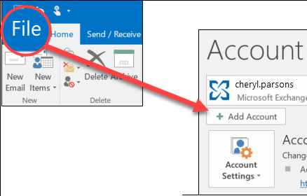
- Enter your email address and click Connect.
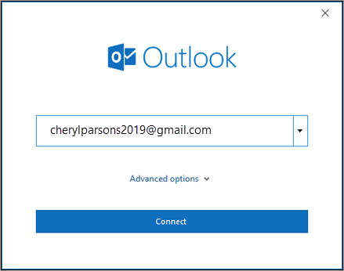
- Outlook will launch a Gmail window that asks for your password. Enter the password and select Sign in.
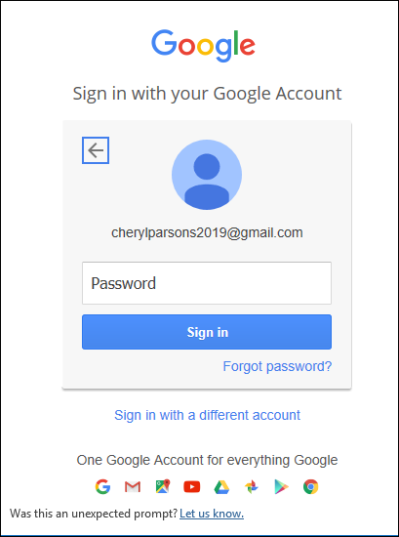
Important: Once you connect your Gmail account to Outlook, you may receive a warning message in your Gmail inbox telling you that a new logon from Internet Explorer was detected. This is expected behavior.
- If you have previously enabled 2-factor authentication for Gmail, you'll be prompted to enter the code sent to your mobile device. If you haven't enabled 2-factor authentication, skip to step 6.
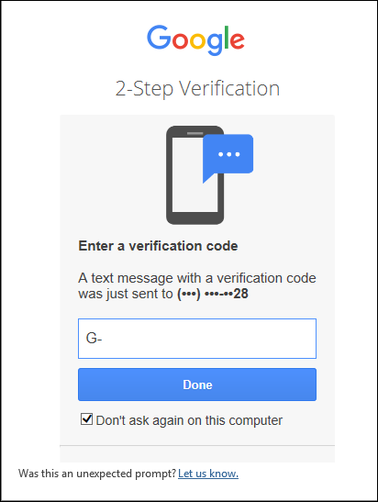
- The Google account permissions window appears. Click Allow.
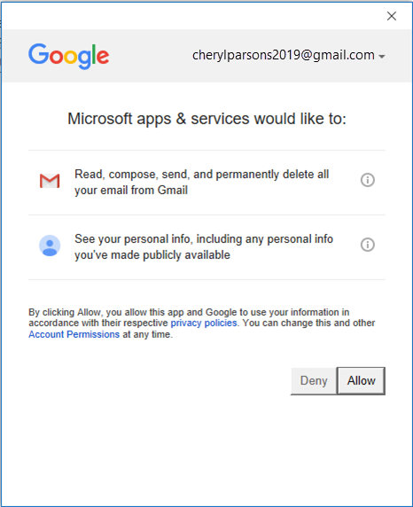
- Once Outlook finishes adding your Gmail account, you can add another email account or select Done.
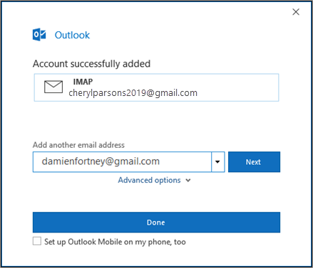
Tips:
  - If you check the box for Setup Outlook Mobile on my phone, too, you'll be taken to a website where you can enter your mobile phone number and you'll receive a link to download Outlook for iOS or Outlook for Android. Installing Outlook Mobile is a great way to stay up-to-date on the go.
  - 
If you need instructions for adding an email account using advanced settings, see Use advanced setup to add a POP or IMAP email account in Outlook for PC.

Outlook won't accept my password
If Outlook won’t accept your password and you know you’re using the right password for your Gmail account, you might have an older version of Outlook that doesn't currently support this faster Gmail setup option. In that case, you'll need to use two-factor authentication and an app password to help verify that you're the person trying to access your Gmail account.
Gmail does allow you to add your account to Outlook without setting up two-factor authentication and using an app password, but you must turn on a setting that allows "less secure apps" to connect to your account. We do not recommend this setting. We recommend turning on two-factor authentication and using an app password.
To turn on two-factor authentication and get an app password, use the following steps.
- Go to Gmail from your browser, then select the Google apps icon in the upper right corner of the screen.

- Select your account.
- On the left, select Security.
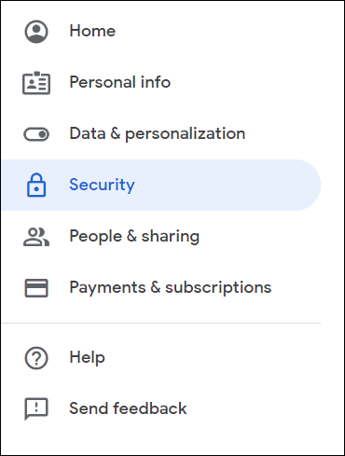
- Under Signing into Google, if 2-Step Verification is OFF, click the>next to OFF to turn it ON. Otherwise, skip to step 4.
  - On the first screen, click CONTINUE.
  - If prompted, enter your Gmail password and then click NEXT.
  - Enter your phone number and select whether you want to receive your verification codes by text message or a phone call. Then click NEXT.
  - Enter the code you received and click NEXT.
  - Click TURN ON to finish setting up 2-step verification.
  - Return to the previous screen by clicking the left arrow at the top of the screen next to 2-Step Verification.

- Select the > on the far right of the App Passwords line.
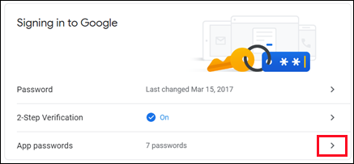
- Enter your Google password and then select Sign in. At the bottom of the next screen, select Mail and Windows Computer from the drop-down lists, then select Generate.

- Google will display an app password for you. Copy this password (without the spaces) and enter this password when Outlook prompts you for a password.

:

